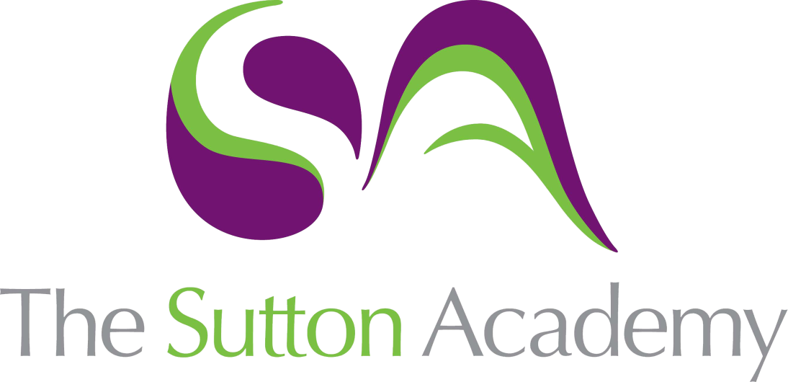

Knowledge Rich Curriculum Plan
Year 10 Term 2

Lesson/Learning Sequence  Formal Elements | Intended Knowledge:  Students will know that… | Tiered Vocabulary | Prior Knowledge:  In order to know this students, need to already know how… | Assessment
Personal Project
Mind Mapping | - Students will know a range of themes through prepared resources for Stimuli.  - Students will know that a mind map opens the mind to explore various viewpoints.  - Students will know how to produce a creative mind map. | A mind map is a diagram starting in the centre of a blank page where you write a keyword or phrase. From this central “idea” you can draw branches and sub-branches to write associated words, ideas and even images that all relate to your main idea. | - How to create a spider Diagram.  - How to discuss various starting points with one word.
Research  Reading Activity | - Students will know how what primary and secondary research is.  - Students will collate relevant research for their chosen theme.  - Students will know what tools to use to research into to their chosen themes. | Primary research is usually considered to be items like personal letters, diaries, records or other documents created during the period under study. But primary sources can also include photographs, jewellery, works of art, architecture, literature, music, clothing, and other artefacts.  Secondary research is material produced by others. Secondary sources can be reproductions of images and artefacts, photographs, film, video or web-based material. If your stimulus is a piece of music, media or literature, you are working from a secondary source.  Relevant: Closely connected or appropriate to what is being done or considered.  Contextual research: Carrying out research that helps you understand and explain where, how and why your ideas fit in terms of contemporary painting and other practices past and present. | - Students need to already know that it is important to research into a theme or project before we begin.  - Students need to already know how to brainstorm an idea, thought or theme.  - How to use online platforms such as Pinterest, Google culture etc.
Mood board | - Students will know how to create a mood board based on their chosen theme/idea.  - Students will know how to collage their ideas together. | A mood board is a visual tool that communicates our concepts and visual ideas. It is a well thought out and planned arrangement of images, materials, pieces of text, etc. that is intended to evoke or project a particular style or concept. | - Students need to already know how to create a collage.  - Students need to already know how to use secondary imagery to inform their ideas.
Primary photographs and contact sheet (SET 1) | - How to take a set of photographs relevant and intentional to their theme.  - How to plan their shoot and what they will take.  - How to reflect and review photos through use of a contact sheet. | Close up: Looking at a piece by zooming or focusing in on one area up close.  Edit: Adjusting an original piece. | - To create effective lighting.  - To use close up to improve composition.  - To think about a successful background to enhance the foreground.
Primary drawing | - Students will know how to draw from direct observation.  - Students will know how to use shadows and highlights in the correct areas.  - Students will know how to apply colour to their drawings | Observational drawings: Drawings from objects in front of you. | - Students need to already know how to form basic shapes.  - Students need to already know how to draw to scale.  - Students need to know their colour theory
Analytical drawings & Drawings from photos. | - Students will know how to experiment with a range of 2D materials and papers.  - Students will know how to use the formal elements to develop their studies into their own style.  - Students will know how to apply colour to their drawings | Formal elements  Line: A long, narrow mark or band.  Tone: Refers to the relative lightness or darkness of a colour  Shape: A shape is an enclosed space, a bounded two-dimensional form that has both length and width.  Texture: The feel, appearance, or consistency of a surface or substance. | - Students need to already know their colour theory.  - Students need to already know how to create graduated tones.  - To create depth into their drawings.
Artist Research  Reading Activity | - Students will know how to carefully select and engage with 2 artists relevant to their theme.  - Students will know how to analyse and write about the artists.  - Students will know how create an artist copy to understand how the artist works.  - Students will know how to compare and contrast both artists using analysis. | Analyse: Examine (something) methodically and in detail, typically in order to explain and interpret it.  Relevant: Closely connected or appropriate to what is being done or considered.  Context: The circumstances that form the setting for an event, statement, or idea, and in terms of which it can be fully understood. | - Students need to already know how to describe an artist work.  - Students need to already know how to present an artist page using TWISBOQ.
Artist Interpretations | - Students will know how to study the artist work and understand how it was made through materials, scale and composition.  - Students will know how to create 2 artist interpretations inspired by the artist. | Interpretation: A stylistic representation of a creative work or dramatic role.  Composition: Arrangement of something i.e a drawing or painting. | - To use their artists, work as inspiration.
Experimentation  Reading Activity | - Students will know that they must experiment with a range of ideas and think about various outcomes.  - Students will know how experiment with successful outcomes and pieces in their work.  - Students with know how to experiment with scale, composition and a range of techniques and processes both 2D and 3D. | Experimentation: To explore different ways or things.  Explore: To try different things or topics. | - To know how to plan ideas and possible pieces to create.  - Students need to already know that experiments must link and connect to their theme and artists.  - Students need to already know how to execute a range of experiments.
Develop and Refine  Reading Activity | - Students will know that they must choose three successful experiments to develop further and respond to.  - Students will know how to develop the work through different compositions, refining materials and techniques and exploring colour.  - Students with know how to be resilient to focusing into three ideas to develop and refine. | Develop: Push an idea further or to its limits.  Refine: Make minor changes so as to improve or clarify | - Students need to already know that they will produce unsuccessful work at times and to be resilient.  - Students need to already know how to reflect onto their work and draw upon their experiences and thoughts.
Design Ideas  Reading Activity | - Students will know to produce three design ideas that is personal and meaningful in its response.  - Students will know how to develop the work through different compositions, refining materials and techniques and exploring colour.  - Students with know how to be resilient to focusing into three ideas to develop and refine. | Design ideas: Thoughts/Ideas or drafts on how a particular piece could look and how it can be made. | - Students need to already know that they will produce unsuccessful work at times and to be resilient.  - Students need to already know how to reflect onto their work and draw upon their experiences and thoughts.
Final design test and plan | - Students will plan the order of their final outcome.  - Students will test materials used in the outcome. |  | - Students need to already know how to use the materials confidently.  - Students need to already know how to plan the order of a piece.
Final Outcome  (Mock exam) | - Students will know how to produce final outcome that is relevant to their intentions and shows clear connections to their artists.  - Students will know how to evaluate their work by realising intentions, strengths Ans weaknesses.  - Students with know how to be resilient and complete their portfolio to the best of their ability. |  | - Students need to already know that they will produce unsuccessful work at times and to be resilient.  - Students need to already know how to reflect onto their work and draw upon their experiences and thoughts.

