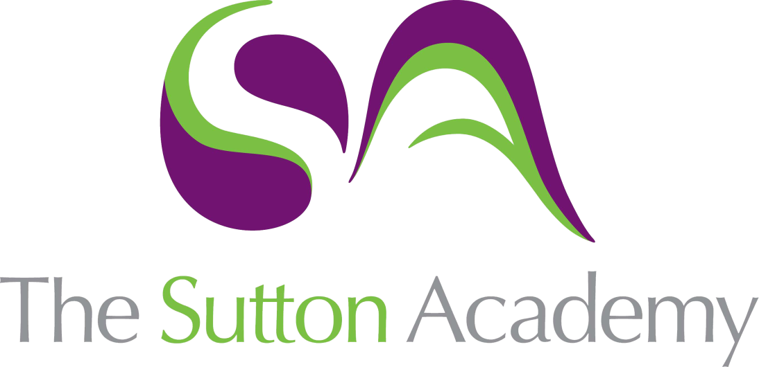

Knowledge Rich Curriculum Plan
Year 13 Term 2

Year 11
Art
Lesson/Learning Sequence | Intended Knowledge:  Students will know that… | Tiered Vocabulary | Prior Knowledge:  In order to know this students, need to already know that… | Assessment
Lesson: Artist responses | - How to create a series of Mature and comprehensive responses and interpretations consistently informed by very good understanding of associated purposes, meanings and contexts.  - How to demonstrate Perceptive and rigorous visual and written critical analysis and evaluation. | Exploited: make full use of and derive benefit from (a resource).  Perceptive: having or showing sensitive insight.  Discriminate: recognize a distinction or difference; differentiate. | - Students need to already know that experiments must link and connect to their theme and artists.  - Students need to already know how to execute a range of experiments.
Lesson:  Selecting successful experiments. | - Students will know that they must experiment with a range of ideas and think about various outcomes.  - Students will know how experiment with successful outcomes and pieces in their work.  - Students will know to create work shows Rigorous and confident exploration of materials and highly skilful control of techniques to fully exploit their creative potential. | Mixed media: artworks composed from a combination of different media or materials.  Creative Making: Explore and select appropriate resources, media, materials, techniques and processes, reviewing and refining ideas as work develops. | - Students need to already know that experiments must link and connect to their theme and artists.  - Students need to already know how to execute a range of experiments.
Lesson:  Selecting and refining. | - Students will know make Significant and perceptive relationships established between working methods and outcomes that are continually reviewed and sensitively refined. | Translate: express the sense of (words or text) through art or drawing.  Rigorous Selection: A test, system, or procedure that is rigorous is very thorough and strict. | - Students need to already know that experiments must link and connect to their theme and artists.  - Students need to already know how to execute a range of experiments.
Lesson:  Developing and refining | - Students will know that they must choose three successful experiments to develop further and respond to.  - Students will know how to develop the work through different compositions, refining materials and techniques and exploring colour.  - Students with know how to be resilient to focusing into three ideas to develop and refine.  - Students will know how to make Significant and perceptive relationships established between working methods and outcomes that are continually reviewed and sensitively refined. | Develop: Development is about selecting ideas, visual elements, compositions and techniques from this initial work and using them in new ways.  Refine: Refinement is the improvement of the idea. It does not involve radical changes, but is about making small changes which improve the idea in some way. | - Students need to already know that they will produce unsuccessful work at times and to be resilient.  - Students need to already know how to reflect on their work and draw upon their experiences and thoughts.
Lesson:  Developing and refining | - Students will know that they must choose three successful experiments to develop further and respond to.  - Students will know how to develop the work through different compositions, refining materials and techniques and exploring colour.  - Students with know how to be resilient to focusing into three ideas to develop and refine.  - Students will know how to make Significant and perceptive relationships established between working methods and outcomes that are continually reviewed and sensitively refined. | Reflective recording: Record ideas, observations and insights relevant to intentions as work progresses.  Personal Presentation: Present a personal and meaningful response that realises intentions and demonstrates understanding of visual language. | - Students need to already know that they will produce unsuccessful work at times and to be resilient.  - Students need to already know how to reflect on their work and draw upon their experiences and thoughts.
Lesson:  Design Ideas | - Students will know to produce three design ideas that is personal and meaningful in its response.  - Students will know how to develop the work through different compositions, refining materials and techniques and exploring colour.  - Students with know how to be resilient to focusing into three ideas to develop and refine. | Design Ideas: a method of human expression that follows a system of highly developed procedures in order to imbue objects, performances, and experiences with significance. Like all art forms, design has the potential to solve problems | - Students need to already know that they will produce unsuccessful work at times and to be resilient.  - Students need to already know how to reflect on their work and draw upon their experiences and thoughts
Lesson:  Final Outcome | - Students will know how to produce final outcome that is highly imaginative, personal and meaningful.  - Students will know how to make Significant and perceptive connections between visual, written, oral and other elements, where appropriate, conveyed in a highly convincing way.  - Students will know how to evaluate their work by realising intentions, strengths and weaknesses.  - Students with know how to be resilient and complete their portfolio to the best of their ability. | Connections: a relationship in which a person or thing is linked or associated with something else.  Intentions: a thing intended; an aim or plan. | - Students need to already know that they will produce unsuccessful work at times and to be resilient.  - Students need to already know how to reflect on their work and draw upon their experiences and thoughts
Lesson:  Introduction of Exam | - Students will know how to share ideas and brainstorm the exam questions and themes.  - Students will know how to interpret one word in numerous ways to gain understanding and exploration. | Creative Mind Map: A creative mind map is a diagram with words and illustration used to visually organize information into a hierarchy, showing relationships among pieces of the whole. | - Students need to already know how to brainstorm ideas and themes.
Lesson:  Research | - Students will know how to research into themes and ideas.  - Students will know how to sources relevant research and knowledge surrounding their themes.  - Students will know how to produce Perceptive and rigorous visual and written critical analysis and evaluation applied to highly relevant contextual and other sources, including the perceptive and rigorous use of appropriate specialist vocabulary.  - Students will produce a mind map and mood board to present their initial thoughts and ideas on their chosen theme. | Contextual Understanding: Develop ideas through investigations, demonstrating critical understanding of sources.  Coherent research: logically or aesthetically ordered or integrated. | - Students need to already know how to brainstorm ideas and themes.  - Students will know how to research around their themes.
Lesson:  Primary and Secondary research. | - Students will know how to draw upon primary research to inform their thoughts and ideas.  - Students will know how to draw in a range of ways, e.g. Continuous line, contour, layering, tonal drawing.  - Students will know how to experiment with a range of materials when drawing from their primary research.  - Students will know how to record observations, experiences, ideas and insights relevant to intentions within the context of thorough and coherent research and enquiry. | Primary Research: primary sources are usually considered to be items like personal letters, diaries, records or other documents created during the period under study. But primary sources can also include photographs, jewellery, works of art, architecture, literature, music, clothing, and other artefacts.  Secondary Research: A resource that discusses a previously created artwork or monument or prior period/event from an academic or research or layperson perspective.  Sustained: Continuing for an extended period or without interruption. | - Students need to already know how to draw from first hand observation.  - Students will know how to take a set of photos or create a still life to draw from.
Lesson:  Primary and Secondary research. | - Students will know how to draw upon primary research to inform their thoughts and ideas.  - Students will know how to draw in a range of ways, e.g. Continuous line, contour, layering, tonal drawing.  - Students will know how to experiment with a range of materials when drawing from their primary research.  - Students will know how to be Perceptive, rigorous and effective when critically reflecting on work and progress is demonstrated. | Highly Relevant: Something that is relevant to a situation or person is important or significant in that situation or to that person.  Extensive research: A large and broad amount of research carried out from various sources.  Coherent research: Coherence is the quality by which we can tell that there is some sort of deliberate and meaningful and intelligent purpose behind the form of a thing. | - Students need to already know how to draw from first hand observation.  - Students will know how to take a set of photos or create a still life to draw from.
Lesson:  Artist research | - Students will know how to research and source artists relevant to their theme or ideas.  - Students will know what inspires the artists, designer or crafts person to create their work.  - Students will know how to critically analyse the artist’s work and explain how they will use the work of others to inform their own ideas. | Rigorous: extremely thorough and careful.  Critical Analysis: responding to, interpreting meaning, and making critical judgments about specific works of art. | - Students need to already know how to research artists.  - Students will know how to write about the work of other.
Lesson:  Artist copies and interpretations | - How to create a series of Mature and comprehensive responses and interpretations consistently informed by very good understanding of associated purposes, meanings and contexts.  - How to demonstrate Perceptive and rigorous visual and written critical analysis and evaluation.  - Students will create a range of copies to consolidate their knowledge and understanding of the artist. | Consolidate: make (something) physically stronger or more solid.  Interpretation: the action of explaining the meaning of something. | - Students need to already know how to about the artist work and the use of materials.  - Students will know how to interpret the work of others.
Lesson:  Experimentation. | - Students will know how to explore a range of materials, techniques and processes. e.g. clay, print, paint, 2D and 3D etc.  - Students will know how to explore colour experiments and processes.  - Students will know how to carefully select successful experiments.  - Students will know how to Rigorously and confidently explore materials with highly skilful control of techniques to fully exploit their creative potential. | Creative Making: Refine work by exploring ideas, selecting and experimenting with appropriate media, materials, techniques and processes. | - Students need to already know how to explore a range of different media.  - Students will know how to experiment with different colours.
Lesson:  Development and refinement. | - Students will know how to develop successful experiments through exploring compositions, colour schemes, mediums etc.  - Students will know how to create development pages to show clarity and personal journey in their work.  - Students will know how to make Significant and perceptive relationships established between working methods and outcomes that are continually reviewed and sensitively refined.  - Students will know how to record their thoughts and ideas. | Refinement: the process of removing impurities or unwanted elements from something. | - Students need to already know how to compare and contrast ideas.  - Students will know how to annotate their work and thought processes.
Lesson:  Design Ideas. | - Students will know how to reflect on their journey and create a set of design ideas for their final 15-hour exam.  - Students will know how to test materials and explore compositions.  - Students will know how to label and annotate ideas and thought processes.  - Students will know how to clear connections between the artist work and their personal journey.  - Student will know how to plan and prepare their resources and order for their 15-hour exam. | Design Ideas: a method of human expression that follows a system of highly developed procedures in order to imbue objects, performances, and experiences with significance. Like all art forms, design has the potential to solve problems | - Students need to draw upon their development and experimentation work.  - Students will know how to annotate their work and thought processes.  - Students will know how to plan and prepare for their final piece.
Lesson:  15-hour exam and evaluation. | - Students will know how to carry out their 15-hour exam successfully with a coherent plan.  - Students will know how to create a Highly imaginative, personal and meaningful response presented, with intentions realised in a perceptive and coherent way.  - Students will make significant and perceptive connections between visual, written, oral and other elements, where appropriate, conveyed in a highly convincing way.  - Students will know how to use all their learning and reflection to complete an imaginative and personal final piece.  - Students will know how to evaluation their work and reflect on the strengths and weaknesses of their project.  - Students will know how to clear connections between the artist work and their personal journey. |  | - Students need to have carefully planned and prepared their final 10-hour piece.  - Students will know how to reflect and evaluate their work.

