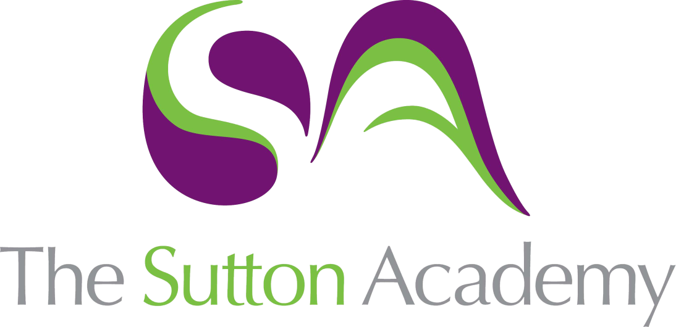

Knowledge Rich Curriculum Plan
Year 7 : Term 1

Lesson/Learning Sequence  Formal Elements | Intended Knowledge:  Students will know that… | Tiered Vocabulary | Prior Knowledge:  In order to know this students, need to already know how… | Assessment
Lesson 1: Baseline Assessment. | Students will carry out a Baseline assessment on their knowledge of colour theory and the formal elements. |  | - How to draw basic objects.  - The colour wheel is made up of Primary, Secondary and Territory colours.
Lesson 2: Colour theory through painting. | - The colour wheel is formed with primary and secondary colours for mixing and blending purposes.  - Primary colours cannot be made.  - 2 primary colours make a secondary colour.  - Students will know how to apply paint in a successful way to create the colour wheel. | Tier 2: Primary colours: Cannot be made.  Secondary colours: Are made by mixing 2 primary colours together. | - What the primary and Secondary colours are.  - Primary Colours : Red, Blue and Yellow and Secondary colours : Green, Orange and Purple.
Lesson 3: Tertiary colours/Warm and cool colours. | - The tertiary colours are made by mixing a primary and a secondary colour together. Orange-yellow, red-orange, red-purple, blue-purple, blue-green, yellow-green.  - Students will know how to mix the primary colours and a secondary colour to make a tertiary colour. | Tier 3: Tertiary colours: A tertiary colour is made by mixing equal amounts of a primary colour and a secondary colour together. There are six tertiary colours. On the colour wheel, they sit between the primary and secondary colour they are mixed from. | - What the primary and Secondary colours are.  - Primary Colours : Red, Blue and Yellow and Secondary colours : Green, Orange and Purple.
Lesson 4: Tertiary colours/Warm and cool colours. | - The harmonious colours are colours that are next to each other in the colour wheel.  - The warm colours are a set of harmonious colours of Red, orange, yellow.  - The cool colours are a set of harmonious colours of Blue, green and purple.  - The tertiary colours are Orange-yellow, red-orange, red-purple, blue-purple, blue-green, yellow-green.  - How to mix the primary colours and a secondary colour to make a tertiary colour. | Tier 3: Harmonious colours: sit beside each other on the colour wheel. These colours work well together and create an image which is pleasing to the eye.  Warm colours: One group of colours in the colour wheel is associated with the sun, warmth and fire.  Cool colours: Cool colours remind you of water and sky, even ice and snow. | - What the primary and Secondary colours are.  - Primary Colours: Red, Blue and Yellow and Secondary colours : Green, Orange and Purple.  - What the tertiary colours are.  - Students need to already know where the primary and secondary are placed on the colour wheel.
Lesson 5&6 : Tint and Tones  Reading Activity | - A tint is adding white or creating light.  - A tone is adding black or creating shade.  - How to create graduated tone in painting and pencil.  - Increasing and decreasing pressure to their pencil will create a graduated tone using a pencil or colour pencils.  - A gradient is a slow gradual change from a dark tone to a light.  - How to blend the correct colours into each other to create a smooth gradual change.  - To keep their pencil lines closer together and gradually take the weight of their hand will create a smooth and graduated tone. | Tier 2: Gradual: taking place or progressing slowly or by degrees.  Tier 2: Graduated tone is a visual technique of gradually transitioning from one colour hue to another, or from one shade to another, or one texture to another.  Tier 3 : Tint and tone : A tint is where an artist adds a colour to white to create a lighter version of the colour. An example of a tint is pink. Pink is a tint created by adding white to red. A shade is where an artist adds black to a colour to darken it down. A tone is where an artist adds grey to a colour. | - Know the all the colours on the colour wheel.  - know how to apply paint smoothly and successfully and ensuring the paint/colour on the brush is concentrated.
Lesson 7:Formal elements Tone, Colour, texture and Pattern. | - Increasing and decreasing pressure to their pencil will create a graduated tone using a pencil or colour pencils.  - How to blend colours in the correct directions to create graduated tone.  - How to explore compositions of colours in a piece of work.  - Texture can be created by a range of lines, marks and dots repeated.  - There is visual texture and there is Physical texture.  - Applying texture with pens and pencils in a range of colours and create tone to the insect.  - Patterns can be made by shapes and lines repeated on a large shape or area. | Tier 2: Graduated tone is a visual technique of gradually transitioning from one colour hue to another, or from one shade to another, or one texture to another.  Tier 2: Texture: Texture means how something feels.  There are two types of texture: actual texture and visual texture. In all art and design, the appearance of texture is an important visual element. In design, texture can also play a part in a product's function. | - Students will already need to know what tone is and looks like from the previous tints and tones lesson.  - Students will already need to know what the harmonious colours are.
Lesson 8: Formal elements : Shape, line, form, composition | - How to blend colours in the correct directions to create graduated tone.  - How to explore compositions of colours in a piece of work. | Tier 2: Compositions: Composition is the arrangement or placement of visual elements in a piece of artwork. You might consider this the same as the “layout” of a piece (a term you hear a lot in graphic design).  Shapes:  2D Shape is width and height, 3D is width, height and depth.  Form: form is the shape, structure, and arrangement of components like length, width, and depth of a shape. | - What harmonising colours are.  - How to create graduated tone from one colour to the other.  - What texture looks like and how to apply colour.
Lesson 9: Reflect and review | - Whole class feedback will be given to identify strengths and weaknesses.  - To reflect on their work and evaluate each element.  - Students will carry out their SSS challenge according to their staff feedback and reflection. | Tier 2: Evaluate: Evaluation is an opportunity to: discuss your development and final work. Help others understand what you were trying to achieve. Explain your successes and weaknesses. | - To reflect on their work and their strengths and weaknesses.  - Identify what they want to improve and how to improve.
Lesson 10: Line drawings of everyday objects. | - To create a contour drawing by using curves lines to represent a 3D shape.  - A continuous line is a line where you do not take you pencil of the page.  - Both drawings will use line to show simple formed drawings of objects. | Tier 2: Contour drawing the artist follows the contours of the drawing carefully taking shapes using line only.  Continuous line involves drawing without taking the pen off the page. | - To create a continuous line drawing.
Lesson 11: Drawing basic shapes.  Reading Activity | - Students will know to create basic 3D shapes by using flat shapes and connecting lines.  - Students will know how produce a range of different mark makings with your pen or pencil.  - Where the lightest and darkest points are on their objects. | Tier 2: Gradient is a visual technique gradually transitioning from one tone to another.  Tier 2: Tone refers to the lightness or darkness of a colour. Tone can mean the colour itself. | - Students will need to already know how to create one using line and marks.  - Students will need to know basic flat shapes.  - Students will need to already know how to create dark and light tone.
Lesson 12: Drawing objects. | - To create more complicated objects by using basic shapes, form, line and observation.  - Students will know how that basic shapes forms more complicated. For example: Bottle has a basic shape of a cylinder.  - Students will know how to use grades of pencil to show 3D geometric form.  - Students will to add mark making/textures into some of your 3D shapes. | Tier 2 : Shape: is a flat area surrounded by edges or an outline. Geometric shapes are precise.  Tier 3: Highlight: Highlights are usually found at the highest point of an object where it is closest to the light source.  Tier 2: Shadow: A shadow is a dark (real image) area where light from a light source is blocked by an opaque object. It occupies all of the three-dimensional volume behind an object with light in front of it. The cross section of a shadow is a two-dimensional silhouette, or a reverse projection of the object blocking the light. | - Students will need to already know how to create 3d basic shapes.  - Students will need to already know how to apply tonal value to their objects.
Lesson 13 and 14 : Jon Burgermann Artist Research  Reading Activity | - Jon Burgermann is a graphic designer and uses food and objects as his inspiration for his work.  - TWISBOQ is used to create an Artist Research Page.  - Students will know how to write the artist work.  - Students will know to how to create studies of Jon Burgermann’s work.  - A good composition is using different scale, colour and filling gaps. | Tier 2: Opinion: a view or judgement formed about something, not necessarily based on fact or knowledge.  Tier 3: Twisboq: Title, written work, images, studies, background, opinion, quote.  Collage describes both the technique and the resulting work of art in which pieces of paper, photographs, fabric and other ephemera are arranged and stuck down onto a supporting surface.  Composition is the arrangement or placement of visual elements in a piece of artwork. You might consider this exactly the same as the “layout” of a piece (a term you hear a lot in graphic design). | - Students will know how to create a visually interesting and relevant title.  - Students will visit a virtual tour of The Guggenheim New York to view Burgermann's Exhibition  - Students will already know how to use line to create artist studies.  - Students will already know quotes from Burgerman by carrying out their own research.
Lesson 15: Character Design | - Students will know how to create a series of design ideas to create their own character illustrations inspired by Jon Burgerman and Every object.  - Students will know how different thickness of line creates 3D effects.  Students will know about the career of an illustrator.  - Students will know the difference between big and small scale. | Tier 3: Scale: Scale refers to the relative size of a design element in comparison to another element. Illustration: An illustration is a visualization or a depiction made by an artist, such as a drawing, sketch, painting, photograph, or other kind of image of things seen, remembered or imagined, using a graphical representation.  Tier 2: Line: a long, narrow mark or band. | - Students will already know how to create a continuous line drawing.  - Students will already know the work of Jon Burgerman.  - Students will already know how to draw everyday objects.
Lesson 16: Painting workshop | - Students will know how to apply watercolours in a smooth way.  - Students will know how to blending colours together using watercolours and acrylic.  - Students will know how to control blends by learning the correct amount of water applied to the brush and what happens if you have too little or too much. | Tier 3: Blend: Blending is a term used often in art, particularly in painting and drawing. It is the technique of gently intermingling two or more colours or values to create a gradual transition or to soften lines.  Dry Brushing: Drybrush is a painting technique in which a paint brush that is relatively dry, but still holds paint, is used.  Tier 2: Gradient: taking place or progressing slowly or by degrees. | - Students will already know the colour wheel and theories.  - Students will already know to blend colours with colour pencil.
Lesson 17 & 18: Character design onto final piece and mark making.  Reading Activity | - A large-scale design will be used for the main element of their final piece.  - Students will know how to apply posca pens and drawing ink to create smooth thick and thin lines.  - Students will know how to use mark making and lines inspired by Jon Burgermann onto their final piece. | Tier 3: Composition is the arrangement or placement of visual elements in a piece of artwork. You might consider this exactly the same as the “layout” of a piece (a term you hear a lot in graphic design).  Tier 3: Scale: Scale refers to the relative size of a design element in comparison to another element. | - To Create a character design inspired but Jon Burgermann.  - To draw in different scales.  - To create lines, patterns and doodles inspired by Jon Burgermann.  - To know what a good composition looks like.
Lesson 19: Evaluation/Whole class feedback and SSS challenge. | - Students will know how to reflect and evaluate their work.  - Students will recap and identify strengths and weakness for this project so they can improve moving into their next project.  - Students will complete a SSS challenge. | Tier 2: Evaluate: the making of a judgement about the amount, number, or value of something; assessment.  Recap: a summary of what has been said or done.  Reflect: think deeply or carefully about actions or doings. | - Students will know how what makes a successful design.  - Students will know to compare their work to the success criteria and the work of Jon Burgerman.  - Students will already know the work of Jon Burgerman.

