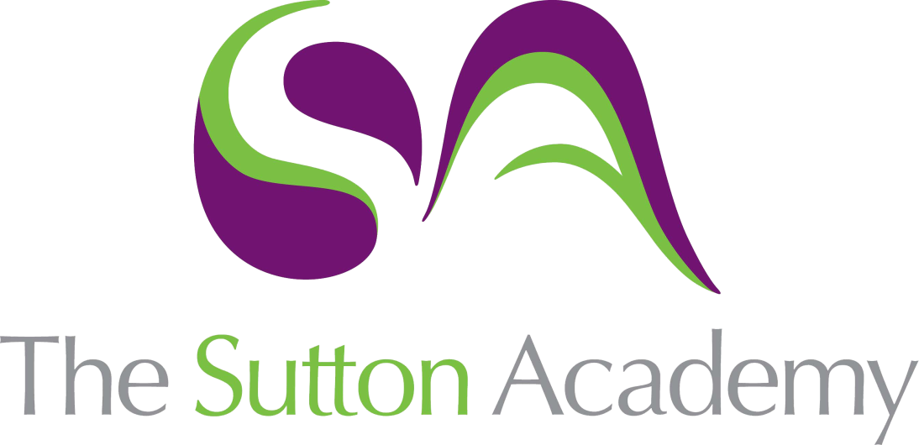

Knowledge Rich Curriculum Plan
Year 8: Term 1

Lesson/Learning Sequence  Formal Elements | Intended Knowledge:  Students will know that… | Tiered Vocabulary | Prior Knowledge:  In order to know this students, need to already know how… | Assessment
Lesson 1: Mark making  Reading Activity | - Students will know about Abstract expressionism movement through reading.  - Students will create a range of neat and compact marks using line and fine liner. | Mark making: Mark making is a term used for the creation of different patterns, lines, textures and shapes. This may be on a piece of paper, on the floor, outside in the garden or on an object or surface.  Expressionism: Expressionist art tried to convey emotion and meaning rather than reality. Each artist had their own unique way of "expressing" their emotions in their art. In order to express emotion, the subjects are often distorted or exaggerated.  Abstract: is art that does not attempt to represent an accurate depiction of a visual reality but instead use shapes, colours, forms and gestural marks to achieve its effect | - Students need to already know how to describe a piece of Art.  - Students need to already know a range of different marks.
Lesson 2 & 3 : Mark Making with drawing ink | - Students will know how to create expressive lines using drawing inks and acrylic paints.  - Students will create a range of expressive marks and stamps to create a successful composition and a range of textures. | Expressive: effectively conveying thought or feeling.  Composition: the way in which a whole or parts are made up.  Tier 2: Gestural: relating to, or characterized by vigorous application of paint and expressive brushwork gestural expressionism. | - Students need to already know how to describe a piece of Art.  - Students need to already know a range of different marks.
Lesson 4 : Layer Experimentation  Reading Activity | - Students will know how to create wax resist using oil pastels and paint.  - Students will know how to mark make with watercolours.  - Students will know how to create layers to their work. | Wax resist: The basic concept is that you lay down some wax on your paper, paint over the wax, and the wax resists the watercolour leaving the white of the paper exposed. | - Students need to already know how to create a series of marks.  - Students need to already know their colour theory  - Students need to already know to collage.
Lesson 5: Layer Experimentation | - Students will know how to develop their backgrounds through layers  - Students will know how to use collage and paint to create textured backgrounds.  - Students will know how to print and stamp objects to create lines and marks. | Collage: Collage describes both the technique and the resulting work of art in which pieces of paper, photographs, fabric and other ephemera are arranged and stuck down onto a supporting surface.  Stamp: to mark or impress with a design, word, mark, etc | - Students need to already know how to create a series of marks.  - Students need to already know their colour theory  - Students need to already know to collage.
Lesson 8: Contextual Studies  Reading Activity | - Students will know how compare and contrast Traditional and contemporary artists in the Abstract Art movement.  - Students will make connections with their own work and the work of their chosen artist.  - Students will know how to create a contextual studies page with a focus on composition.  - Students will produce a piece in the style of their chosen artist using the formal elements. | Analyse: examine (something) methodically and in detail, typically in order to explain and interpret it.  Connection: a relationship in which a person or thing is linked or associated with something else. | - Students need to already know how to describe a piece of Art.  - Students need to already know a range of different marks.  - How to identify formal elements in a piece of art.
Lesson 7: Contextual Studies | - Students will know how to form their own opinion on the artist work.  - Students will know how to create their own interpretation of their work. | Analyse: examine (something) methodically and in detail typically in order to explain and interpret it.  Connection: a relationship in which a person or thing is linked or associated with something else. Connection: a relationship in which a person or thing is linked or associated with something else. | - Students need to already know how the artists create their work.  - Students need to already know to form their own opinion about the artist work.  - Students need to already know their colour theory, how to dry brush and mark make.
Lesson 8 : Design Ideas | - Students will record drawing and ideas for their final piece inspired by Abstract artists.  - How to use the formal elements and mark making skills to carefully plan a range of outcomes.  - Students will show thinking through annotation | Annotation: making notes, explaining or adding comments to a text or diagram. Image. | - To produce a design idea.  - To use artist to inspire their own work.  - Annotate their own sketches.
Lesson 9: Final piece | - Students will know how to use their own style when creating interpretation i.e. own colours, marks, shapes etc.  - Students will build layers with collage, paint and mark making tools to create a successful composition. | Interpretation: the action of explaining the meaning of something. | - How to mix colour theory.  - How to create layers.  - How to use mark making to create a successful composition.
Lesson 10: Final outcome. | - Students will know how to use their own style when creating interpretation i.e. own colours, marks, shapes etc.  Students will build layers with collage, paint and mark making tools to create a successful composition. | Interpretation: the action of explaining the meaning of something. | - How to mix colour theory.  - How to create layers.  - How to use mark making to create a successful composition.
Lesson 11: Final outcome | - Students will know how to use their own style when creating interpretation i.e. own colours, marks, shapes etc.  - Students will build layers with collage, paint and mark making tools to create a successful composition. | Interpretation: the action of explaining the meaning of something. | - How to mix colour theory.  - How to create layers.  - How to use mark making to create a successful composition.
Lesson 12: Evaluation | - Students will compare their work against the assessment criteria.  - Students will reflect and review on their work | Evaluate: reflect on strengths and weaknesses.  Compare: Thinking of similarities with something else.  Contrast: Differences. | - To evaluate their work against the artist and they assessment criteria.
Lesson 13: SSS challenge | - Students will reflect and review on their work and complete an SSS challenge to either Secure, Sustain or stretch their ability.  - Students will complete a task that will challenge them according to their ability. | Discuss vocab used and meanings throughout this lesson. | - To evaluate their work against the artist and they assessment criteria.

