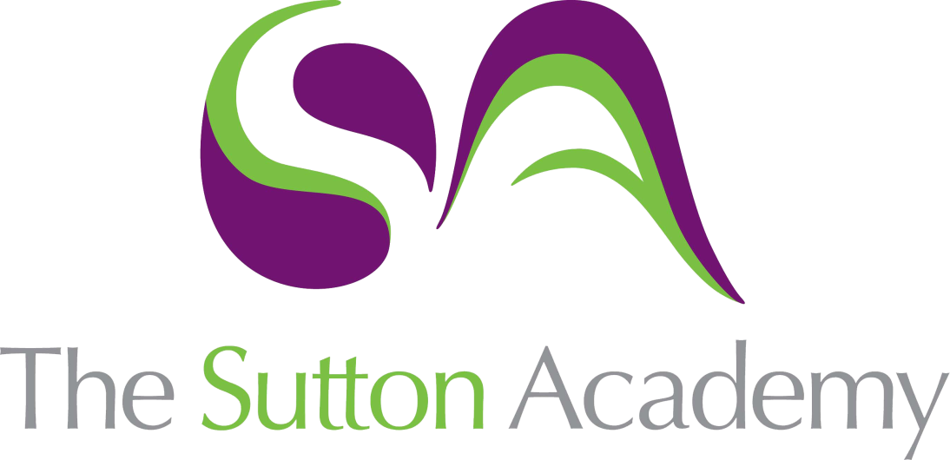

Knowledge Rich Curriculum Plan
Year 9: Natural forms – Clay
Term 2:2

Lesson/Learning Sequence  Formal Elements | Intended Knowledge:  Students will know that… | Tiered Vocabulary | Prior Knowledge:  In order to know this students, need to already know how… | Assessment
Lesson 1: The work of Peter Randall. | - How to read and discuss the work of Peter Randall’s and how his work is inspired by natural form.  - How to produce a series of small studies of natural forms in the style of Peter Randalls. | Structure: a building or other object constructed from several parts.  Sculpture: make or represent (a form) by carving, casting, or other shaping techniques. | - How to form their own opinion of the artists work.  - Talk about artists work using subject  - vocabulary with their peers.  - How to apply paint onto fabric.
Lesson 2: Clay Design ideas. | - How to use the textures and shapes of natural forms to inform ideas for design a clay piece.  - The possibilities and restrictions when using clay.  - To plan each step of the making to ensure a successful ceramic piece.  - How to select the most successful designs by reviewing your work. | Restrictions: the limitation or control of someone or something, or the state of being restricted. | - To produce sketches ideas and label their thinking process.  - To handle clay and what its texture feels like.
Lesson 3: Pinch ppt | - The process of creating a pinch pot.  - The process and importance of scoring and slipping the clay to add additional shapes. |  | - To manipulate clay  - To identify if they clay have been overworked and becomes dry.
Lesson 4: Scoring into the pot | - How to score and carve into the pinch pot to create grooves and lines inspired by nature and the work of Peter Randall. | - Score : a method of joining two pieces of clay together. First, score the clay; this means that you make scratches in the surfaces that will be sticking together. Then you slip it; that is you wet the surface with some slip, using it like glue. Next, you press the two pieces together. | - To score and slip  - Carve and make marks into clay
Lesson 5: Attaching shapes | - How to attach shapes to securely and smoothly to interpret textures and shapes of natural forms.  - Add texture and mar making into the clay using the clay tools correctly. | Interpret: explain the meaning of (information or actions). | - To make shapes out of clay  - How to apply texture using mark making
Lesson 6: Glaze and reflect | - The application of glaze and the kiln process to produce a shiny surface.  - Reflect on work and what they have learned through the term.  - Whole class feedback will be given to identify strengths and weaknesses.  - To reflect on their work and evaluate each element.  - Students will carry out their SSS challenge according to their staff feedback and reflection. | Glaze : a mixture of powdered materials that often includes a premelted glass made into a slip and applied to a ceramic body by spraying or dipping and capable of fusing to glassy coating when dried and fired  Evaluation is an opportunity to: discuss your development and final work. Help others understand what you were trying to achieve. Explain your successes and weaknesses. | - To reflect on their work and their strengths and weaknesses.  - Identify what they want to improve and how to improve.

