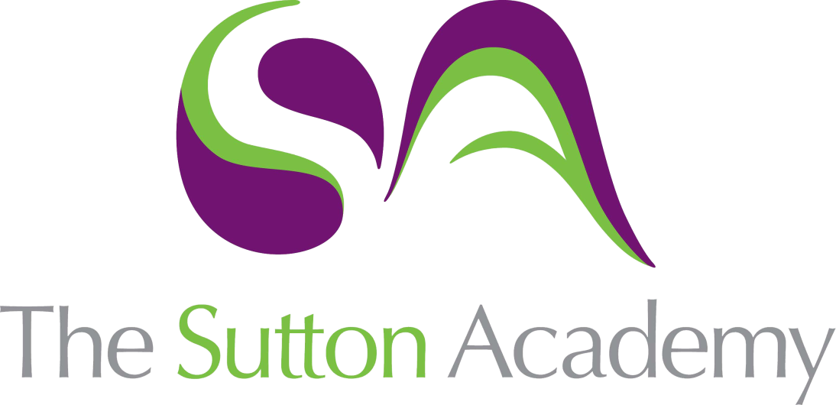

Knowledge Rich Curriculum Plan
GCSE Design NEA
Unit: Non Examined Assessment

GCSE Design NEA | Unit: Non Examined Assessment  The purpose of our curriculum is to inspire our students to think creatively about solving problems, rather than dwelling on solutions. They will experience a wide range of technologies that will give them the knowledge and skills, to make better decisions to design and make products that will improve people’s lives. Regardless of ability or endpoint, our aim is to equip our students with the knowledge of ever developing technologies that can be applied to their chosen pathways both in and outside of the Academy.
Lesson/Learning Sequence | Intended Knowledge:  Students will know that… | Tiered Vocabulary | Prior Knowledge:  In order to know this students, need to already know that… | Assessment
Lesson:  Investigation | - Students will know how to investigate their chosen contextual challenge  - Students will know the different type of factors that can affect a products investigation  - Students will know how to research and investigate their chosen contextual challenge  - Students will know how to analyse their research findings  - Students will know to analyse different factors to investigate their chosen contextual challenge | Investigation: the action of investigating something or someone; formal or systematic examination or research.  Contextual: depending on or relating to the circumstances that form the setting for an event, statement, or idea.  Analysis: detailed examination of the elements or structure of something. | - Students need to already know the term investigate  - Students need to already know how to investigate a problem  - Students need to already know the term research  - Students need to already know how to use computers to research different task  - Students need to already know the different types of materials available for products  - Students need to already know the properties of different types of products | How can we use investigation methods to answer the contextual challenge?  How can we use investigation to help solve the needs and wants posed?
Lesson:  Work of others/Product analysis | - Students will know how to analyse an existing product  - Students will know how to identify the positive and negatives of a product  - Students will know how to provide alternatives to a products design and materials | Identify: establish or indicate who or what (someone or something) is.  Alternative: (of one or more things) available as another possibility or choice. | - Students need to already know how to identify a products flaw  - Students need to already know how products can change for better or worse  - Students need to already know to to develop en existing product  - Students need to already know the different types of materials | Comparing different types of products can aid our development, how?  Can the analysis of products help develop our investigation?
Lesson:  User profile | - Students will know how to identify a potential client for their product  - Students will know how to use Primary and Secondary data to inform decisions  - Students will know Primary data is information collected by yourself  - Students will know Secondary data is information collected by others | Primary: a methodology used by researchers to collect data directly  Secondary: a methodology used by researchers to collect data from a third party  Client: the entity that has commissioned the design project | - Students need to already know how to identify a client  - Students need to already know how to identify a client’s needs  - Students need to already know to how analyse data to produce findings  - Students need to already understand a client’s needs and wants | How does applying a client to our problem help guide our product?  How can primary data help us understand the clients needs?
Lesson:  Design specification and Design brief | - Students will know how to create a design specification  - Students will know that a design specification is a set list of criteria to help make a product successful  - Students will know how to identify a client’s wants and needs  - Students will know how to identify the needs for their product | Identify: establish or indicate who or what (someone or something) is.  Brief: of short duration; not lasting for long.  Specification: an act of identifying something precisely or of stating a precise requirement. | - Students need to already know the products requirements  - Students need to already know what a design brief is  - Students need to already know the client’s needs and wants | How can a designer use a design brief to create their product?  How can the specification help assist the manufacturing process?
Lesson:  Design ideas. | - Students will know how to design in 3D  - Students will know how to design in 2D  - Students will know how to design in isometric  - Students will know isometric drawing requires 30-degree lines  - Students will know how to render their ideas  - Students will know rendering ideas requires products to look like the materials they are using  - Students will know how to analyse and develop designs through feedback and assessment | Develop: grow or cause to grow and become more mature, advanced, or elaborate.  Isometric: unique way of presenting visuals by drawing three-dimensional objects in two-dimensional planes  Rendering: the process of add shading, color and lamination to a 2-D or 3-D wireframe in order to create life-like images on a screen. | - Students need to already know that Isometric drawings use 30-degree angles  - Students need to already know how to draw basic shapes  - Students need to already know how to design ideas based upon feedback  - Students need to already know how to apply basic colour or designs  - Students need to already know how to use 2D design software  - Students need to already know how to apply material textures to their ideas | Compare the effectiveness of 2D designs and 3D designs  How can the use of 3D rendering help support a designer’s idea?  How does rendering help a product become more realistic?
Lesson:  Design models | - Students will know how to create 3D models  - Students will know how to use various materials to create 3D models  - Students will know how to use CAD to create 3D models  - Students will know how to use CAM to create 3D models  - Students will know how to develop ideas and create 3D models  - Students will know how to analyse and develop 3D models | Model: a three-dimensional representation of a person or thing or of a proposed structure, typically on a smaller scale than the original.  CAD: the use of computers to aid in the creation, modification, analysis, or optimization of a design.  CAM: is the use of software and computer-controlled machinery to automate a manufacturing process. | - Students need to already know how to use craft knives safely  - Students need to already know how to use cutting boards  - Students need to already know how to use hot glue guns safety  - Students need to already know how to use modelling materials such as cardboard to create models  - Students need to already know how to turn 2D drawings in 3D models | Compare the effectiveness of CAD designs vs hand drawn.  How does a CAM machine aid manufacture of models?
Lesson:  Orthographic drawing and manufacturing plan | - Students will know that an Orthographic drawing is a 2D drawing which shows all the products dimensions  - Students will know how to create an Orthographic drawing  - Students will know what a manufacturing plan is  - Students will know that a manufacturing plan is a step by step guide of how a product is made  - Students will know a manufacturing plan explores all the reasons and causes of making the product  - Students will know how to create a step by step guide for making their product | Orthographic: An orthographic drawing represents a three-dimensional object using several two-dimensional views of the object  Manufacturing: the creation or production of goods with the help of equipment, labour, machines, tools, and chemical or biological processing or formulation. | - Students need to already know how different tools and equipment are used  - Students need to already know how different manufacturing processes are used to create products  - Students need to already know how to add dimensions to their product  - Students need to already know how to draw a product in a plan, side and front view | Can a manufacturing plan help aid the production of your product?  How effective can a plan be to your manufacture?
Lesson:  Manufacture | - Students will know how their chosen products will be manufactured  - Students will know how to mark out and cut certain joints into their chosen products  - Students will know how to use certain manufacturing processes used for their products  - Students will know how to assemble their chosen products  - Students will know how to apply a finish to their chosen product  - Students will know how to use certain power tools to help manufacture their product  - Students will know the power tools available are Power Drills, Jigsaws, Routers  - Students will know how to use pillar drills as part of their manufacture  - Students will know pillar drills are used to drill various holes in materials | Manufacturing: the creation or production of goods with the help of equipment, labour, machines, tools, and chemical or biological processing or formulation.  Pillar drill: versatile machines that can be used on a wide range of materials where single hole drilling is required.  Jigsaw: a machine saw with a fine blade enabling it to cut curved lines in a sheet of wood, metal, or plastic.  Router: a power tool with a shaped cutter, used in carpentry for making grooves for joints, decorative mouldings, etc. | - Students need to already know how to manufacture their products  - Students need to already know how to mark out and cut different types of materials  - Students need to already know how to use certain power tools  - Students need to already know how to use pillar drills and disk sanders  - Students need to already know how to apply a finish to their product  - Students need to already know how to assemble their products | Compare the use of different workshop tools that perform the same job. How similar are they?  How can quality control aid the purpose of the manufacture?
Lesson:  Evaluation | - Students will know how to evaluate their work  - Students will know evaluation is to make a judgement against something  - Students will know how to evaluate their work against their specification  - Students will know how to evaluate their work against their design brief  - Students will know how to evaluate their work against their clients’ needs and wants | Evaluate: form an idea of the amount, number, or value of; assess.  Brief: of short duration; not lasting for long.  Specification: an act of identifying something precisely or of stating a precise requirement. | - Students need to already know how to evaluate  - Students need to already know how to evaluate using different types of language  - Students need to already know to analyse positives and negatives | Compare a variety of different evaluation styles, which style is most effective?  How does evaluating your product aid development?

