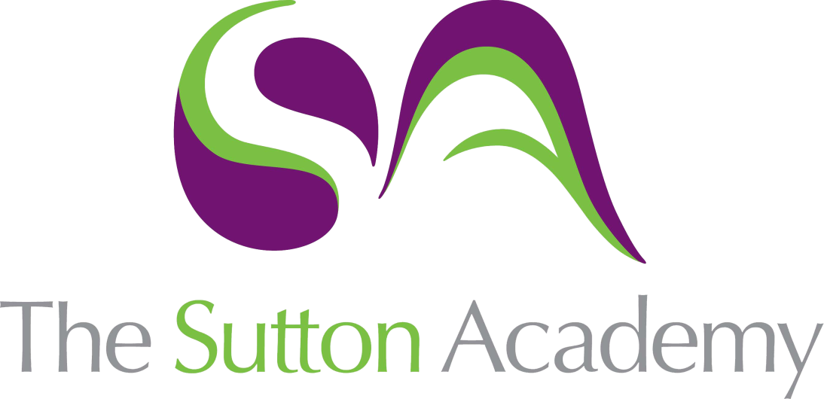

Knowledge Rich Curriculum Plan
Year 7 – Term 2

Lesson/Learning Sequence  Formal Elements | Intended Knowledge:  Students will know that… | Tiered Vocabulary | Prior Knowledge:  In order to know this students, need to already know how… | Assessment
Lesson 1: Reading and Research on African Masks  Reading Activity | - Students will know about the African culture particularly the masks.  - African masks are symmetrical and each mask and colour used symbolises a trait.  - It's Art and traditions through reading and understanding vocabulary.  - Students will know how to apply elements of the art to their page.  - Students will know how to layout and plan a research page using TWISBOQ. | Culture: the ideas, customs, and social behaviour of a particular people or society.  Composition: Although in a general sense any piece of music or writing, painting or sculpture, can be referred to as a composition, the term usually refers to the arrangement of elements within a work of art.  Symmetrical: made up of exactly similar parts facing each other | - Students need to already know that the basic of a Title, images and information always needs to be present in an artist research page. Artist inspiration and work always informs your own work and ideas.  - Students need to already know how to describe artist work and what the work Composition means in Art.
Lesson 2: Building on Sketchbook page. | - The patterns, symbols and colours used in African culture.  - Student will apply patterns and sketches to build onto their research pages. | Composition: Although in a general sense any piece of music or writing, painting or sculpture, can be referred to as a composition, the term usually refers to the arrangement of elements within a work of art.  Scale: the relative size of one object compared to another, typically the size of the artwork to the viewer's body. | - How to identify African patterns through colour.
Lesson 3: Understanding the content.  Reading Activity | - How to incorporate important text and writing to inform their research page in a creative way.  - Reflect on their page against the criteria and make an improvement. | Font: A font is a particular size, weight and style of a typeface. | - Students need to already know key facts in to African Art.  - To reflect on their work and on assessment criteria.
Lesson 4 & 5: Mask Design | - Students will know the work of Kenal Louis.  - Students will draw a mask design of their own inspired by Africa.  - A monochrome and a colour mask will be created using patterns and symbols. | Monochrome: Monochrome means one colour, so in relation to art, a monochrome artwork is one that includes only one colour.  Geometric: Geometric art is the artwork of a non-representative nature that uses straight and curved lines and colour to form shapes, patterns, and designs with more complex mathematical features and relationships. | - To create monochrome patterns through Zentangle.  - What Monochrome means.
Lesson 6& 7: Cardboard Moquette | - Carboard relief is used when cardboard is built on top of each other.  - Students will create a section of their mask to understand its limitations and possibilities. | A cardboard relief is a collage made out of cardboard pieces layered together.  High relief: More than 2 layers  Low relief : One layer. | - To identify possible limitations.  - How to build and layer cardboard shapes.
Lesson 8 & 9: Painting and Pattern | - Acrylic paint is the best paint to use onto cardboard.  - Students will know how to apply Acrylic paint successfully to their Moquette.  - Student will apply patterns in areas using posca pen and acrylic paint. | Moquette: A moquette is model for a larger piece of sculpture, created in order to visualise how it might look and to work out approaches and materials for how it might be made | - How to build and layer cardboard shapes.  - To mix colours.  - Apply posca pens with intricate patterns.
Lesson 10 & 11: Construction of mask | - How to draw and cut out the base of their mask.  - Will cut and build out the shapes separately creating layers and relief. | A cardboard relief is a collage made out of cardboard pieces layered together. | - How to build and layer cardboard shapes.  - To mix colours.  - Apply posca pens with intricate patterns.
Lesson 11 &12 : Construction of mask | - Will cut out their remaining shapes.  - Students will glue each layer to build their relief mask. |  | - How to build and layer cardboard shapes.  - To mix colours.  - Apply posca pens with intricate patterns.
Lesson 13 & 14 : Application of colour and Paint  Reading Activity | - The colours that are used are relevant to the African Culture.  - Students will apply acrylic paint smoothly and successfully to their mask.  - Colour used need to compliment each other on the mask. | Harmonious colours: Colours that are next to each other on the colour wheel.  Warm colours: Colours that make you feel warm. Yellow, orange and red. | - Students will already know their colour theory.
Lesson 15 & 16: Application of pattern and decoration. | - Students will apply smaller details into their masks such as dots, lines and patterns.  - Students will use posca pens to create small and intricate patterns.  - Using black and white lines and patterns will add contrast to their colour. | Intricate: very complicated or detailed.  Decoration: something that adorns, enriches, or beautifies: ornament. | - How to build and layer cardboard shapes.  - To mix colours.  - Apply posca pens with intricate patterns.  - To apply acrylic paint smoothly
Lesson 17: Evaluation and SSS Challenge | - Students will compare their work against the assessment criteria.  - Students will reflect and review on their work and complete an SSS challenge to either Secure, Sustain or stretch their ability. | Evaluate: form an idea of the amount, number, or value of; assess. | - To evaluate their work against the artist and they assessment criteria.

