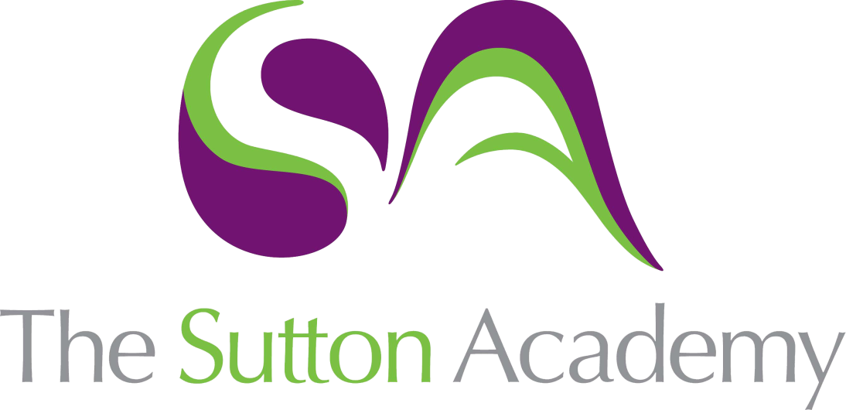

Knowledge Rich Curriculum Plan
Year 10 Business and Enterprise
Unit: Component 3 – Promotion

Business and Enterprise  Year 10 | Unit: Component 3 – Promotion
Lesson/Learning Sequence | Intended Knowledge:  Students will know that… | Tiered Vocabulary | Prior Knowledge:  In order to know this students, need to already know that… | Assessment
Lesson:  The Promotional Mix | - Students will know why enterprises use promotion and that there are 5 elements to the Promotional Mix  - Students will know how the correct combination of promotion to suit the enterprise can lead to their success. | Tier 3  Promotion/The Promotional Mix: The range of techniques a business will use to inform and persuade people to buy their goods or service.  Medium: This is how a business chooses to communicate with and advertise to its market. For example; TV adverts instead of using posters.  Message: This is what the business wants to say to their customers.  Media: This is the general term used to describe all of the following collectively: newspapers, magazines, books, television, radio, websites and the internet. | - Students need to already know from life experience that enterprises promote in different ways.  - Students need to already know how to identify when an enterprise is trying to promote something to them as consumers.
Lesson:  Advertising | - Students will know the purpose and meaning of advertising.  - Students will know how different types of advertising are used and why enterprises may use them. | Tier 2  Ambient:  Audio:  Tier 3  Digital Advertising: When a company advertises their product or service online through a website or an app. Business to Business: This is a market in which one company sells products to another company.  Business to Customer: This is a market in which one company sells products to potential customers | - Students need to already know that advertising is a form of promotion that fits within the Promotional MIx.  - Students need to already know how enterprises may use advertising along with other forms of promotion to attract the right customers.
Lesson:  Sales Promotion | - Students will know the different methods of sales promotion.  - Students will know how the different methods of sales promotion can be used. | Tier 2  Persuade:  Coupon:  Tier 3  Sales Promotions: hen a company advertises their product or service online through a website or an app.  Discount: When a customer receives the product or service for a price cheaper than it was originally listed for. | - Students need to already know that sales promotion sits within the Promotional Mix. They should also have some understanding of seasonality.  - Students need to already know how to calculate percentages
Lesson:  Personal Selling | - Students will know the process and methods of personal selling.  - Students will know how to choose the correct method of personal selling for particular industries. | Tier 2  Qualify:  Nuisance:  Conferencing:  Representative:  Tier 3  Personal Selling: When a representative of an enterprise contacts potential customers directly. The salesperson will use their skills and knowledge of the product to persuade potential customers to make a purchase. | - Students need to already know that personal selling falls within the Promotional MIx and can be used in conjunction with other methods of promotion.  - Students need to already know how enterprises and people use different forms of communication, such as e-mail and telephone.
Lesson:  Direct Marketing | - Students will know that there are three different methods of Direct Marketing. They will also know at this point how to structure a shot analytical paragraph.  - Students will know how enterprises use Direct Marketing and which methods are appropriate to use when. | Tier 2  Catalogue:  Destination:  Package:  Tier 3  Junk mail: This is promotional material, either printed or digital, that the receiver regards as unwanted.  Direct Marketing: This is when an enterprise communicates with a customer directly to try to sell them something. It involves any communication that is directly targeted at customers. | - Students need to already know that Direct Marketing fits within the Promotional Mix and can be used as a method to lead onto Personal Selling.  - Students need to already know how to use connective words to enable analysis that shows impacts.
Lesson:  Public Relations | - Students will know what public relations is and how it is a role within enterprises. They will also know the different ways in which an enterprise may use Public Relations.  - Students will know how public relations can benefit an enterprise. | Tier 2  Publicity:  Investment:  Audience:  Reputation:  Journalist:  Tier 3  Public Relations: How a company communicates with their customers to promote the enterprise, brand, product or service they provide.  Image: People’s opinions of goods or a service and what they associate it with. Having a good image is crucial to being a successful enterprise. | - Students need to already know that enterprises use the likes of sponsorship on social media to showcase their products.  - Students need to already know how public relations fits into the Promotional Mix.
Lesson:  Market Segmentation | - Students will know how and why and how markets are divided into different segments.  - Students will know how to identify the different segmentations – Demographic and Geographic and apply this to different industries. | Tier 2  Segmentation:  Geographic:  Specialise:  Ethnicity:  Feasible:  Tier 3  Market Segmentation: The process of dividing a market of potential customers into groups, or segments, based on different characteristics.  Geographic Segmentation: The business can also focus on location when segmenting the market. Different customer types are likely to have different needs, depending on where they live. | - Students need to already know that populations are split up into different groups depending on their different wants and needs.  - Students need to already know how to split the population up into different demographic groups.

