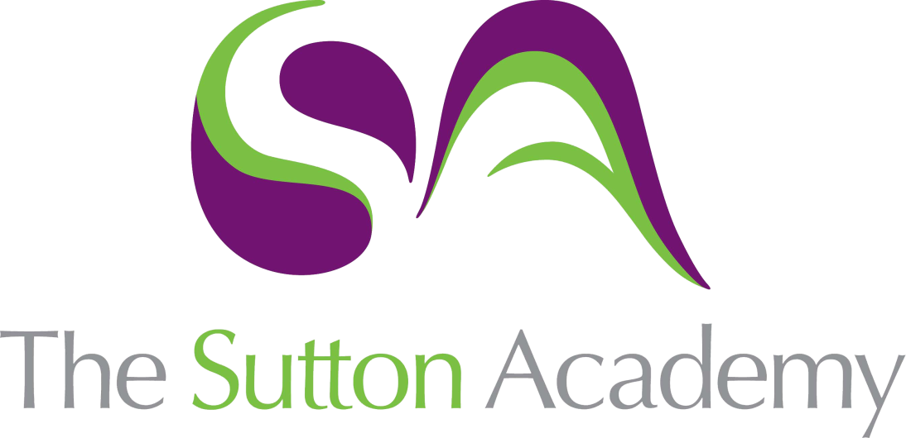

Knowledge Rich Curriculum Plan
Year 7 - Topic 2: Boolean Logic

Lesson/Learning Sequence | Intended Knowledge:  Students will know that… Students will know how to… | Tiered Vocabulary | Prior Knowledge:  In order to know this… Students need to already know that… | Assessment
1 | - Students will know the different symbols which are used for Boolean expressions.  - Students will know how to correctly display their own Boolean expressions.  - Students will know that a condition is a statement which is true or false. | Symbol  Mathematical  Calculations  Expression  Operators  Boolean  Condition  Accounts | - Students need to already know some of the mathematical operators such as: + - x / < >.  - Students need to know that computers can be used for calculations. | Questioning  Worksheet
2 | - Students will know that search engines operate using keywords and Boolean operators.  - Students will know that refining the search on the internet will produce fewer results but more accurate information.  That they can use Boolean operators to search for more than one criteria. | Keywords  Accurate  Criteria  Boolean  Search Engine  Operators | - Students need to already know what a search engine is and how to use one.  - Students need to already know how to pick out keywords from a sentence. | Retrieval Task  Questioning  Worksheet
3 | - Students will know that binary consists of a sequence of 0s and 1s.  - Students will know that binary is used to represent numbers within a computer system.  - Students will know how to convert from denary to binary and binary to denary.  - Students will know that binary is base 2 as the outcomes can only be 0 or 1. | Sequence  Conversion  Combinations  Binary  Denary  Outcome | - Students need to already know how to work with powers of two.  - Students need to already know that the standard system for numbers used around the world consists of combinations of 0-9. | Knowledge Check Quiz  Retrieval Task  Worksheet
4 | - Students will know that ASCII code represents alphanumeric data in most computers.  - Students will know that numbers, letters and symbols need to be encoded in to binary because computers store all information in binary.  - Students will know the importance of encrypting messages. | Sequence  Representation  Integers  ASCII  Binary  Alphanumeric  Encryption | - Students need to already know that binary consists of a sequence of 0s and 1s.  - Students need to already know that you need a key for any coded information to make any sense. | Retrieval Task  Questioning  Worksheet
5 | - Students will know how images are converted to binary.  - Students will know how to work out how many different colours they can use with 1, 2 or 3 bits per pixel.  - Students will know how to create basic images and which colours to use based on the binary code. | Sequence  Representation  Converted  Pixels  Binary  Graphic | - Students need to already know that images are made up of different coloured pixels.  - Students need to already know that binary with 0s and 1s can be used to represent different outcomes (colours). | Retrieval Task  Questioning  Worksheet
6 | - Students will know how to answer the end of unit assessment using their prior knowledge.  - Students will know how to improve on their work from previous lessons in the unit. | Students will need to use all of the vocabulary from the previous lessons. | - Students need to know all of the intended knowledge from the previous lessons in the unit. | End of Unit Assessment  Student Response Task

