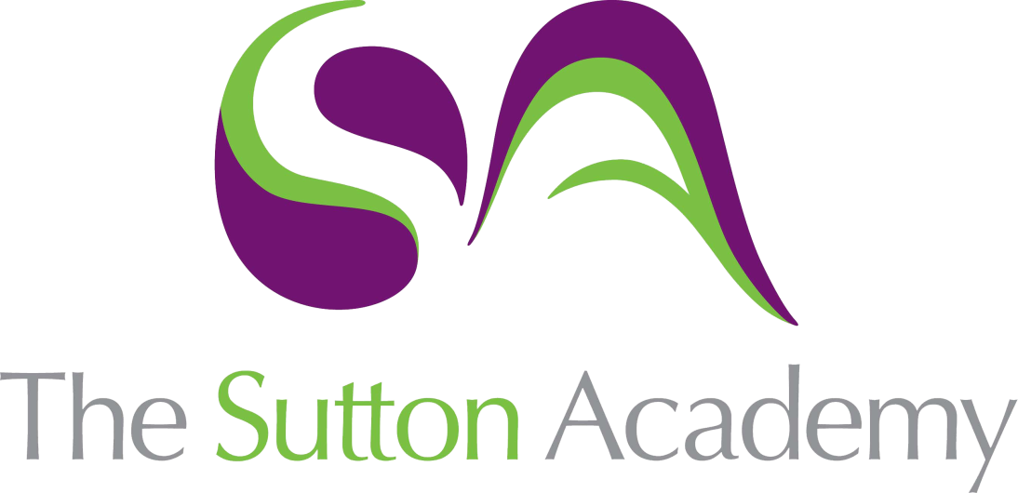

Knowledge Rich Curriculum Plan
OCR Cambridge National in Creative iMedia Level 2
R097 – Interactive Digital Media

Lesson/Learning Sequence | Intended Knowledge:  Students will know that… Students will know how to… | Tiered Vocabulary | Prior Knowledge:  In order to know this students, need to already know that… | Assessment
Task 1:  Client Requirements | - Students will know that a client requirement is the features and designs that the client wants on their product.  - Students will know that a client requirement is important to understand before they start the design process. | Interpret  Requirement  Client  Purpose  Interactive  Multimedia  Product | - Students need to already know that a client is a person or organisation who asks for a product to be created for them. | Retrieval Task  Questioning  NEA Task
Task 1:  Target Audience | - Students will know that there are different factors for target audience which can include age range, gender, interests, income or location.  - Students will know that the target audience can influence the design of the product in terms of colour, text, images and layout. | Influence  Designs  Interests  Gender  Target Audience  Composition | - Students need to already know that different age ranges such as children and adults will affect how a product is designed.  - Students need to already know that an audience is the people who are viewing or using the product. | Retrieval Task  Questioning  NEA Task
Task 1:  Mood Board | - Students will know that the purpose of a mood board is to generate ideas or get an impression about theme of a product.  - Students will know that a mood board should include images, colour schemes, fonts and explanations about the ideas. | Planning  Theme  Impression  Colour Scheme  House Style  Typography | - Students need to already know that a mood board is a collage of images about a particular topic or theme.  - Students need to already know that a mood board is something you create before you start making a product. | Retrieval Task  Questioning  NEA Task
Task 1:  Mind Map | - Students will know that the purpose of a mind map is to generate ideas and make connections or links between them.  - Students will know that a mind map should include a central node, sub-nodes and branches. | Connections  Diagram  Planning  Central Node  Sub-nodes  Branches | - Students need to already know that a mind map is a diagram where you can write down all of your thoughts and ideas.  - Students need to already know that a mind map helps with the planning before creating the product. | Retrieval Task  Questioning  NEA Task
Task 1:  Visualisation Diagram | - Students will know that the purpose of a visualisation diagram is to plan the layout and features of a product.  - Students will know that a visualisation diagram should include sketches, colour schemes, fonts and annotations explaining design decisions. | Design  Layout  Features  Visualisation  Annotations  Typography | - Students need to already know that a designer/developer will draw sketches or designs of the product before they create them.  - Students need to already know that designs of a product could be hand drawn or digitally created. | Retrieval Task  Questioning  NEA Task
Task 1:  Assets and File Formats | - Student will know that an asset is a multimedia element which could be text, graphic, image, video, animation or sound.  - Students will know that properties of an asset such as resolution, file size and file format can be adjusted to make them more appropriate for digital or printed products. | Properties  Suitable  Properties  Asset  Multimedia  Resolution | - Students need to already know that there are different parts that make up a product including images, text and graphics.  - Students need to already know some of the basic file formats such as .jpg, .mp3 and .mp4. | Retrieval Task  Questioning  NEA Task
Task 1: Test Plan | - Students will know the importance of testing a product so that any errors can be fixed.  - Students will know that functionality is when you check that the features of the product work correctly. | Testing  Errors  Outcomes  Functionality  Bugs  De-bugging | - Students need to already know that computer programs can have bugs (errors) that can affect how it works.  - Students need to already know that running or using the product once completed will help to identify any bugs. | Retrieval Task  Questioning  NEA Task
Task 2:  Sourcing Assets | - Students will know how to correctly source and store their assets in to an Assets folder.  - Students will know that Copyright law is in place to prevent other people from using assets without the owner’s permission. | Source  Permission  Implication  Multimedia  Asset  Copyright | - Students need to already know that an asset is a multimedia element which could be text, graphic, image, video, animation or sound.  - Students need to already know that assets can be created by yourself or collected using the internet. | Retrieval Task  Questioning  NEA Task
Task 2:  Visual Identity | - Students will know that visual identity is the logo, brand name and slogan.  - Students will know that the visual identity can include graphics, shapes and text. | Logo  Brand  Recognisable  Graphic  Slogan  House Style  Visual Identity | - Students need to already know that organisations use logos to make them visually recognisable.  - Students need to already know that organisations will use a colour scheme in their logo to help with their branding. | Retrieval Task  Questioning  NEA Task
Task 2:  Website Banner | - Students will know how to decide suitable dimensions for the website banner.  - Students will know the importance of using a house style on a product. | Design  Dimensions  Promote  Website Banner  Graphic  House Style | - Students need to already know that a graphic is a visual design which has been created using a computer.  - Students need to already know what should be included on a banner at the top of a website. | Retrieval Task  Questioning  NEA Task
Task 2:  Navigation Buttons | - Students will know that navigation buttons can have different states to make them interactive.  - Students will know the importance of using a house style on a product. | Buttons  Shape  Colours  Navigation  House Style  Up/Over State | - Students need to already know that websites use buttons to access different web pages.  - Students need to already know that buttons are graphics which are made up of shapes, colours and text. | Retrieval Task  Questioning  NEA Task
Task 2:  Master Template | - Students will know that a master template will use a table to help position assets in different positions on the page.  - Students will know the importance of using a template to keep a consistent house style on a product. | Layout  Consistent  Template  Navigation  House Style  Hyperlink | - Students need to already know that a template can be used to structure the layout of a product.  - Students need to already know the features of a website including background, banner, navigation and titles. | Retrieval Task  Questioning  NEA Task
Task 2:  Website Content | - Students will know that all images should be the same file formats and dimensions for a consistent approach.  - Students will know how to insert a range of different multimedia on to the web pages. | Content  Information  Relevant  Formatting  Dimensions  Properties | - Students need to already know that web pages need to provide information for its intended audience.  - How to select relevant images and information to populate their web pages. | Retrieval Task  Questioning  NEA Task
Task 2:  Tables and Forms | - Students will know that a table can be formatted to include borders, headings, alignment and colours.  - Students will know that answers to form questions could include text fields, check boxes, radio buttons and drop-down options. | Tables  Forms  Questionnaire  Formatting  Radio buttons  Check Boxes | - Students need to already know that a table is used to clearly lay out information in a presentable way.  - Students need to already know that websites have features where the user can fill out a form or answer a questionnaire. | Retrieval Task  Questioning  NEA Task
Task 2:  Recording Audio | - How to use techniques to edit audio such as importing, trimming, adjusting volume and exporting.  - That recording audio could be used for sound effects, narration or music. | Music  Volume  Sound Effects  Importing  Trimming  Exporting | - Students need to already know that a script can be used to plan out a number of products including videos, films, tv shows and TV or radio adverts.  - Students need to already know that resources needed to record an audio would include microphone, headphones and sound editing software. | Retrieval Task  Questioning  NEA Task
Task 2:  Video Editing | - Students will know how to use techniques to edit audio such as importing, trimming, adjusting volume and exporting.  - Students will know that recording video could be used for adverts, trailers or promotional videos. | Video  Editing  Volume  Importing  Trimming  Titles/Captions  Transitions | - Students need to already know that a storyboard can be used to plan out a number of products including videos, films, tv shows/adverts, animations and games.  - Students need to already know that resources needed to edit a video would include mouse, headphones and video editing software. | Retrieval Task  Questioning  NEA Task
Task 2:  Animation | - Student will know that animations are created using frames, layers and motion tweens.  - Student will know that file formats for animations such as .gif, .html5 and .svg and which one will be more suitable for their website. | Motion  Layers  Frames  Animation  Tween  Export | - Students need to already know that an animation is a moving graphic.  - Students need to already know that animations are used on a product because they are more eye-catching and appealing to the audience. | Retrieval Task  Questioning  NEA Task
Task 3:  Testing | - Students will know that thorough testing of a product will assess the effectiveness and accuracy of its features.  - Students will know that testing is used to identify any improvements that still need to be made to a product before it is released. | Testing  Errors  Improvements  Functionality  Bugs/Glitches | - Students need to already know the importance of testing a product so that any errors can be fixed.  - Students need to already know that functionality is when you check that the features of the product work correctly. | Retrieval Task  Questioning  NEA Task
Task 3:  Website Review | - Students will know that a website review will assess the suitability of the product for the client and the target audience.  - Students will know that a review is useful to assess what you would do differently for future projects and further developments. | Advantages  Disadvantages  Suitability  Functionality  Properties  Developments | - Students need to already know that a review should focus in the advantages and disadvantages of a product.  - Students need to already know that a review happens at the end of the process once the product is complete. | Retrieval Task  Questioning  NEA Task

