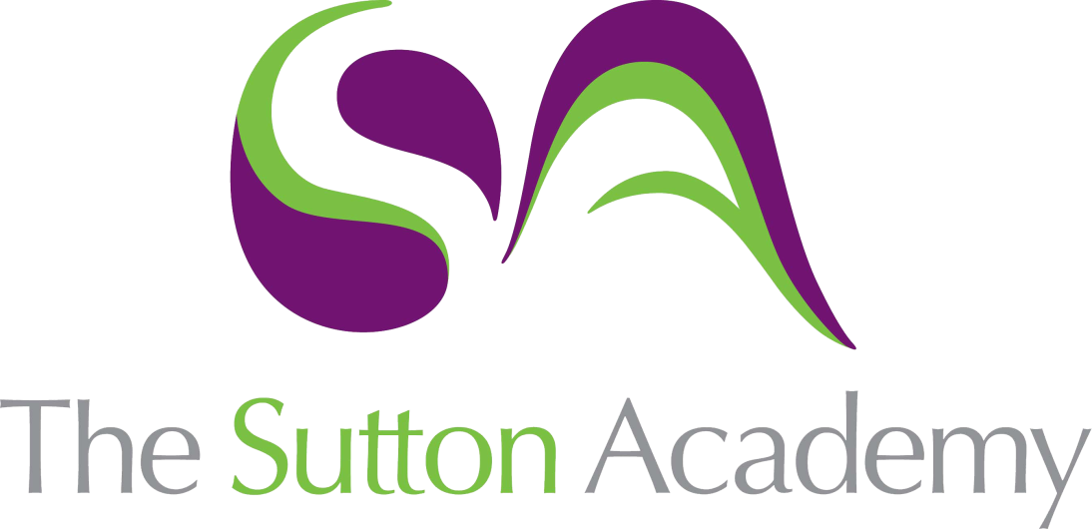

Knowledge Rich Curriculum Plan
OCR Cambridge Technicals Level 3 IT
Unit 8

Lesson/Learning Sequence | Intended Knowledge:  Students will know that… Students will know how to… | Tiered Vocabulary | Prior Knowledge:  In order to know this students, need to already know that… | Assessment
Lessons 1-3  P1 | - Students will know that there are four different phases within the project life cycle and what is involved in each one. The phases are Initiation, Planning, Execution and Evaluation.  - Students will know that there is documentation that is needed to be completed in each phase. | Resource  Financial  Acceptance  Quality  Progress  Deliverables  Initiation  Planning  Execution  Evaluation | - Students need to already know that they are developing an app as their project.  - Students need to already know the destination and client that their theme is based around. | 1st Submission  2nd Submission
Lessons 4-6  P2 | - Students will know that there are different project methodologies which are the different approaches that can be taken to complete a project. The methodologies covered will be Waterfall Model, PRINCE2, Spiral Methodology and Agile Development. | Stages  Phases  Project  Objectives  Methodologies  Waterfall  PRINCE2  Spiral  Agile | - Students need to already know that there is usually and analysis and planning phase before the implementation of a product.  - Students need to already know the importance of having testing and evaluation when developing a product. | 1st Submission  2nd Submission
Lessons 7-9  M1 | - Students will know the advantages and disadvantages of each of the four different methodologies.  - Students will know the situations when methodologies would be better to use than others. | Stages  Phases  Project  Objectives  Methodologies  Waterfall  PRINCE2  Spiral  Agile | - Students need to already know the phases/stages of the four different methodologies which they covered in the P2 task.  - Students need to already know what a comparison is and how to make comparisons with different methodologies. | 1st Submission  2nd Submission
Lessons 10-12  D1 | - Students will know where each of the phases lies within the project life cycle and the importance that it has on the client, objectives and overall project. | Resource  Financial  Acceptance  Quality  Progress  Importance  Deliverables  Initiation  Planning  Execution  Evaluation | - Students need to already know that there are four different phases within the project life cycle and what is involved in each one. The phases are Initiation, Planning, Execution and Evaluation.  - Students need to already know that there is documentation that needs to be completed in each phase. | 1st Submission  2nd Submission
Lessons 13-15  P3 | - Students will know about Project Initiation Documents (PID) and how to explain the client/stakeholders, tools and structure of their project.  - Students will know the importance of objectives, scope and timescales in relation to their project. | Objectives  Stakeholders  Resources  Project Initiation Document (PID)  Gantt Chart  Milestones  Structure | - Students need to already know the client requirements and objectives for the app they are producing as part of Unit 6. | 1st Submission  2nd Submission
Lessons 16-18  P4 | - Students will know how to create a range of different plans for their chosen project. This will include a Resource, Acceptance, Risk and Quality plan.  - Students will know about Financial Plans and Gantt Charts and how to create them for a scenario. | Plan  Phase  Resource  Financial  Acceptance  Risk  Quality | - Students need to already know some basic skills in Microsoft Excel, including formatting techniques and creating formulae for totals. | 1st Submission  2nd Submission
Lessons 19-21  M2 | - Students will know how to reflect on this planning phase in relation to the schedule, budget, risks and any issues which came up.  - Students will know the importance of reviewing the Planning phase before moving on to the Execution phase. | Plan  Phase  Review  Budget  Schedule  Issues  Conclusion | - Students need to already know the range of plans that were required as part of this phase including Resource, Financial, Acceptance, Risk and Quality plans. | 1st Submission  2nd Submission
Lessons 22-24  D2 | - Students will know that a Business Case will include the current problem, possible solutions and a recommendation.  - Students will know the importance of presenting a Business Case to the client or stakeholders of the project. | Benefits  Drawbacks  Costing  Analysing  Solution  Recommendation  Business Case | - Students need to already know the current situation with the client and their requirements for this project.  - Students need to already know some of the benefits/drawbacks of using websites or apps. | 1st Submission  2nd Submission
Lessons 25-27  P5 | - Students will know how to reflect on this execution phase in relation to the schedule, budget, deliverables, risks and any issues which came up.  - Students will know the importance of reviewing the Execution phase before moving on to the Execution phase. | Plan  Phase  Review  Budget  Schedule  Issues  Conclusion | - Students need to already know what happens during the Execution phase such as the creation of the product, testing and the setting of milestones and deadlines. | 1st Submission  2nd Submission
Lesson 28-30  P6 | - Students will know how to use the project objectives to reflect on the success of the project.  - Students will know the importance of reviewing their own projects and learning lessons to improve future projects. | Achievements  Failures  Review  Objectives  Business Benefits  Software | - Students need to already know what project objectives are and which ones they selected for their project.  - Students need to already know a range of business benefits that computerised systems can bring such as increasing productivity and reducing human error. | 1st Submission  2nd Submission
Lessons 31  M3 | - Students will know that the success of the project/product can be assessed by testing, client feedback and reflection.  - Students will know the importance of recommending improvements and the impact it can have on future projects. | Achievements  Failures  Review  Recommendations  Objectives  Business Benefits  Software | - Students need to already know the methods for collecting client feedback.  - Students need to already know the major achievements and failures for their current project. | 1st Submission  2nd Submission
Lessons 32-34  D3 | - Students will need to know the importance of a project closure report at the end of the execution phase.  - Students will need to know that a project closure report will include an assessment on performance, lessons learnt, next steps and a summary. | Achievements  Failures  Performance  Recommendations  Execution  Objectives  Business Benefits | - Students need to already know what project objectives are and which ones they selected for their project.  - Students need to already know the major achievements and failures for their current project. | 1st Submission  2nd Submission

