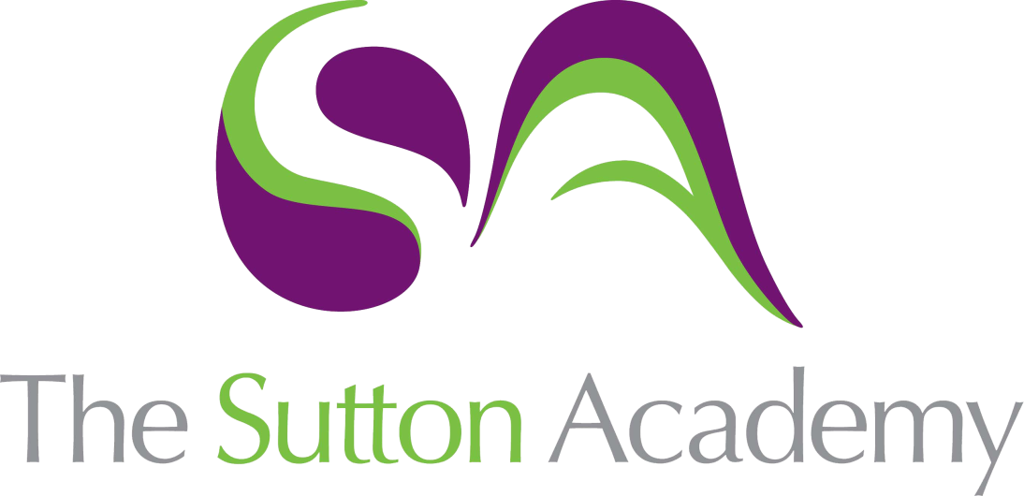

Knowledge Rich Curriculum Plan
OCR Cambridge National in Creative iMedia Level 2
R094 – Digital Graphics

Lesson/Learning Sequence | Intended Knowledge:  Students will know that… Students will know how to… | Tiered Vocabulary | Prior Knowledge:  In order to know this students, need to already know that… | Assessment
Task 1:  Visual Identity Designs | - Students will know that a visual identity will include the name, a logo design and a slogan.  - Students will know that several designs will need to be created for the client to make their final selection. | Design  Requirement  Branding  Visual Identity  Graphic  Slogan | - Students need to already know that organisations use logos to make them visually recognisable.  - Students need to already know that organisations will use a colour scheme in their logo to help with their branding. | Retrieval Task  Questioning  NEA Task
Task 1:  Justify Design Choices | - Students will know how to justify why their visual identity designs are fit for purpose.  - Students will know how to justify why their visual identity designs are suitable for both the client and the target audience. | Design  Requirements  Suitable  Appropriate  Purpose  Target Audience  Composition | - Students need to already know that organisations use logos to make them visually recognisable.  - Students need to already know that several designs will need to be created for the client to make their final selection. | Retrieval Task  Questioning  NEA Task
Task 1:  Mood Board | - Students will know that the purpose of a mood board is to generate ideas or get an impression about theme of a product.  - Students will know that a mood board should include images, colour schemes, fonts and explanations about the ideas. | Planning  Theme  Impression  Colour Scheme  House Style  Typography | - Students need to already know that a mood board is a collage of images about a particular topic or theme.  - Students need to already know that a mood board is something you create before you start making a product. | Retrieval Task  Questioning  NEA Task
Task 1:  Mind Map | - Students will know that the purpose of a mind map is to generate ideas and make connections or links between them.  - Students will know that a mind map should include a central node, sub-nodes and branches. | Connections  Diagram  Planning  Central Node  Sub-nodes  Branches | - Students need to already know that a mind map is a diagram where you can write down all of your thoughts and ideas.  - Students need to already know that a mind map helps with the planning before creating the product. | Retrieval Task  Questioning  NEA Task
Task 1:  Visualisation Diagram | - Students will know that the purpose of a visualisation diagram is to plan the layout and features of a product.  - Students will know that a visualisation diagram should include sketches, colour schemes, fonts and annotations explaining design decisions. | Design  Layout  Features  Visualisation  Annotations  Typography | - Students need to already know that a designer/developer will draw sketches or designs of the product before they create them.  - Students need to already know that designs of a product could be hand drawn or digitally created. | Retrieval Task  Questioning  NEA Task
Task 2:  Create Visual Identity | - Students will know that visual identity is the logo, brand name and slogan.  Students will know that the visual identity can include graphics, shapes and text. | Logo  Brand  Recognisable  Graphic  Slogan  House Style  Visual Identity | - Students need to already know that organisations use logos to make them visually recognisable.  - Students need to already know that organisations will use a colour scheme in their logo to help with their branding. | Retrieval Task  Questioning  NEA Task
Task 2:  Sourcing Assets | - Students will know how to correctly source and store their assets in to an Assets folder.  - Students will know that Copyright law is in place to prevent other people from using assets without the owner’s permission. | Source  Permission  Implication  Multimedia  Asset  Copyright | - Students need to already know that an asset is a multimedia element which could be text, graphic, image, video, animation or sound.  - Students need to already know that assets can be created by yourself or collected using the internet. | Retrieval Task  Questioning  NEA Task
Task 2:  Editing and Preparing Assets | - Students will know that visual identity is the logo, brand name and slogan.  - Students will know that the visual identity can include graphics, shapes and text. | Logo  Brand  Recognisable  Graphic  Slogan  House Style  Visual Identity | - Students need to already know that organisations use logos to make them visually recognisable.  - Students need to already know that organisations will use a colour scheme in their logo to help with their branding. | Retrieval Task  Questioning  NEA Task
Task 2:  Create Digital Graphic | - Students will know how to decide suitable dimensions for the website banner.  - Students will know the importance of using a house style on a product. | Design  Dimensions  Promote  Website Banner  Graphic  House Style | - Students need to already know that a graphic is a visual design which has been created using a computer.  - Students need to already know what should be included on a banner at the top of a website. | Retrieval Task  Questioning  NEA Task
Task 2:  Editing Techniques on Digital Graphic | - Students will know that navigation buttons can have different states to make them interactive.  - Students will know the importance of using a house style on a product. | Buttons  Shape  Colours  Navigation  House Style  Up/Over State | - Students need to already know that websites use buttons to access different web pages.  - Students need to already know that buttons are graphics which are made up of shapes, colours and text. | Retrieval Task  Questioning  NEA Task
Task 2:  Exporting Digital Graphic | - Students will know that a master template will use a table to help position assets in different positions on the page.  - Students will know the importance of using a template to keep a consistent house style on a product. | Layout  Consistent  Template  Navigation  House Style  Hyperlink | - Students need to already know that a template can be used to structure the layout of a product.  - Students need to already know the features of a website including background, banner, navigation and titles. | Retrieval Task  Questioning  NEA Task

