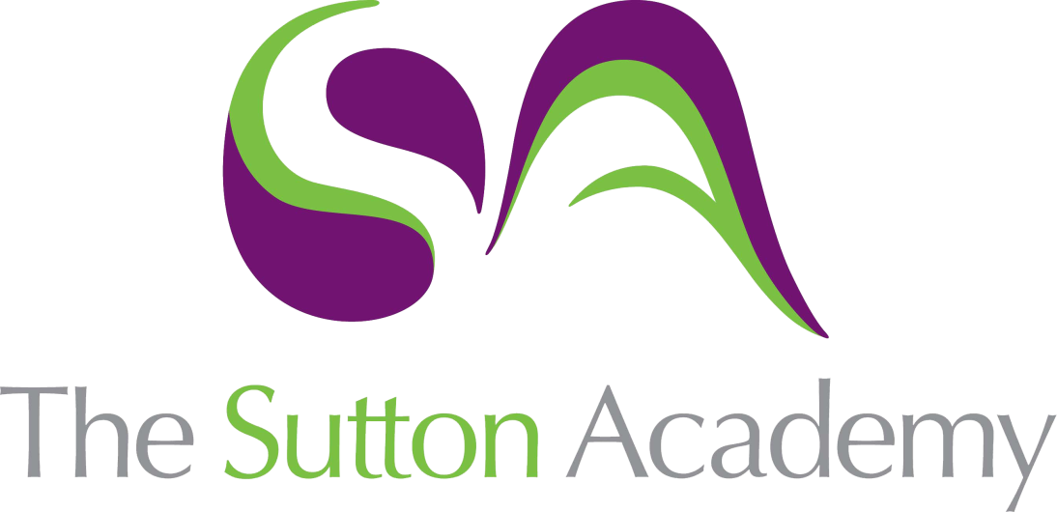

Knowledge Rich Curriculum Plan
Year 10 Higher – Geometry 3

Lesson/Learning Sequence | Intended Knowledge:  Students will know that… | Tiered Vocabulary | Prior Knowledge:  In order to know this, students need to already know that… | Assessment
To learn how to calculate the surface area of prisms and cylinders | - Students will know how to find the surface area of prisms including cubes, cuboids and triangular prisms  - Students will know how to find the surface area of other prisms including compound prisms.  - Students will know how to find the surface area of cylinders. Students will know how to calculate this in terms of π as well as by using a calculator.  - Students will know how to solve problems involving the surface area of prisms and cylinders | Surface area - the total area of all of the faces of a 3D solid added together  Prism – A solid object with two identical ends and flat sides  Compound Solid - a solid that is made up of 2 or more solids. | - Students need to be able to draw nets of shapes and identify nets of different 3D objects  - Students need to know how to calculate the area of squares, rectangles, triangles and compound shapes  - Students need to know how to calculate area and circumference of circles
To learn how to find the surface area of pyramids and spheres | - Students will know how to find the surface area of pyramids.  - Students will know how to find the surface area of sphere and hemi-spheres.  - Students will know how to find the surface area of compound solids involving pyramids spheres, leaving their answers in terms of π where necessary.
To learn how to calculate the surface area of cones | - Students will know how to calculate the curved surface area of a cone using the formula $Curved surface area of a cone=πrl$  - Students will know that to calculate the total surface area for a cone they need to add on the area of the circle on the base  - Students will know to use Pythagoras’ theorem to calculate missing lengths required for the curved surface area of cone  - Students will know how to work backwards from the surface area of a cone or sphere to find missing lengths.  - Students will know how to solve problems involving the surface area of cones and spheres |  | - Students need to be able to substitute into formulae  - Students need to be able to use Pythagoras’ theorem to calculate missing lengths in right-angled triangles
To learn how to calculate the volume of prisms and cylinders | - Students will know that: Volume of a Prism = Area of Cross Section x Length  - Students will know how to find the volume of cubes, cuboids, triangular prisms and compound prisms by calculating the area of the cross-section and multiplying it by the length of the prism  - Students will know how to find the volume of cylinders. Students will know how to leave their answers for this in terms of π.  - Students will know how to work backwards from the volume of a prism to find missing lengths  - Students will know how to work backwards from the volume of a cylinder to calculate its height or the radius/diameter  Students will know how to solve problems involving the volume of prisms and cylinders | Volume – the amount of space inside a 3D object  Prism – A solid object with two identical ends and flat sides  Compound Solid - a solid that is made up of 2 or more solids. | - Students need to be able to calculate the area of squares, rectangles, triangles, compound shapes and circles
To learn how to calculate the volume of pyramids and cones | - Students will know how to find the volume of pyramids and cones.  - Students will know how to find the volume of cones, leaving their answers in terms of π.  - Students will know how to work backwards from the volume of a pyramid to calculate missing lengths  - Students will know how to find the volume of cones.  - Students will know how to work backwards from the volume of a cone to calculate its height, radius or diameter  - Students will know how to find the volume of compound solids and solve problems involving the volume of pyramids and cones |  | - Students will need to know how to calculate the volume of cuboids, cubes and cylinders  - Students need to be able to find 1/3 of a number  - Students need to be able to divide an integer by 1/3  - Students will need to know how to substitute numbers into formulae
To learn how to calculate the volume of a sphere and solve problems involving cones and spheres | - Students will know how to find the volume of spheres and hemi-spheres.  - Students will know how to find the volume of sphere and hemi-spheres, leaving their answers in terms of π.  - Students will know how to work backwards from the volume of a sphere to calculate its radius or diameter  - Students will know how to find the volume of compound solids involving pyramids, cylinders, cones and hemi-spheres, leaving their answers in terms of π where necessary.  - Students will know how to solve problems involving working backwards with the volume and surface area of cones, spheres, hemispheres and compound shapes |  | - Students need to be able to substitute into formulae.  - Students need to be able to multiply an integer by 4/3  - Students need to be able to divide an integer by 4/3
To learn how to calculate Density, Mass and Volume | - Students will know how to calculate mass, density or volume using two variables.  - Students will know how to combine the densities, mass and volumes of two materials/liquids to make a third material/liquid. Students will know how to find missing values from a liquid using the density, mass or volumes for the other liquids.  - Students will know how to solve more complex problems involving density, mass and volume | Density – a measurement of the amount of a substance contained in a certain volume  Mass – the weight of an object | - Students need to be able to convert units for mass  - Students need to be able to convert units for length and understand how to convert units for volume

