Knowledge Rich Curriculum Plan
Year 10 Intermediate – Geometry 3

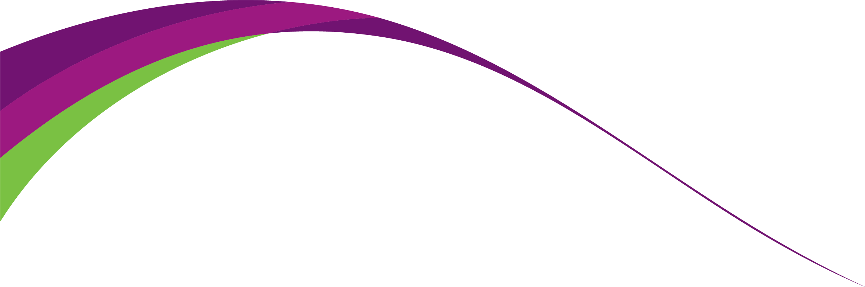

Lesson/Learning Sequence | Intended Knowledge:  Students will know that… | Tiered Vocabulary | Prior Knowledge:  In order to know this, students need to already know that… | Assessment
To learn how to identify 3D shapes and draw and recognise nets | - Students will know how to determine the number of faces, edges and vertices for 3D solids.  - Students will know that a face is the individual flat surface of a 3D solid.  - Students will know how to identify a 3D shape from its net  - Students will know how to draw nets of 3D solids. | Prism – A solid object with two identical ends and flat sides  Vertex (plural vertices) – corner  Net – net means a pattern that you can cut and fold to make a model of a solid shape.  Face – in maths, a face is a flat surface of a solid object  Polygon – a closed shape with straight sides  Edge – a line segment where two faces meet | - Students will need to be able to name different prisms, pyramids and spheres.
To learn how to identify and draw plans and elevations from shapes and draw shapes from plans and elevations | - Students will identify front, side and plan elevations of 3D solids. Students will know that an elevation means a 2D drawing of a 3D shape from different viewpoints.  - Students will draw the front, side and plan elevations of 3D solids.  - Students will know how to sketch a 3D solid using the front, side and plan elevations.  - Students will know how to use isometric grids to sketch 3D solids. | Plan – A drawing of something as viewed from above  Elevation – the view of a 3D shape when it is looked at from the side or from the front. | - Students need to be able to recognise 2D shapes
To learn how to calculate the surface area of prisms | - Students will know how to find the surface area of prisms including cubes, cuboids and triangular prisms  - Students will know how to find the surface area of other prisms including compound prisms.  - Students will know how to solve problems involving the surface area of prisms  - Students will know how to find the surface area of cylinders. Students will know how to calculate this in terms of π as well as by using a calculator.  - Students will know how to solve problems involving the surface area of cylinders | Surface area - the total area of all of the faces of a 3D solid added together  Prism – A solid object with two identical ends and flat sides  Compound Solid - a solid that is made up of 2 or more solids. | - Students need to know how to calculate the area of squares, rectangles, triangles and compound shapes  - Students need to know how to calculate area and circumference of circles
To learn how to calculate the surface area of pyramids and spheres | - Students will know how to find the surface area of pyramids.  - Students will know how to find the surface area of sphere and hemi-spheres.  - Students will know how to find the surface area of compound solids involving pyramids spheres, leaving their answers in terms of π where necessary. |  | - Students need to be able to substitute into formulae.  - Students need to be able to find the area of circles.  - Students need to know that π = 3.142 and be able to use the π button on the calculator.
To learn how to calculate the volume of prisms | - Students will know that: Volume of a Prism = Area of Cross Section x Length  - Students will know how to find the volume of cubes, cuboids, triangular prisms and compound prisms by calculating the area of the cross-section and multiplying it by the length of the prism  - Students will know how to solve problems involving the volume of prisms | Volume – the amount of space inside a 3D object  Prism – A solid object with two identical ends and flat sides  Compound Solid - a solid that is made up of 2 or more solids. | - Students need to be able to calculate the area of squares, rectangles, triangles and compound shapes
To learn how to calculate the volume of cylinders | - Students will know how to find the volume of cylinders. Students will know how to leave their answers for this in terms of π.  - Students will know how to work backwards from the volume of a cylinder to calculate its height or the radius/diameter  - Students will know how to solve problems involving the volume of cylinders |  | - Students need to be able to calculate the area of circles
To learn how to calculate the volume of pyramids, cones and spheres. | - Students will know how to find the volume of pyramids.  - Students will know how to find the volume of cones.  - Students will know how to find the volume of spheres and hemi-spheres. |  | - Students need to be able to substitute into formulae.  - Students need to be able to multiply an integer by 1/3 and 4/3
To learn how to calculate Density, Mass and Volume | - Students will know how to convert between units of density.  - Students will know how to calculate mass, density or volume using two variables. Students will know that density means a measure of how much matter is in a certain volume.  - Students will know how to find the mass or density given one of the variables and by working out the volume. Students will know that a variable means a symbol for a value we do not know yet. It is usually a letter like x or y. |  | - Students need to be able to convert units for mass  - Students need to be able to convert units for length and understand how to convert units for volume
To learn how to calculate speed, distance and time | - Students will know that $Speed=\frac{distance}{time}$  - Students will know that $Time= \frac{distance}{speed}$  - Students will know that $Distance=Speed×Time$  - Students will know the formula triangle for speed, distance and time  - Students will know how to solve basic SDT problems where the time is an integer number of hours and all units correspond  - Students will know how to make simple conversions for minutes to decimal hours - they will know that 30 minutes is 0.5 hours and 15 minutes is 0.25 hours  - Students will know how to calculate speed, distance or time given the two other variables including where the time needs to be converted into a decimal number of minutes or hours  - Students will know how to calculate speed, distance or time using two variables where they need to convert time written in hours and minutes to a decimal  - Students will know how to calculate average speed given distance and time for multi-stage journeys  - Students will need to know how to solve more complex problems involving speed, distance and time | Speed – the rate at which someone or something moves or operates or is able to move or operate. | - Students should already know how to convert from minutes to hours and minutes
To learn how to draw and interpret distance-time graphs | - Students will know how to draw distance–time graphs.  - Students will know how to work out time intervals for graph scales.  - Students will know how to find the total time taken of individual sections of a distance-time graph.  - Students will know how to find the speed of individual sections of a distance-time graph.  - Students will know how to find the total distance in individual sections of a distance-time graph.  - Students will know how to interpret information presented in a range of linear and non-linear graphs;  - Students will know how to interpret graphs with negative values on axes;  - Students will know how to interpret gradient as the rate of change in distance–time and speed–time graphs, graphs of containers filling and emptying, and unit price graphs. | Gradient – the change in height divided by the horizontal distance. | - Students need to know how to find the difference between two times

