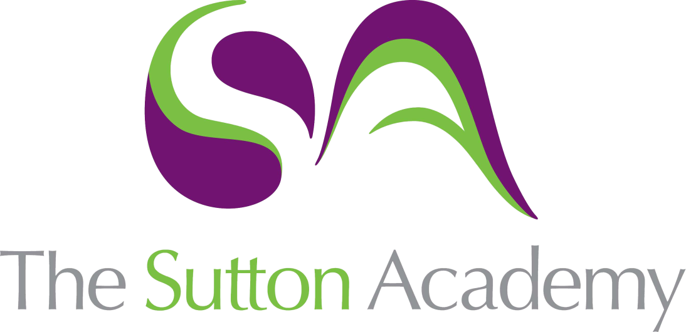

Knowledge Rich Curriculum Plan
Y11 HT2
Social and Global

Lesson/Learning Sequence | Intended Knowledge:  Students will know that… | Tiered Vocabulary | Prior Knowledge:  In order to know this students, need to already know that… | Assessment
Lesson 1 – El medioambiente | - 16 key verbs relating to the environment see KO  - How to tackle a reading comprehension where the answers must be given in the target language. | To consume  To conserve  Natural resources  Renewable (energy)  Ecological  Combustibles  Chemical waste | - Time phrases  - How to identified negative phrases | Past paper reading questions
Lesson 2 – Problemas locales | - 13 key phrases that relate to social / environmental problems – See KO  - Identifying key phrases for box fill reading style activity | Unemployment  Deforestation  Extinction  Inequality  Pollution | - How do identify positive and negative phrases within sentences | Past paper reading questions.
Lesson 3 – Problemas globales | - 8 key phrases that relate to problems in the local area – See KO  - How to develop translation skills |  | - Use of superlatives and comparisons | Reading questions  Translation tasks.
Lesson 4 – Parar y pensar
Lesson 5 – Una vida sana | - 13 phrases relating to having a healthy lifestyle – See KO  - How to identify key tenses to be able to complete reading activities which focus on ‘en el pasado’ / ‘ahora’ / ‘en el futuro’. | Future tense  Conditional tense | - Use of ‘se debe’ and ‘no se debe’ | Translation tasks
Lesson 6 – Una vida sana II | - How to use their vocab from their previous lesson in the context of 3 different tense.  - How to complete translation activities. |  | - Phrases relating to a healthy lifestyle  - Use of the conditional tense  - Use of the imperfect tense | Translation task
Lesson 7 – Exam practise | - Writing focus – how to tackle a 90 word writing task (foundation) and 150 word writing task (higher) |  | - Key vocab relating to environmental and social isses  - Knowledge of how to form the preterite tense  - Knowledge of how to form the imperfect tense  - Knowledge of how to form the future and conditional tense | Whole class feedback  Writing task.
Lesson 8 – Para y pensar

