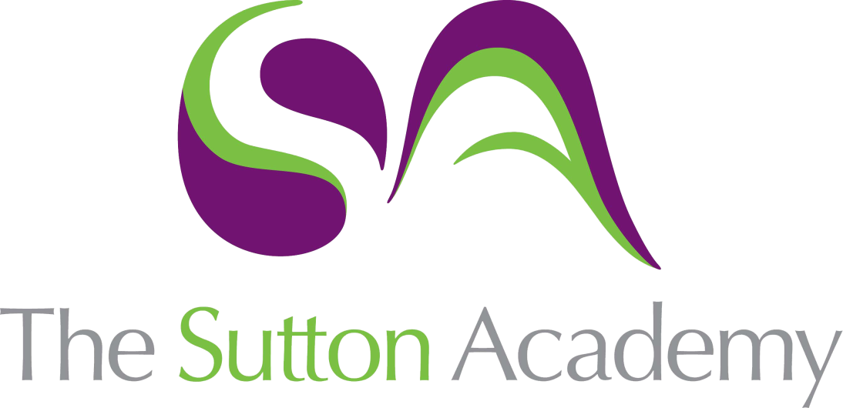

Knowledge Rich Curriculum Plan
Y8 Unit 3
En mi colegio
Focus Skill: Writing

Lesson/Learning Sequence | Intended Knowledge:  Students will know… | Tiered Vocabulary | Prior Knowledge:  In order to know this students, need to already know… | Assessment
Lesson 1  El uniforme | - How to describe their school uniform using 14 items of vocab for clothes – see KO and 10 adjectives – see KO.  - Llevo = I wear / llevamos = we wear  - Tengo que = I have to / Tenemos que = We have to | Mandatory  Progressive  Emblem | - Items of clothing  - Colours  - Adjectives to describe clothing  - The rule for adjectival agreements  - How to conjugate the verb llevar | Reading tasks  Listening tasks
Lesson 2  Uniforme ventajas y desventajas | - How to describe the advantages and disadvantages of their school uniform  - Estoy a favor = I’m in favour  - Estoy en contra = I’m against | Debate | - Items of clothing  - Adjectives to describe clothing  - 5 higher level opinion phrases | MWBs  Writing tasks
Lesson 3  Cuando era joven | - How to describe their school uniform from primary school using the imperfect tense | Elegant | - How to conjugate the imperfect tense  - How to conjugate the verb llevar in the imperfect tense  - Items of clothing  - Colours  - Adjectives to describe clothing  - The rule for adjectival agreements | MWBs  Whole Class Feedback –  Translation tasks
Lesson 4  El uniforme en mi escuela primaria | - How to compare their uniform now with their uniform in primary school  - Más … que = more … than  - Menos … que = less … than | Era | - How to conjugate the imperfect tense  - How to conjugate the verb llevar in the imperfect tense  - Items of clothing  - Colours  - Adjectives to describe clothing  - The rule for adjectival agreements | MWBs  Translation tasks
Lesson 5  Parar y pensar | - TBC |  | - TBC
Lesson 6  Mi uniforme ideal | - How to describe their uniform using the conditional tense  - How to conjugate the conditional tense | Ideal  Conditional tense | - Llevar = to wear  - Items of clothing  - Colours  - Adjectives to describe clothing  - The rule for adjectival agreements  - Más … que = more … than  - Menos … que = less … than | MWBs  Whole Class Feedback –  Writing tasks
Lesson 7  Las reglas de mi insti | - Se debe = you should  - No se debe = you shouldn’t  - 6 things you should do in school – see KO  - 6 things you shouldn’t do in school – see KO  - Ayuda con el trabajo = it helps with work  - Limita la individualidad = it limits individuality  - Mejora la disciplina = it improves discipline  - 11 adjectives to describe school rules – see KO | Prohibited  Unjust | - A range of infinitives – see KO | Reading tasks  Listening tasks
Lesson 8  Problemas de mi insti | - Not planned yet
Lesson 9  Las diferencias entre mi insti y mi escuela primaria | - How to describe the differences between their school now and their primary school using comparatives |  | - How to use comparatives  - How to conjugate the present and imperfect tenses | Reading tasks  Listening tasks
Lesson 10  Parar y pensar | - TBC |  | - TBC

