Year 7 – Cheerleading
Unit aim | Pupils should become more competent, confident and expert in their techniques  Perform cheer sequences using advanced cheer techniques within a range of cheer levels.  Analyse their performances compared to previous ones and demonstrate improvement to achieve their personal best
Lesson outcomes | To learn basic cheer motions. | To learn basic cheer jumps. | To learn basic cheerleading tumbles. | To gain an understand of different cheer stunt positions and how to perform level 1 stunts. | To perform a cheerleading routine consisting of the different elements required to make a successful routine.
Intended Knowledge | Students will know…  - What skills make up a cheerleading routine.  - Cheer arms are used during all E.g. in dance, jumps, tumbles and stunts.  - A range of cheerleading arms.  - Arms must be performed strong and accurate. | Students will know:  - Different types of cheerleading jumps.  - What makes a successful cheerleading jump.  - Why it is important to use cheer motions before performing a jump. | Students will know:  - The difference between standing tumbles and running tumbles.  - A range of different types of tumbles to put into a routine.  - How to perform tumbles aesthetically. | Students will know…  - What are the roles of the base’s, spotter’s and flyer.  - A range of different cheerleading stunts.  - How to work well as a team to ensure the stunt is successfully.  - Health and safety when performing cheerleading stunts. | Students will know…  - What makes a successful cheerleading routine.  - How to improve sections of their routine.  - How to identify strengths and areas of improvement in their own and others routines.
Prior knowledge | - Cheerleading skills learned in primary school.  - Cheerleading arms they may have learned in cheerleading groups outside of school in the community. | - Links with gymnastics and trampoline movements- jumps such as star, tuck, pike and straddle. | - Links with gymnastics and basic tumbling movement such as taking weight on hands, handstand, forward rolls, cartwheels and walkovers. | - Cheerleading outside of school or in primary school.  - Cheer arms are used within this lesson so this will relate back to lesson one. | - Prior knowledge from previous 4 sessions to put together the cheerleading unit. Students will watch a video at the start of the lesson of what makes up a cheer routine and how to put it together.

 | Unit aim | Pupils should become more competent, confident and expert in their techniques  Perform cheer sequences using advanced cheer techniques within a range of cheer levels.  Analyse their performances compared to previous ones and demonstrate improvement to achieve their personal best
 | Lesson outcomes | To learn basic cheer motions. | To learn basic cheer jumps. | To learn basic cheerleading tumbles. | To gain an understand of different cheer stunt positions and how to perform level 1 stunts. | To perform a cheerleading routine consisting of the different elements required to make a successful routine. | Assessment- Core Task.

Lesson 1
Do now  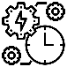 | - What skills would you expect to see in a cheerleading routine?  - What is your prior knowledge of what cheerleading is? |  |  | Core Knowledge gained in this lesson
Teacher exposition  (I do) | What makes up a cheer routine? Youtube Clip: Cheer Factory Heat- Level 1 @ The Summit  https://www.youtube.com/watch?v=pTmsfQh9NSo  Q+A- list/bullet point/ mind map all elements on the whiteboard.  Cheer Arms must be performed:  - Strong arms  - Ensure you are making the shapes correctly  - Motions must be precise. |  |  | Students will know…  - What skills make up a cheerleading routine.  - Cheer arms are used during all E.g. in dance, jumps, tumbles and stunts.  - A range of cheerleading arms.  - Arms must be performed strong and accurate.
Learning task (We do / you do)

Practice  Teacher to lead from the front with the students following:  High V  Low V  T  Broken T  Diagonal Left  Diagonal Right  Bow and Arrow  ‘K’  ‘L’  High touch down  Daggers high and low  ‘Bring it in’  ‘O’  ‘N’  (Please see worksheet of images all the cheer motions) |  | Application  Students to create their own cheer arm sequences.  ‘Spell your name’ activity:  Students try to spell their name using cheer motions or arm movements. They can create their own shapes and letters using their bodies.  Sequence will include:  - Teacher taught section (cheer motions)  - Spell your name section  - Create 4x8 of cheerleading arms/choreography in small groups.
Responsive adaptations | Developing  - Students focus on cheerleading motions set by the teacher in small groups. Students focus on trying to remember the sequence to music or cheer counts. | Securing  - Students are able to create their own cheer motions in small groups. | Mastering  - Students can apply the cheer motions they have created along with the ones they have learned into a routine in small groups and perform it to music or cheer counts.
Progress check questions | - What are cheer arm motions?  Cheer arm motions are arm movements added into a cheerleading routine to support in the aesthetic appreciation of the routine, timing and synchronisation of a routine and showing a variety of movements.  - Why are cheer arm motions important in cheer?  They are used in all aspects of cheer such in cheer stunts, jumps, dance and tumbles.  - How does it improve a routine?  Overall aesthetic appreciation of the routine- cleanest of a routine.
Errors or misconceptions to look out for | - The only cheer motions you can use are the ones taught by the teacher- They are just the basis of what cheer motions are. We encourage students/ cheerleaders to invent new ways of putting cheer motions together.  - Cheer motions are only used in dance- Cheer motions are used throughout a routine. In transitions to one position to another, in stunts, during jumps and also before and after performing a tumble.

Year 7 - Cheerleading
 | Unit aim | Pupils should become more competent, confident and expert in their techniques  Perform cheer sequences using advanced cheer techniques within a range of cheer levels.  Analyse their performances compared to previous ones and demonstrate improvement to achieve their personal best
 | Lesson outcomes | To learn basic cheer motions. | To learn basic cheer jumps. | To learn basic cheerleading tumbles. | To gain an understand of different cheer stunt positions and how to perform level 1 stunts. | To perform a cheerleading routine consisting of the different elements required to make a successful routine. | Assessment- Core Task.
Lesson 2
Do now | - What shapes can you make when you jump?  - What makes a successful jump? |  |  |  | Core Knowledge gained in this lesson
Teacher exposition  (I do) | What makes a successful jump?- show video clip:  https://www.youtube.com/watch?v=-TZ2SaAh-XA&t=5s  The best jump sequences in Cheerleading 2014  Q+A- list/bullet point/ mind map all elements on the whiteboard.  Students to identify what makes the jump successful.  Answers to include:  - Strong arm placements/cheer motions  - Good height  - Start and finishing the jump with feet together  - Good flexibility  - Pointed toes |  |  |  | Students will know…  - Different types of cheerleading jumps.  - What makes a successful cheerleading jump.  - Why it is important to use cheer motions before performing a jump.
Learning task (We do / you do)

Practice  Teacher to lead from the front with the students following:  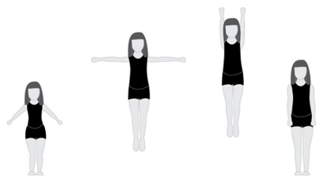  Straight  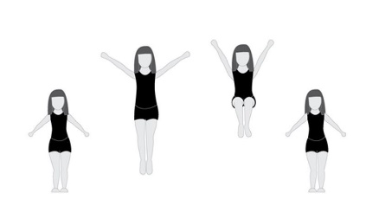  Tuck  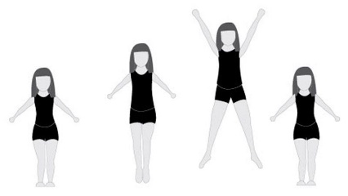  Star  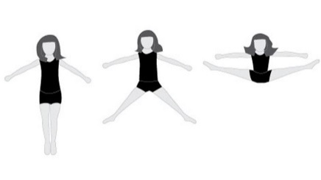  Straddle  - Students make the shape in isolation on the floor.  - Students then perform the jump without a preparation jump (cheer motions)  - Students perform jump with preparation.  - Students then perform jump with preparation x 4 times. |  | Application  Students to create a cheer jump sequence in small groups.  Students can perform the jumps individually or as a combination to either cheer counts or music.  Students to perform their jump sequences to the class for feedback.
Responsive adaptations | Developing  Students perform the shape without a preparation (cheer motions) focusing just on the shape and also starting and landing with their feet together. |  | Securing  Students will create a short routine in small groups to cheer counts or music including their cheerleading jumps. | Mastering  Start to link jumps together in a combination.  Examples of combination jumps:  Straight, tuck, star  Tuck, star, straddle  Straddle, Straddle, Straddle
Progress check questions | - Are you starting and ending with your feet together?  - Are you getting up off the ground high enough?  - Where should your arm placements be at the start, during and after the jump?  - What are the names of the jumps we have looked at?  - How can we make our jumps better?
Errors or misconceptions to look out for | - Cheer motions performed incorrectly- arms are all in the wrong places when performing the jump.  - When performing the preparation before the jump students must not stop the movement it must all flow.

Year 7 - Cheerleading
 | Unit aim | Pupils should become more competent, confident and expert in their techniques  Perform cheer sequences using advanced cheer techniques within a range of cheer levels.  Analyse their performances compared to previous ones and demonstrate improvement to achieve their personal best
 | Lesson outcomes | To learn basic cheer motions. | To learn basic cheer jumps. | To learn basic cheerleading tumbles. | To gain an understand of different cheer stunt positions and how to perform level 1 stunts. | To perform a cheerleading routine consisting of the different elements required to make a successful routine. | Assessment- Core Task.
Lesson 3
Do now | - What is tumbling?  - Can you give an example of different types of tumbles you would expect to see performed in a cheerleading routine? |  |  | Core Knowledge gained in this lesson
Teacher exposition  (I do) | Teacher to demonstrate each tumble and break down the skill with teaching points.  Use Teaching cards. |  |  | Students will know…  - The difference between standing tumbles and running tumbles.  - A range of different types of tumbles to put into a routine.  - How to perform tumbles aesthetically.
Learning task (We do / you do)

Practice  Students work through teaching card of 3 basic tumbles  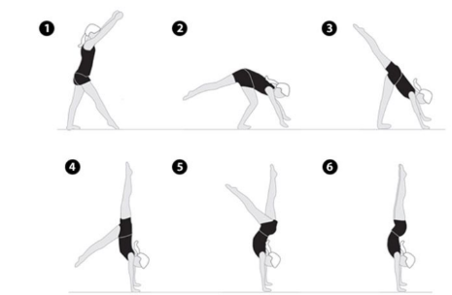  Handstand  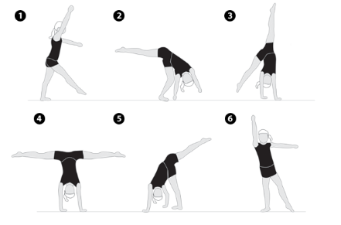  Cartwheel  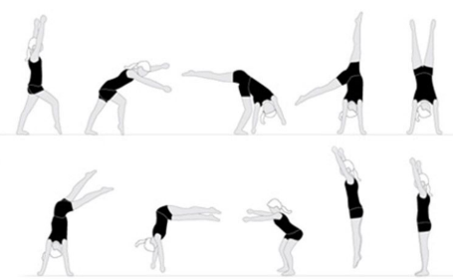  Round- off |  | Application  Students to create a running tumble pass which must include a range of basic tumbles to travel from one position on the floor to another.
Responsive adaptations | Developing  Students to concentrate on taking weight on their hands.  Bunny hops  Bunny ups  Handstands  Handstand forward roll | Securing  Students start to work on more difficult tumbles:  Cartwheels  One handed cartwheels  Round-offs with and without a rebound. | Mastering  Students combine tumbles together in order to create a tumble pass they could include in their cheerleading routine:  Bunny hop, Bunny hop, Handstand.  Handstand, Cartwheel, Round-off without a rebound.  Handstand forward roll, one handed cartwheel, round- off with a rebound.
Progress check questions | - Are your legs straight in your tumbles?  - Are you pointing your toes?  - Are you tumbling on the correct counts?  - How can we improve our tumbles to make them more aesthetically pleasing?  - Are arms locked when performing all tumbles?
Errors or misconceptions to look out for | - Make sure in round-offs feet land together.  - Round-offs must be half turn.  - With cartwheels make sure the student is putting the correct hand down first for their cartwheel  - Cartwheels must kick over the legs, one followed by the other NOT at the same time.  - Arms must be locked and kept straight in all tumbles.  - Push off the ground for a rebound in round-offs.

Year 7 - Cheerleading
 | Unit aim | Pupils should become more competent, confident and expert in their techniques  Perform cheer sequences using advanced cheer techniques within a range of cheer levels.  Analyse their performances compared to previous ones and demonstrate improvement to achieve their personal best
 | Lesson outcomes | To learn basic cheer motions. | To learn basic cheer jumps. | To learn basic cheerleading tumbles. | To gain an understand of different cheer stunt positions and how to perform level 1 stunts. | To perform a cheerleading routine consisting of the different elements required to make a successful routine. | Assessment- Core Task.
Lesson 4
Do now | - What is a group stunt?  - How many people make up a group stunt?  - What are the roles and responsibilities of the people in a group stunt? |  |  | Core Knowledge gained in this lesson
Teacher exposition  (I do) | Students put into height order and then put into groups.  Teacher to pick a demonstration team to talk through the health and safety points of stunting and also to demonstrate the first stunt. |  |  | Students will know…  - What are the roles of the base’s, spotter’s and flyer.  - A range of different cheerleading stunts.  - How to work well as a team to ensure the stunt is successfully.  - Health and safety when performing cheerleading stunts.
Learning task (We do / you do)

Practice  Teacher led due to health and safety in the first instance.  Teacher to demonstrate and talk through stunts with a demo team whilst all students listen and watch.  Class practice the stunt with the teacher.  Then practice and perform by themselves  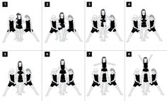  Double- based thigh stand  V Sit/Teddy Bear Lift  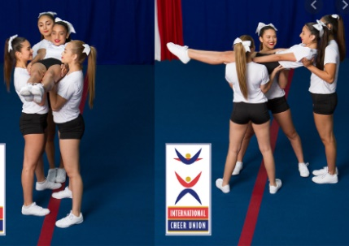  Flat back  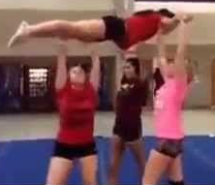  Superman lift  Loading |  | Application  Students to create their own group stunt routine using the stunts they learned in the lesson.  The routine should include at least 3 stunts.  Students to perform their routine at the end of the lesson and receive peer feedback on their stunts.
Responsive adaptations | Developing  Students focus on 1 or 2 stunts ensuring that the stunt is performed aesthetically. Students will have a particular focus on getting in and out of the stunt safely. | Securing  Students create a stunt routine including at least 3 cheer stunts. After each stunt they count to 8 before moving into the next stunt. | Mastering  Students to create a stunt routine where they try and link stunts together so the flyers feet does not touch the floor after each stunt. They must choose stunts carefully and decide which ones can link together safely and successfully.
Progress check questions | - What is the role of the flyer, spotters, base’s?  - Revisit teaching points of each stunt.  - Why is it important that the flyer squeezes tight during the stunts and always keeps their body strong?  - Why is it important that bases lift from their legs and not their backs?
Errors or misconceptions to look out for | - The flyer does no work: It is really important that the flyer can hold their own weight up and ensures they have good body tension to allow the bases to lift them.  - The spotters take the weight: Spotters main role is to protect the flyer so keeping hold of them. The only time they take any weight is during a V sit. It has been known for bases to swap position with the spotter to ensure the stunt goes up.  - Timing is KEY! If people go up on different counts the stunt simply won’t go up. They must count together and lift on the same count.
Year 7 - Cheerleading
 | Unit aim | Pupils should become more competent, confident and expert in their techniques  Perform cheer sequences using advanced cheer techniques within a range of cheer levels.  Analyse their performances compared to previous ones and demonstrate improvement to achieve their personal best
 | Lesson outcomes | To learn basic cheer motions. | To learn basic cheer jumps. | To learn basic cheerleading tumbles. | To gain an understand of different cheer stunt positions and how to perform level 1 stunts. | To perform a cheerleading routine consisting of the different elements required to make a successful routine. | Assessment- Core Task.
Lesson 5
Do now | - RECAP: What elements make up a cheerleading routine?  - What are the different roles in a group stunt?  - Can you give examples of different stunts, tumbles and jumps you can include in a cheer routine? |  |  | Core Knowledge gained in this lesson
Teacher exposition  (I do) | Teacher to show the following 2 clips on youtube:  https://www.youtube.com/watch?v=A-hyytJjeno  Platinum Athletics Shine- Level 1 Routine (The Summit 2019)  https://www.youtube.com/watch?v=X1UVPPaJhzs  Gloucester Wildcats Junior B- Level 1 Routine (UKCA)  Can you spot the difference between the two routines?  Which routine was better and why? (pair share)  What makes up a successful cheer routine? (Teacher to write down responses on the whiteboard) |  |  | Students will know…  - What makes a successful cheerleading routine.  - How to improve sections of their routine.  - How to identify strengths and areas of improvement in their own and others routines.
Learning task (We do / you do)

Practice  Students to work in small groups to put together a cheerleading routine using all the elements from each lesson.  The routine must include the following elements:  - Cheer Dance  - Cheer Jumps  - Standing Tumbles  - Running Tumbles  - Cheer Stunts |  | Application  Students to create a routine in small groups including all of the cheerleading elements.  The routines are then performed to another group where they will complete a peer assessment form and they also film their routine.  Students take their feedback form and video of their routine and then work on the areas they need to improve on.
Responsive adaptations | Developing  Students perform:  - 1x8 cheer dance  - 1 cheer jump  - 1 tumble  - 1 cheer stunt | Securing  Students perform:  - 2x8 cheer dance  - 2 cheer jumps  - 2 tumbles  - 2 cheer stunts | Mastering  Students perform:  - 4x8 Cheer Dance  - 3 Cheer Jumps connected  - Standing Tumble  - Running Tumble  - 3 Cheer Stunts
Progress check questions | - Does your routine flow from one section to another?  - Is everyone in your group performing something all the time?  - Is your routine aesthetically pleasing?  - Are you all in time with the counts?
Errors or misconceptions to look out for | - Timing is KEY! If people go up on different counts the stunt simply won’t go up. They must count together and lift on the same count. This is also important for the overall routine. Everyone must be in time with the music.

