Year 8 - Football
Unit aim | To become more confident and competent when performing core skills required to retain or regain possession.
Lesson outcomes | Demonstrate how to manipulate the ball with different parts of the foot and show close control when dribbling. | Demonstrate core turning techniques to retain possession of the ball. | Demonstrate a fake and take or step over to eliminate a defender in a 1 v 1. | Demonstrate effective shielding skills to retain possession of the ball when your back is to goal. | Demonstrate the defensive skills of a stab tackle and defensive jockeying to regain possession of the ball.
Intended Knowledge | Students will know that manipulate means to handle or control the ball in a skilful manner  Student will know how to manipulate the ball with the sole, laces, and instep of the foot  Students will know that dribble means to move with the ball in different directions.  Students will know how to exploit space with a quick dribble.  Students will know that exploit means to make full use of or benefit from a situation  Students will know the importance of looking up and scanning ahead when dribbling with the ball  Students will know that scanning means to look quickly to identify what is ahead of them | Students will know that turning means to move so that you are in a different position to opponent  Students will know how to perform the following turning techniques: inside hook, outside hook, pull back and cruyff turn  Students will know how to accelerate quickly out of the turn to create space.  Students will know that accelerate means to begin to move more quickly  Students will know how to put disguise on a turn to outwit an opponent  Students will know that disguise means to conceal what it is you actually want to do | Students will know that 1 v 1 means two players battling against each other  Students will know that they should beat an opponent in a 1 v 1 situation if there is clear space to run behind the defender.  Students will know how to beat an opponent using a fake and take, step over and inside-outside beating skills  Students will know how to use the beating skills above to create and exploit space on a football pitch. | Students will know that shielding is a technique used to keep possession of the ball in tight spaces  Students will know how to shield the ball by keeping their body between the defender and the ball  Students will know that shielding the ball in attacking positions can help to build an attack.  Students will know how team mates should support a player who is shielding the ball by making runs off the ball.  Students will know that support means to give assistance to a team mate | Students will know that goal side is a tactic used when defending by staying between the ball and the goal being defended  Students will know that they have to stay goal side of an attacker when defending.  Students will know how to stay goal side of an attacker when defending  Students will know how to perform the following defending skills - block tackle, stab tackle and a jockey  Students will know that defensive pressing means to create tension with the intention of getting the ball back  Students will know how to press an attacker  Students will know that pressing means to get close to the attacker and not let them pass, dribble or shoot
Prior Knowledge | Students need to already know that when you are running you keep your head up to see what is around you  Students need to already know that to change direction they need to use their weight and push off.  Students need to already know how to use their foot to move with a ball | Students will need to know how to manipulate the ball with different parts of their feet to perform each type of turn  Students will need to already know how to dribble with the ball and keep it under control  Students will need to already know how to dribble with the ball  Students will already know that when you dribble you need to keep you head up and scan ahead | Students need to already know that accelerating away from a player helps to create space  Students will know how to use disguise to conceal what it is you actually want to do  Students will how to change their direction by shifting their body weight | Students need to already know how to manipulate the ball with different parts of their feet.  Students need to already know how to perform different turns and 1 v 1 skills to keep the ball away from an opponent.  Students will already know how to create space by moving away from a defender | Students need to already know that attackers can use their body to protect the ball from a defender  Students need to already know the types of turns and skills an attacker can use to outwit them  Students need to already know how to accelerate to keep up or move quickly against an attacker

Lesson 1 - Demonstrate how to manipulate the ball with different parts of the foot and show close control when dribbling.

Do now | When you watch (insert famous footballer) move with the ball what makes them effective?
Teacher exposition  (I do) | Context: Ball mastery or ball manipulation involves using different parts of your feet to keep possession and move with the ball. It allows you to become more creative and positive e.g. in 1 v 1 situations. Gives players the confidence to try things when faced with an opponent and make good decisions and enables performers to operate in tight areas and under pressure.  - Low centre of gravity.  - Keep arms up and out for balance.  - Keep the head and eyes up. The eyes should not be on the ball.  - Scan the field as you are dribbling. This will improve your vison and awareness.  - Dribble with the shoelaces when dribbling.  Keep the ball close in pressure and away from you in space.
Learning task (We do / you do)

Practice – dribbling and ball manipulation  - Students move freely in the area propelling and stopping the ball in a controlled manner.  - Backwards and sideways  - Around cones (figures of 8 etc)  - Penguin and toe taps  - Trapping |  |  | Application – End zone  - Small sided games 2v2, 4v4 or 2v1  - Points gained every time ball gets dribbled into the end zone.  Two balls in play at all times to keep the game active.  (This game is used in hockey Yr 7 – discuss links)
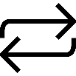  Responsive adaptations | Developing  Larger playing space  3 balls during game | Securing  As above |  | Mastering  Weak foot only  Smaller playing space  More pressure  One ball during game
Progress check questions | What is meant by the term “scanning”?  Why should we move the ball with our head up?  Why should we use different parts of our feet when dribbling?  How can different methods of turning with the ball help you protect the ball from opposition players?
Errors or misconceptions to look out for | Tapping the ball with the toe – Needs to use the outside of either foot to push the ball forwards  Bumping into other players whilst moving around – Not looking up and “scanning”  Losing control of the ball – Moving too quickly, needs to slow down

Lesson 2 - Demonstrate core turning techniques to retain possession of the ball.

Do now | How can we be effective when turning away from a defender?
Teacher exposition  (I do) | Context: Turning or changing direction with the ball is required to beat defenders and find your way to goal. It is also required as a means to prevent the ball being taking from you. Turning also allows you to see the field of play and help you make a decision as to where you should move the ball next.
 | Inside hook or outside hook  Plant closest foot to the side and behind the ball  Use the foot furthest from the ball to perform the turn.  Use your big toe or little toe to chop the ball in the direction you have come from. | Pull back or drag back  Plant non kicking foot to side of ball  Place sole of the opposite foot on the ball and roll directly behind you  Turn 180 degrees in direction of the ball (turn right when using right foot, left with left) |  |  | Cruyff Turn  Plant non kicking foot alongside ball, as if to pass or shoot.  Fake to pass/shoot bring kicking foot round ball, so that toes end up pointing towards each other at a right angle.  Push ball between legs, using inside of foot  Turn body to left when using right foot and right when using left foot.
Learning task (We do / you do)

Practice – turns through gates or World famous turns  Gates spread around the area  Students dribble through a gate and perform turn.  OR  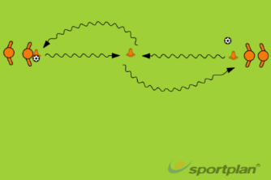  4’s  Students dribble to centre cone perform a turn and pass back to partner |  |  |  | Application - attack the side gate  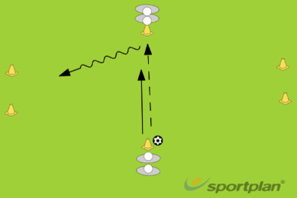  Pass to other side  Students must receive the ball and attack either side goal  Try to get the defender to commit then change your direction  Read how the defender approaches before committing to a turn  OR  The player who is dribbling with the ball is trying to score points by dribbling through a gate but only if it’s empty and no other “pair” is going through it. This is quite challenging as it means the player is looking away from the ball at their feet, so be patient and provide lots of opportunities to practise.
Responsive adaptations | Developing  - Focus on the inside and outside hook turn |  | Securing  - Drag back and Cruyff turn |  | Mastering  - Perform the figure of 8 turn
Progress check questions | What are the benefits of using both feet when turning?  Why do we use turns in football?  Why should you vary the type of turn you use?  How do you get the defender to commit in a direction before turning?
Errors or misconceptions to look out for | Limited disguise on the turn so unable to outwit defender – Greater exaggeration of fake pass or shot  Attacker unable to get away from the defender once turn has been performed – Need to be more explosive and accelerate away

Lesson 3 - Demonstrate a fake and take or step over to eliminate a defender in a 1 v 1.

Do now | Can you name any skills you would use to beat an opponent in a 1 v 1?
Teacher exposition  (I do) | Context: 1 v 1’s are the most common and frequent tactical situation a player will find themselves in. In a similar way to turning – 1 v 1 skills enable you to beat defenders and find your way to goal to create goal scoring chances. Having a variety of 1 v 1 skills will help you to outwit your opponent regularly.
 | Fake and take  - Keep ball between feet when dribbling  - Step to one side of the ball  - Bend knee and drop shoulder  - Bring other foot across to the side of ball, toe pointed down  - Push ball diagonally forward with outside of foot | Step over or scissors  - Take ball left or right foot move foot around the ball, from the inside to the outside (clockwise with right, counter clockwise for left)  - Plant foot (that rotated round ball), bend knee, drop shoulder  - Bring opposite foot to the side of the ball and point toe down  - Use outside of foot and push past defender |  |  | Inside – outside  - Use inside of one foot to move ball towards opposite foot  - Bend knee and drop shoulder  Bring foot to opposite side of ball and point toe down use outside of foot to push ball diagonally forward past opponent
Learning task (We do / you do)

Practice – repeat the skill and 1 v 1 battle  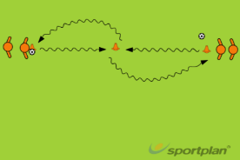  In 4’s  Dribble to cone and practice the different 1 v 1 skills  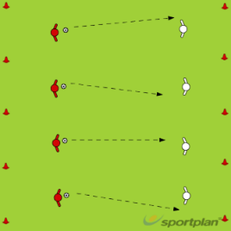  2’s  1 v 1 across grid  Start with attacker in possession  Winner up loser down a place |  |  |  | Application – Gates make goals or skill zone  Gates in centre of pitch  1 v 1  Dribble through gates then attack goal  More gates dribbled though the more goals it is worth if you score.  Get tackled and score resets.  OR  Two teams cannot pass in the centre channel.  Encourages players to use dribbling and 1 v 1 skills to get out
Responsive adaptations | Developing  Passive defender in the 1 v 1  Game  Allow students to pass forwards out of the box.  Decrease the size of the box so they can get out easier. |  | Securing  As above  Game  As above |  |  | Mastering  Perform double scissors technique  Encourage use of weak foot.  Defender starts with ball and passes ball to attacker for greater pressure.  Game  Increase the size of the central area to make it more challenging to escape.  Must beat 2 players before leaving the box.
Progress check questions | What is the aim of a step over/fake and take?  Why would you choose not to perform a skill?  How can you create space for 1 v 1 situations if you are not on the ball?
Errors or misconceptions to look out for | Defender intercepts the ball during the skill – Performing the skill too close to defender must start movement earlier.  Unable to make the defender move in a different direction – The fake is not exaggerated enough.

Lesson 4 - Demonstrate effective shielding skills to retain possession of the ball when your back is to goal.

Do now | When you have your back to the goal and you are put under pressure how do you keep the ball?
Teacher exposition  (I do) | Context: shielding is an important dribbling technique often used to keep possession in tight spaces. Shielding occurs when the player in possession of the ball positions themselves between the ball and their opponent creating a barrier with their body.  Shielding  Look to keep body between the ball and their opponent.  Try to position 'side on' to the defender  Keep arm out to 'feel' for the player, in order to give additional distance from the ball to the defender.  Try to use the outside of their foot to keep the ball under close control, in order to move the ball fast if needed be.  Move the ball away from the defender if they come around the side of you  Don’t turn into the defender, as this allows the defender an easy chance to take the ball away from the player in possession.
Learning task (We do / you do)

Practice – shield the ball  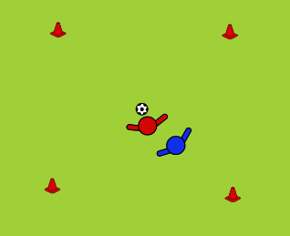  - Ball positioned on top of a marker  - Attacker positions to shield from defender.  - Progression to have ball in play  - Rotate  Back to goal  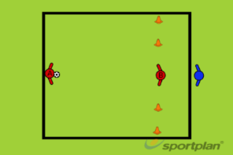  - A plays B as B checks in.  - Blue must attempt to steal and dribble through Red players' side (left side of the box).  - Red "B" attempts to control, shield and use dribbling skills to dribble through the gates.  - OPTIONAL: A may join the play to make it a 2v1 |  |  | Application – Pirates  - All players have a ball or half have ball half without  - Try to dribble around and remain in possession of the ball  - Use shielding skills if a player tries to kick the ball away or steal the ball away
Responsive adaptations | Developing  - Larger playing area  - Dribbling over a line not through a gate | Securing  - As above |  | Mastering  - Use ball rolls to protect and shield the ball  - Smaller gates
Progress check questions | What situations will you chose shield the ball?  Why is shielding so important as a striker?  How does shielding the ball support build up play?
Errors or misconceptions to look out for | Defender gets ball easily – 1. Not using arm to “feel” for defender  2. Not positioning body between ball and defender  3. Not moving the ball as defender moves

Lesson 5 - Demonstrate the defensive skills of a stab tackle and defensive jockeying to regain possession of the ball.

Do now | How many different methods can you think of to regain possession of the ball?
Teacher exposition  (I do) | Context: The primary and important purposes of tackling are to dispossess an opponent of the ball, to stop the player from gaining ground towards goal or to stop them from carrying out what they intend.
 | Block tackle  Plant the non-tackling foot firmly on the ground to provide an anchor.  Let the tackling foot make contact with the middle of the ball – like a side-foot pass  Strength and weight behind the ball.  Head down over the ball.  Eyes on the ball.  Bend the knees. | Poke or stab tackle  Taking the opportunity to poke the ball away from the attacker when they miss time their control.  Timing is important – don’t commit unless the ball is winnable.  Use the toe of your foot. |  | Jockey  Stay within touching distance of the attacker.  Keep body between attacker and goal.  Body position slightly side ways.  Get low and bend knees.  Stay balanced and on toes.  Watch the ball.  Don't dive in – track the attacker.  Force the attacker sideways/away from goal/on to weak foot/down the line
Learning task (We do / you do)

Practice – block, poke and jockey  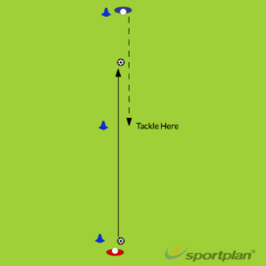  - 1 v 1  - Pass across and run to tackle  - Start with passive dribble  - Move to active  - Develop into pass and jockey  - Pass, jockey and poke  Stopping the turn  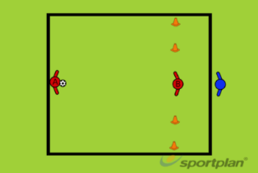  - Similar to last week but the emphasis is now on the defender.  - As the player receives the ball they must stop the turn using defensive techniques  - Try to force attacker out to the side |  | Application – Pressing high  - Two teams  - Pitch split in two  - If team wins ball in opposition half and score = double points  - If players win ball in own half and then score = 1 point  - This rewards pressing high up the pitch
Responsive adaptations | Developing  Passive attacker to allow tackle  Attacker has to get through a gate to make it easier for the defender | Securing  As above | Mastering  Attacker has to get across a line to make it harder for the defender
Progress check questions | What is the trigger to go from jockeying a opponent to tackling?  Why should we press high up the pitch?  Why do you want to prevent an attacker from turning?  How should you press opponent players?
Errors or misconceptions to look out for | Attacker is able to turn and face up – Not getting close enough to the attacker to put pressure on. Move quicker.  Attacker is able to turn away easily even with pressure – Getting too close, keep a few step away to react to any turns

