Year 8 – Table Tennis
Unit aim | To develop competence and confidence when playing attacking and defensive shots close up and away from the table
Lesson outcomes | Recap backhand push | Forehand topspin from a varied feed.  Close and away | Forehand topspin down the line / cross table  Close and away | Countering the topspin with a block shot and slice | Loop shot
Intended knowledge | Students will know how to feed the ball in correctly  Students will know how to complete a backhand push correctly  Students will know how to outwit an opponent with this shot  Students will know how to maintain a score in a game type situation | Students will know how to use a forehand topspin correctly  Student will know when to use this type of shot  Students will know how to change the direction of the ball  Students will know how to feed the ball in correctly (higher bounce)  Students will consider the angle of the bat when playing this shot | Students will know how to use a forehand topspin correctly  Students will know how to change the direction of the ball  Students will know how to feed the ball in correctly (higher bounce)  Students will consider the angle of the bat when playing this shot | Students will know the term “countering” in table tennis  Students will know how to block a ball  Students will know how to use a block shot and a slice | Students will consider the term loop and apply it to table tennis  Students will know when to use this type of shot  Students will know the technique involved in this shot
Prior knowledge | Students will know how to feed the ball in correctly  Students will know the basic scoring system for a game  Students will know the basic rules for a game  Students will know how to hold the bat correctly | Students will know how to feed the ball in correctly  Students will know the basic scoring system for a game  Students will know the basic rules for a game | Students will know when to use this type of shot  Students will know how to create topspin  Students will know the techniques involved for a topspin | Students will know why they may need to apply this shot  Students will have attempted this shot during a game | Students will know how to feed the ball in correctly  Students will know the basic scoring system for a game  Students will know the rules for a game

Lesson 1 - Recap backhand push

Do now  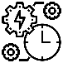 | What are the key teaching points for a backhand push?  Why is it important that we use this skill in a game?  How would you use this skill to outwit an opponent?
Teacher exposition  (I do) | Use the following task card to support with this lesson:  Task cards\backhand push task card.doc  How to feed the ball correctly:  M:\PE\__The Sutton Academy PE department 2018\Schemes of learning and resources\Year 7 and 8 (KS3)\Table Tennis\Useful drills and game ideas\How to feed the ball in table tennis.pdf
Learning task (We do / you do)

Practice  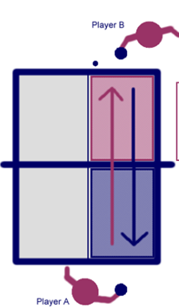  Set up  Player A to feed the ball into player B using just one side of the table.  10 successful feeds each then swap over.  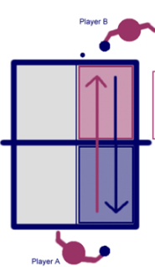  Use the task card to support further and provide additional challenge. |  |  | Application  Set up  Both players A and B play a continuous rally down the one side of the table (could additionally move this to full table/diagonal).  Maintain rally for 20 shots.  Change to the opposite side of the table.  Game  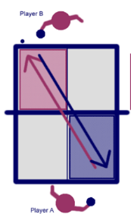  Allow for a small game, first to 5 points.
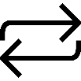  Responsive adaptations | Developing  Overhead feed  Provide large targets to hit | Securing  Overhead feed  Provide large targets to hit and vary location |  | Mastering  Serving feed  Provide small targets to hit and vary location  Allow for a game
Progress check questions | What are the key teaching points for a backhand push?  Ready – Preparation – Contact – Follow through  Why would you use this shot in a game situation?  Defensive based shot  How can you use this shot to outwit an opponent?  Vary the distance/power/location of shot
Errors or misconceptions to look out for | Holding the bat incorrectly  Angle of the bat for a backhand push  Power of the shot  Positioning and stance

Lesson 2 - Forehand topspin from a varied feed.
Close and away

Do now | Backhand push  How do we feed the ball in?  How to we play a backhand push?  How can we beat an opponent with this shot?
Teacher exposition  (I do) | Use the following task card to support with this lesson:  Task cards\forehand topspin task card.doc  How to feed the ball correctly:  M:\PE\__The Sutton Academy PE department 2018\Schemes of learning and resources\Year 7 and 8 (KS3)\Table Tennis\Useful drills and game ideas\How to feed the ball in table tennis.pdf
Learning task (We do / you do)

Practice  Set up  Player B to feed the ball into player A using just one side of the table to begin with. This can vary from arm feeds to serves.  Begin to vary the distance/speed of the feeds.  10 successful feeds each then swap over.  Use the task card to support further and provide additional challenge.  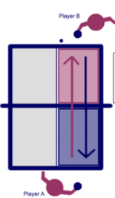 |  |  | Application  Set up  Allow for a game, first to 5 points  Where possible, encourage the use of a forehand topspin  Continue to use the targets for additional challenge
Responsive adaptations | Developing  Attempt regular serve  Provide large targets to hit | Securing  Attempt regular serve  Provide large targets to hit and vary location  Spin evident at times |  | Mastering  Normal serve to outwit  Provide small targets to hit and vary location  Spin evident and sometimes successful
Progress check questions | What are the key teaching points for a forehand topspin?  Ready – Preparation – Contact – Follow through  Why would you use this shot in a game situation?  Outwit opponents/varied return  How can you use this shot to outwit an opponent?  Vary the distance/power/location of shot
Errors or misconceptions to look out for | Holding the bat incorrectly  Angle of the bat  Timing of the shot  Power of the shot  Positioning and stance

Lesson 3 - Forehand topspin down the line / cross table
Close and away

Do now | Forehand topspin  What are the key teaching points for a forehand topspin?  Ready – Preparation – Contact – Follow through  Why would you use this shot in a game situation?  Outwit opponents/varied return  How can you use this shot to outwit an opponent?  Vary the distance/power/location of shot
Teacher exposition  (I do) | Use the following task card to support with this lesson:  Task cards\forehand topspin task card.doc  Opening the body up to change direction of the ball
Learning task (We do / you do)

Practice  Set up  Task 1  Player B feeds the ball to player A  Player A returns the ball cross table to a target (or straight if they are finding it too challenging)  10 successful feeds each then swap over.  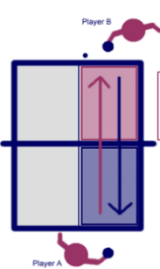  Use the task card to support further and provide additional challenge.  Task 2  Both players A and B play a continuous rally down the one side of the table (could additionally move this to full table/diagonal).  Maintain rally for 20 shots. |  |  | Application  Set up  Game/Tournament
Responsive adaptations | Developing  Attempt forehand shot  Change direction of the ball | Securing  Attempt forehand topspin with some success  Change the direction of the ball to outwit an opponent |  | Mastering  Use forehand topspin with regular success  Outwit opponents
Progress check questions | What are the key teaching points for a forehand topspin?  Ready – Preparation – Contact – Follow through  Why would you use this shot in a game situation?  Outwit opponents/varied return  How can you use this shot to outwit an opponent?  Vary the distance/power/location of shot
Errors or misconceptions to look out for | Holding the bat incorrectly  Angle of the bat  Timing of the shot  Power of the shot  Positioning and stance

Lesson 4 - Countering the topspin with a block shot

Do now | Forehand topspin  How do you change the direction of the ball?  When is this shot used?  How can you outwit an opponent with this shot?
Teacher exposition  (I do) | Use the following task cards to support with this lesson:  Task cards\forehand counterhit task card.doc  Task cards\backhand counterhit task card.doc
Learning task (We do / you do)

Practice  Set up  Player B feeds the ball to player A  Player A returns the ball cross table to a target (or straight if they are finding it too challenging)  Player B will be counterhit the ball upon the return  10 successful feeds each then swap over.  Use the task card to support further and provide additional challenge. |  |  | Application  Set up  Game/Tournament
Responsive adaptations | Developing  Can sometimes return a shot using a counterhit | Securing  Can often return the ball using a counterhit |  | Mastering  Consistently returning the ball using a counterhit and can use it in competitive situations
Progress check questions | What are the key teaching points for a block shot?  Why would you use this shot in a game situation?  Defensive  How can you use this shot to outwit an opponent?  Vary the distance/power/location of shot
Errors or misconceptions to look out for | Holding the bat incorrectly  Angle of the bat  Timing of the shot  Power of the shot  Positioning and stance

Lesson 5 - Loop shot

Do now | What is a loop shot?  How can we use this shot to help us beat an opponent?
Teacher exposition  (I do) | Use the following task cards to support with this lesson:  M:\PE\__The Sutton Academy PE department 2018\Schemes of learning and resources\Year 7 and 8 (KS3)\Table Tennis\Task cards\Loop shot.docx
Learning task (We do / you do)

Practice  Set up  Task 1  Player B feeds the ball to player A  Player A returns the ball cross table to a target (or straight if they are finding it too challenging)  10 successful feeds each then swap over.  Use the task card to support further and provide additional challenge. |  |  | Application  Set up  Game/Tournament
Responsive adaptations | Developing  Attempts to use a loop shot during controlled practice | Securing  Attempts to use a loop shot during a game |  | Mastering  Is successful at using a loop shot during a game to outwit an opponent
Progress check questions | What are the key teaching points for a forehand topspin?  Ready – Preparation – Contact – Follow through  Why would you use this shot in a game situation?  Make it difficult for opponent to return my shot with an attacking one and add extra spin to deceive the opponent  How can you use this shot to outwit an opponent?  Vary the distance/power/location of shot
Errors or misconceptions to look out for | Holding the bat incorrectly  Angle of the bat  Timing of the shot  Power of the shot  Positioning and stance

