Year 8 - Basketball
Unit aim | To become more confident and competent when performing core skills required to retain or regain possession.
Lesson outcomes | Demonstrate basic dribbling techniques and ball manipulation skills. | Demonstrate how to protect the ball with a pivot. | Demonstrate a cross over and to outwit an opponent in a 1 v 1. | Demonstrate correct defending techniques in a 1 v 1. | Demonstrate how to ‘Cut’ to create space when not in possession.  Assessment – core task
Intended Knowledge | Students will know that dribbling allows you to move the ball into space  Students will know how to perform the correct technique for dribbling  Students will know that the two dribbling violations are "double dribble" and "travel"  Students will know how to manipulate the ball with either hand  Students will know that manipulate means to control the ball in a skilful manner | Students will know how to perform a forwards and backwards pivot  Students will know that to pivot means to keep one foot stationary and rotate around it with your other foot.  Students will know that by pivoting it will allow an attacker to avoid a defensive player  Students will know how a pivot can create attacking options | Students will know how to perform a cross over and through the legs dribble  Students will know that these skills can be used to evade an opponent  Students will know that evade means to avoid a defender using trickery  Students will know that these skills can be used to create space for a shot or a pass | Students will know how to perform the correct individual defensive technique  Students will know the importance of the "triple threat" position to beat a strong defence  Students will know that the triple threat position involves standing in a way that allows you look like you might pass, shoot or dribble  Students will know how to work as a team to prevent baskets from being scored  Students will need to know how to stand in a 'boxers’ stance' with one hand up to prevent the pass and the other hand down in front of the body to prevent the crossover | Students will know how to evade an opponent using a V cut or L cut  Students will know that cutting means to sharply change direction to create space and time to pass or shoot  Students will know that using cuts are deliberate attacking moves to create space
Prior Knowledge | Pupils will know basic dribbling technique from KS2 basketball experience in primary school. Therefore, will know and understanding to dribbling with the finger tips (not the palm) and the ball should bounce up to hip height.  Pupils will have gained an understanding from the year 7 basketball unit of how to shoot in a variety of situations  Pupils will know that a set shot is when your feet are on the floor when the ball is released. Pupils will know how to release the ball by 'reaching up into the cookie jar' / swan neck hand position.  Pupils will know that a jump shot is when your feet leave the floor when the ball is released and the shooter jumps vertically. The ball is released at the jumper’s highest point to avoid the shot being blocked by a defender.  Pupils will know that a layup is when your dribbling towards the basket and shoot whilst on the move. Pupils will know the basic lay-up technique of driving the inside knee up towards the basketball and extending the arms up at the same time. Pupils are allowed to take two steps whilst carrying the ball.  Pupil will know which shot to use in a game situation based on their position and the pressure being applied by defenders | Students need to already know that when they receive the ball their first action should be to square up (triple threat). This means to face the basket you are attacking with both feet facing the net. Pupils know that this action gives them more options when attacking the basket (pass, dribble, shoot, fake & drive).  Students need to already know how to perform a triple threat - meaning pupils will already have some experience of 'pivoting' in practice and game situations. | Pupils will have experienced a variety of ball familiarisation work – ball around back, ankles, head, figure of eight, catch behind back.  Pupils will know that a crossover is linked to beating a defender in other sports in rugby (side step) and football (step over) principles of changing direction, and changing pace – cross curricular link made prior to the unit starting  Students need to already know how to dribble the ball - using their finger tips and not the palm.  Students will already know that they need to be between 1 and 2 metres away from the opponent before attempting to beat them in a 1 on 1 situation.  Pupils will know that when they beat an opponent in a 1 on 1 situation is creates a point scoring opportunity.  Pupils will know where on a court to attempt a 1 on 1 dribble (final third of the court in the opposition half / 3 point area) | Students will already know what a cross over is  Students need to already know how to stand when defending a one-on-one situation from the hockey / football units previously taught -to allow the defender to turn quickly. | Students will already know the importance of moving into space and losing the defender from previous lessons taught in games activities – cross curricular link made  Students will already know to make an attacking movement to 'threaten' the basket  Students will know that the term 'threaten the basket' in basketball means to drive toward the basketball with or without the ball in an attempt to get into a close position to score

Lesson 1 - Demonstrate basic dribbling techniques and ball manipulation skills.

Do now  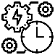 | What are the two main dribbling rules called?  Can you remember what they mean?
Teacher exposition  (I do) | Context: Dribbling is a very important fundamental of both offensive and defensive basketball. Offensively it is used to advance the ball in the back court, to make a drive-in to the basket, and to free oneself from close or congested defensive areas.  Use your fingertips. - Don't slap the ball with your palm - spread your fingers out so you can really feel the basketball  Keep your hand on top of the ball - This will give you more control as you change directions, as well as help you prevent carrying violations.  Keep the ball low. The ball should bounce somewhere between your knee and hip. This means that you will have to bend your knees. Ideally the ball will bounce as low to the ground as possible.  Keep your body between your defender and the ball - You can use the hand that isn't dribbling as an arm bar. Don't push the defender or commit another foul. Simply put your arm up near your body to maintain a little more space between you and the defender.  Look up. - When you first start dribbling, it is instinctive to look at the ball. However, it is important to practice looking at anything else.
Learning task (We do / you do)

Practice – dribbling and ball manipulation  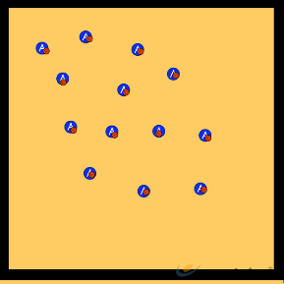  - All students have a basketball.  - Dribbling around an area focusing on the teaching points.  - Teacher to give different ball manipulation commands.  - Around ankles /waist / head  - Ball pounds  - Figure of 8  - Through the legs |  |  | Application – Pirates  - Students dribble around and try and protect their ball from being hit away by another student.  - All students can have a ball or a few students can be moving around without a ball as defenders.  To come back into the game students must dribble to an end basket and score a layup
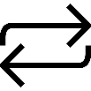  Responsive adaptations | Developing  Larger area for students to move in.  Less defenders | Securing  As above |  | Mastering  Students to use weaker hand when moving with the ball
Progress check questions | What are the main focus points for dribbling?  - Use pads of fingers (not palms).  - Bounce the ball to waist height  - Push ball in front of the body when running with the ball  - Protect the ball with the non-dribbling arm  Why should we dribble with the ball at waist height?  - Any higher and the ball could be taken off you by an opponent more easily  - Feel for the ball easily at waist height without having to look at the ball  How would you use dribbling within a game situation?  - When travelling with the ball  - When up the court with the ball moving into space  - When ‘driving’ with the ball up the court on a fast break
Errors or misconceptions to look out for | Student pushes the ball too far out to make contact on the bounce to continue the dribble - Start with dribbling in place, controlling the bounce and meeting it with your hand.  Student slaps at the ball at the top of the dribble. - Remember to have your hand low and feel for the ball as it comes back up off the floor.  Students watches the ball when dribbling. - Keep your head up and look occasionally for the rim.  Student dribbles too high or wide to control the ball when changing direction. - Practice dribbling at knee  height: stationary and then moving and changing direction.

Lesson 2 - Demonstrate how to protect the ball with a pivot.

Do now | If you stop dribbling how can you protect and keep the ball away from a defender?
Teacher exposition  (I do) | Pivoting  Context: Pivoting is an important part of offense. It helps a player avoid a defensive player and find an opening on the court to take a shot, make a pass, or dribble toward the basket.  Pivoting is moving only one foot.  The foot that stays planted on the floor is called your pivot foot. You can’t pick up your pivot foot once it is set. The other foot can be moved forward or backward.  Squeeze the ball and keep your elbows put to protect it.
Learning task (We do / you do)

Practice – protecting the ball  Protecting the ball (1) In two’s, ball each partners face each other and both dribble their ball on the spot, they must protect the ball with their other arm with elbow up and use the side of their body Play for 1 MIN try to touch your partners ball.  Protecting the ball (2) Half class put the ball away – show students how to squeeze the ball, elbows out. Partners try to slap the ball out of their partners hands. Swap over.  Protecting the ball with a pivot (3) Explain the importance of pivoting to protect the ball moving it high and low to keep the ball away from the defender use your body and keep elbows up. |  |  | Application – Pivot and drive  - Students form a line near the hoop.  - In turn, each player cuts to the foul line  - Receives a pass from the feeder  - Executes a front or reverse pivot around chair and drives to the basket for a layup or jump shot  - Next person in line rebounds the ball and passes out to the feeder.  Drill repeats
Responsive adaptations | Developing  No chair to pivot around | Securing  As above |  | Mastering  Use a live defender as the attacker receives the ball
Progress check questions | What are the main focus points for protecting the ball?  Why use a pivot within a game of basketball?  How can pivoting create more options when playing basketball?
Errors or misconceptions to look out for | Student doesn’t protect the ball during pivot – squeeze ball, encourage elbows out.  Not being able to pivot without traveling - A simple way to practice pivots is to dribble down the court and jump stop. After the jump stop, use two pivots to rotate 360 degrees back to where you started. Then, continue dribbling down the court.

Lesson 3 - Demonstrate a cross over and through the legs dribble to outwit an opponent in a 1 v 1.

Do now | What dribbling skills do you know that will help you beat an opponent in a 1v1?
Teacher exposition  (I do) | Context: 1 v 1’s are the most common and frequent tactical situation a player will find themselves in. 1 v 1 skills enable you to beat defenders and find your way to the basket to create basket scoring chances. Having a variety of 1 v 1 skills will help you to outwit your opponent regularly.
 | Cross over dribble  The crossover dribble is one of the most effective ways to maintain control of the ball against heavy pressure, or, while attempting to go by your man. It is the primary tool used by the point guard while travelling up the court under defensive pressure.  Place the ball in your right hand  While stepping forward with your right foot, move the ball—in one dribble—from your right to your left hand.  If done properly, your left foot should be hitting the floor just as the ball has reached your hand. Repeat this movement, beginning with the ball in your left hand. |  |  | Through legs dribble  Used when the defensive player is playing in such close proximity to you. The between the legs move, you are using your body as a natural shield against the defender allowing you to change both direction and speed.  Place the ball in your right hand. At the same time that you begin to dribble, step with your left foot, moving your leg at a 45 degree angle towards the left sideline—in other words, step in the direction of your left.  As your foot is about to touch the floor, guide the ball through the space that you’ve created between your feet. While this is happening, place your left hand behind you—your palm facing your back—ready to catch the ball after its passed through.
Learning task (We do / you do)

Practice – Isolated practice  Working across court students practice 1 v 1 skills around central cones  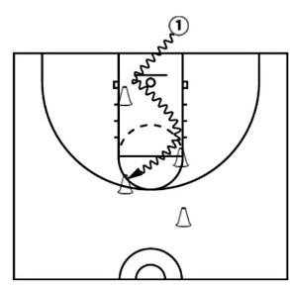  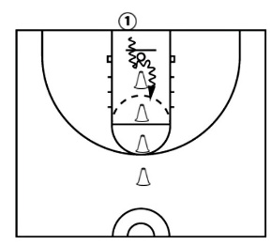  - Start with ball in the right hand and dribble at the cone crossing over from right to left at the first cone.  - As they dribble by the cone, take a big, quick step with the right leg to get the leg between the cone (defender) and the ball.  - Continue to the next cone and crossover left to right hand. |  |  | Application – 1 v 1  - Throw ball out with spin, jump stop and pivot  - Student 2 to close out  - 1 v 1 back to basket using cross over and through legs  Vary the starting angle to the basket
Responsive adaptations | Developing  To use dominant hand only  Cross over against passive defender | Securing  As above |  |  | Mastering  Students to perform any of the additional skills in the link below  https://www.usab.com/youth/news/2012/08/5crossover-dribbling-techniques.aspx
Progress check questions | What is meant by the term ‘cross over’?  What happens if you have your head down when performing these skills?  Why might the cross over be easier to intercept in front of your body than through the legs?  How else can you move the ball from one side of the body to the other?
Errors or misconceptions to look out for | The ball is stolen on the cross over – Student is dribbling too high on crossover, push the ball lower and keep body position low.  Carrying the ball – Hand needs to be at the side of the ball and not under it when making the crossover.  Loses control of the ball on crossover – Slapping the ball and not having the receiving hand ready.

Lesson 4 - Demonstrate correct defending techniques in a 1 v 1.

Do now | What would be an effective position to be in to defend well against an attacker?
Teacher exposition  (I do) | Context: Defense is required to prevent your opponents from creating basket scoring opportunities. A good defensive stance allows you to be ready to move in any direction, to contest shots, and to have active hands, ready to steal the ball, tip passes or simply make the offense work harder to do what they want to do.  Man-to-Man Defence - Defensive Stance and Focus  Weight should be on the balls of your feet (not your heels)  Feet should be about shoulder width apart.  Keep your knees bent and your back straight. Keep your head up, eyes forward, arms out with your palms up and elbows bent a little.  Watch the offensive player's belly-button, especially if he/she is quick and hard to stay with. The offensive player can fake you with a head fake, eye fake, arm or shoulder fake, or a jab-step, but the belly-button will always go only in the direction that he/she is going.
Learning task (We do / you do)

Practice – Defensive specialist  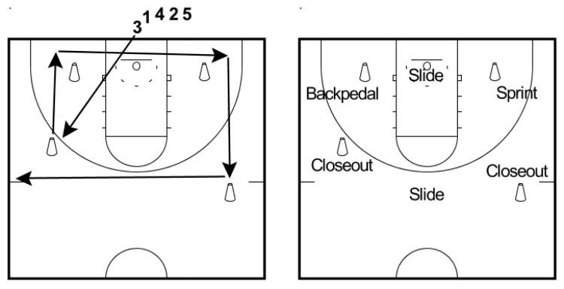  This practice will familiarise students with different defensive movement patterns.  Pass denial  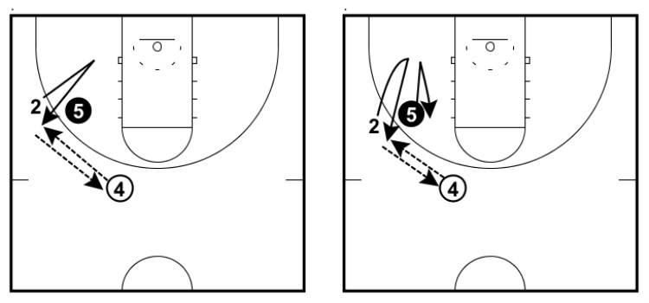  - The drill starts with the offensive player walking the defender in and exploding out looking to receive the pass from the player in the slot.  - Defence attempts to constantly deny the pass to the offensive player on the wing.  - The offensive player can perform a v-cuts and utilise changes of speed but must stay on the line between the wing and the basket.  - Each time the offensive player catches the basketball, they immediately pass back to the player in the slot and the drill continues.  - After the third catch, the players swap positions. |  |  | Application – Active defence “deflection game”  - 4 v 4  - Defending team will earn points or baskets for the following:  - Getting a hand on the offensive players pass or dribble to create a turnover.  - Stealing the ball in a passing lane  - Blocking an opponents shot
Responsive adaptations | Developing  Attacker to only make cutting movements on one side to make it easier for defender | Securing  As above |  | Mastering  Attacker can use cuts away from the wing  Defend in a 2 v 1 situation
Progress check questions | What is the difference between a close out and defensive slide?  Why is it important to stay low in a defensive position?  Why is having one hand high and one hand low effective?  How might your defensive stand change when playing basketball?
Errors or misconceptions to look out for | Student gets too close to a player who receives a pass, allowing them to drive past. - Form an imaginary triangle between student, the ball and the player student is defending, making sure student can see both the ball and the player.  When defending during a shot, defender fouls the shooter. - Remind student to keep arms straight up overhead and not reaching over.  The offensive ball handler moves around the defender. - Make sure defender is moving the feet and sliding to match their movement side to side and up and back.

Lesson 5 - Demonstrate how to ‘Cut’ to create space when not in possession.

Do now | In basketball what methods can you use to create space when you do not have the ball?  Are these methods similar to other sports?
Teacher exposition  (I do) | Context: Cutting does a number of things to cause havoc for a defense. It helps an offense get a player open. It also creates proper spacing - which in turns gives the offense enough room to operate properly. Cutting makes defenses pay attention to each player on the court as the offense make deliberate attacking movements.
 | V cut  V-cuts are the most common type of cut and are mostly used when on the perimeter in isolation when you need to get open for a pass.  V-cutting requires body-to-body contact by players.  They are executed by walking the defender a couple of feet inside the 3-point line, planting your foot, and then exploding out to receive the ball. | L – Cut  L-cuts are a great way to get open on the perimeter when starting on the block.  Take the defender up to the elbow, get your top foot over theirs, give a small nudge to create space, and lead directly out to the wing while calling for the ball. |  |  | Front cut  The front cut involves getting on the ball-side of your opponent.  Usually this is executed by performing a jab step or a small cut behind the defence to get them to move back. Once they do, you cut in front of them closest to the ball.
Learning task (We do / you do)

Practice – Cutting to shoot  - This activity will introduce students to cutting but also recap key shooting skills.  - Students (A) cut (V cut) to the first cone and pop back out to receive a pass from B  - A then squares up to the basket and shoots.  - Shooter gets rebound and becomes feeder  Cutting practice  In 3’s students practice the different cutting techniques below to create shooting opportunities  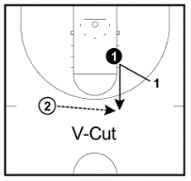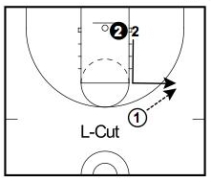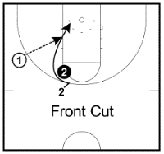 |  |  | Application – Active attack  - 4 v 4  Attacking team need to be constantly cutting to create space for their team mate on the ball.
Responsive adaptations | Developing  Students focus only on the V-cut | Securing  As above |  | Mastering  Students perform the front cut  Change the starting pass location
Progress check questions | What is meant by a “cut” from an opponent?  Why should you use different types of “cuts” in a game against an opponent?  How can you prevent an opponent reading your cut?
Errors or misconceptions to look out for | Defender reads the cut – not cutting hard enough away from the defender. Make sure the attacker takes the defender away.  Not making contact with defender - In trying to get open, go right up to the defender and make contact, then quickly "bounce off" in the direction of your cut. He won't be able to react fast enough to your quick first step.  Poor timing so cutting player is not ready for pass - A key in making an effective cut is timing. Try to time your cut, so you arrive at the correct time to receive the pass.

