Knowledge Rich Curriculum Plan
Year 10 GCSE Dance
Theory – A Linha Curva

 | Theory Unit: A Linha Curva
Lesson/Learning Sequence | Intended Knowledge:  Students will know that… | Tiered Vocabulary | Prior Knowledge:  In order to know this students, need to already know that… | Assessment
Lesson 1  Fact File, Opening Chant and Liris | -A Linha Curva is a professional dance work choreographed by Itzik Galili.  - The stimulus for the work is “The curved line” in Portuguese. The stimulus is also Brazilian culture and a sense of Brazilian life.  - The choreographic intent of the work is to have fun, the contradiction between straight lines and curved ones (as in the title), showing off (male competitiveness) and the men pursuing the women.  -There are 28 dancers, 15 male and 13 female.  -The dance is in a contemporary, samba and capoeira blended together.  -It is set on an end stage  For the section Opening Chant: 13 dancers stand with feet apart and arms down. They chant ‘Tum Tarakka Tum’ 3 times. They are answered by 7 kneeling dancers, who put their hands to the mouths and call ‘he he he’ in shrill voices.  For the section Liris: Liris is a fast unison septet facing upstage. This motif is named after the Brazilian dancer that created it – Liris. The motif shows Galili’s style perfectly – “everything out” with hyperextension and concave torso. 7 dancers stand downstage in a line. The whole motif is performed facing upstage. We are going to see this motif repeated in various ways later on in the dance.  Students will know how…  -To describe the set, lighting, costume, aural setting and the movements in the sections called ‘Opening Chant’ and ‘Liris’.  -How to analyse and critically appreciate the work answering the following questions;  - How does the lighting work with the costume in this section?  - How else is the lighting effective in this section?  - How might the chanting of ‘Tum Tarakka Tum’ support the choreographic intent and or the stimulus?  - How does the aural setting support the stimulus of Brazilian Culture?  - Why is the lighting effective?  - Why is there a raised platform on the stage?  - What is your interpretation of the physical setting? | See vocab below | Students need to already know that…  - That a stimulus is inspiration for an idea and movement.  - Choreographic intent is the aim of the dance; what the choreographer aims to communicate.  - What choreographic devices are e.g. repetition, contrast, manipulation of number, unison, canon, highlights and climax,  - Mood words such as tender, tense, sombre, isolated, foreboding, mysterious, secretive, hopeful, optimistic, lonely, isolated, suspenseful and confused.  Students need to already know how…  - How to analyze a professional work as they have previously learnt how to do this through Within Her Eyes and A Linha Curva. | End of unit test
Lesson 2:  Robson, Wagner and Big Square | For the sections Robson, Wagner and Big Square:  Robson is a fast phrase, swinging the arms over the head over a wide based in 2nd.  Robson’s phrase is a fast, energetic and lively 8 counts. The dancers stand in 2nd and constantly rise up to their toes and down again with each arm gesture. The arms swing over their heads to the left and back again, and then across the body to the right and back again. The motif repeats on a loop. The Robson motif returns again in section 5.  Students will know how…  -To recall the small chunks of information from the Fact File.  -Start to create links of how the features above link to stimulus and choreographic intention.  -To describe the lighting, aural setting, costume, movements, choreographic devices and relationships in ‘Robson’, ‘Wagner’ and Big Square’.  -How to analyse and critically appreciate the work answering the following questions;  - Is the costume gender specific and why?  - How does the costume support the stimulus of Brazilian Culture?  - Do you think the costume places the work in Brazil?  - How does the movement of Liris and Robson link to the stimulus and choreographic intent of the work?  - How do the costumes work with the lighting and the set?  - Why are the costumes easy to move in?  - What era do the costumes suggest and why?  - How does the raised platform support the stimulus of the work?  - How does the choreographic device you have named above effectively demonstrate the stimulus of Brazilian culture?  - Describe how the lighting and set work together?  - How does the set support the lighting? | See vocab below | Students need to already know that…  -A Linha Curva is a professional dance work choreographed by Itzik Galili.  - The stimulus for the work is “The curved line” in Portuguese. The stimulus is also Brazilian culture and a sense of Brazilian life.  -What choreographic devices are e.g. repetition, contrast, manipulation of number, unison, canon, highlights and climax.  -What relationships are e.g. Mirror image, complementary, contrast, contact, formations, accumulation, counterpoint, lead and follow and action reaction.  -Mood words such as tender, tense, sombre, isolated, foreboding, mysterious, secretive, hopeful, optimistic, lonely, isolated, suspenseful and confused.  Students need to already know how…  -How to analyse a professional work as they have previously learnt how to do this through Within Her Eyes and the first section of A Linha Curva. | End of unit test
Lesson 3:  Adage Septet | For the section Adage Septet  -Adage – A slow, fluid, rippling phrase for 7 girls. They perform this section in accumulation.  -The motif is almost in slow motion, fluid and extended in the arms, with moments of rippling torso. There are no counts for this section. The girls must use their sensitivity to each other to keep together.  -Later in the section, the motif is developed further again. The 7 dancers fall into different points of the motif creating contrast. At first it appears fragmented, but in fact it is a simultaneous canon.  -3 dancers start from the beginning in canon but face different directions, 2 dancers fall into the bounce first and 2 dancer’s start with the lunge at the end.  Males use the skateboards and propel themselves across the stage lying on their backs whilst the females hold their balance with low leg extension.  Students will know how…  -To describe the props, lighting, movement and accompaniment in ‘Adage Septet’.  -How to analyse and critically appreciate the work answering the following questions;  - The slow section for the 7 girls uses warm yellow squares of light for each dancer. What effect does this create?  - How does the aural setting support the stimulus of “the curved line”?  - Draw and label where adage septet is on the curved line.  - Circle any of the following words to describe the mood of the aural setting.  - Why are the skateboards effective? | See vocab below | Students need to already know that…  -The set, lighting, accompaniment and costume need to be described in detail.  -Props come under the feature of set.  -They need to think critically when analysing the sections of the work justifying why the production features are effective, demonstrate the stimulus and choreographic intent.  -How the movement correlates with the aural setting of the work.  -What choreographic devices are e.g. repetition, contrast, manipulation of number, unison, canon, highlights and climax.  -Mood words such as tender, tense, sombre, isolated, foreboding, mysterious, secretive, hopeful, optimistic, lonely, isolated, suspenseful and confused.  Students need to already know how…  -They need supporting evidence from the work to justify their analysis. | End of unit test
Lesson 4:  12 Mark Comparison Question on Costume | - In the exam they will need to be able to answer 6 and 12 mark questions on the production features, relationships, choreographic devices and movement of the work  - One of the 12 mark questions is comparing two works on one of the production features.  - KER is the technique used to answer all of the 6 and 12 mark questions in dance.  - KER stands for knowledge, example and relate back to the question.  - To recall the description and effectiveness of the costume for both ALC and WHE from the previously learnt sections, using images from the knowledge organiser as a prompt.  - To identify areas of their knowledge that they know least about.  To apply this information to a 12 mark exam style question on costume. | See vocab below | The descriptions of the costumes:  Within Her Eyes:  Female:  1. Cardigan (Prologue)  2. Beige thin, long sleeved shirt buttoned up to the top.  3. Beige skirt  4. Beige lycra shorts  5. No shoes  Male  1. Khaki Jumper  2. Khaki Jeans  3. Black shoes  The costumes are effective by:  1. Demonstrates the stimulus  2. Character  3. Gender  4. Supports the movement  5. Modern Era  6. Compliments the lighting  7. Compliments the set  8. Supports the narrative  9. Time of day  A Linha Curva  1. Black sleeveless tunic  2. Coloured Lycra shorts.  3. Girl’s tops are backless  4. Men’s open at front  5. Zip in the same colour as shorts  The costume is effective by:  1. Demonstrates the stimulus  2. Demonstrates the choreographic intent  3. Gender  4. Movement  5. Modern Era  6. Complements the lighting  7. Genre of dance  To answer exam style questions that are low in marks that have been used as a scaffold to support them in answering the 6 and 12 mark questions. This is through homework and questions in their booklet.  How to green pen their work. | End of unit test
Lesson 5:  Wagner Development, Showing Off and Showing Off Solo | For the section Wagner Development:  - This is a short transitional section leading into Showing Off. The girls from the septet exit leaving one girl behind.  - 5 men enter in canon with a large travelling jump, legs behind and arms wide in the air. They land in 2nd and hold the position for several seconds. Each dancer lands in one of these positions:  -With hands on ears - ‘hear no evil (x 2 dancers)  -With hands on eyes - ‘see no evil’  -With hands on mouth - ‘speak no evil’ (x 2 dancers, 1 with arm outstretched)  - As the section progresses the dancers repeat in a faster overlapping canon, the solo girl facing upstage, watching them.  Showing Off:  - This motif travels on a diagonal from upstage left to downstage right, where a solo girl stands. The men thrust their hips towards the girl as they move forwards and perform athletic leaps to show off their masculinity.  - This motif clearly shows the choreographic intention:  • The way the men stalk the girls.  • The way the men show off to the girls.  - The motif later repeats in a fragmented form, travelling from upstage right. We see the thrust action and the jump performed in counterpoint.  - The men perform an athletic travelling contact phrase, travelling from upstage left to downstage right on a diagonal. The phrase repeats 3 times with the men taking different roles in the contact each time.  - At any one time there is:  • 1 dancer bending over to support  • 1 dancer standing/balancing on his back  • 1 dancer supporting the standing dancer  • 1 dancer diving along the floor at their feet  • 1 dancer behind the group, preparing to run into the next balance  - After the 3 repetitions, 4 men group together and bend forwards whilst the 5th man runs from behind them, and launches himself over their heads in a rigid lying position. He lands in front of them, his hands protecting his fall, and rolls.  Showing off Solo:  - A huge change. For the 1st time, the grid is off. Now two high intensity floodlights stage left wash the stage with white light.  - A fluid, whirling travelling solo for a female dancer. This time it is the girl that flirts with the men.  - To describe the lighting, movement and accompaniment in ‘Wagner development’, ‘Showing Off’ and ‘Showing Off Solo’.  How to analyse and critically appreciate the work answering the following questions;  1. What did you hear in the aural setting that links to the choreographic intention of showing off?  2. How does the motif demonstrate the way the men stalk the women and show off?  3. Could the lighting suggest a time of day and why? | See vocab below | - The set, lighting, use of camera, accompaniment and costume need to be described in detail.  - They need to think critically when analysing the sections of the work justifying why the production features are effective, demonstrate the stimulus and choreographic intent.  - How to answer 6 and 12 mark questions. This will allow them to think actively about the K and E knowledge needed. | End of unit test
Lesson 6:  Robson and Liris Developments | Students will know that...  For the section Robson and Agade – Samba!:  - Two motifs return from sections 1 and 2, this time they are performed in counterpoint and accumulation. It is performed to the whistles and energetic rhythms of a samba in the accompaniment.  - The septet is now performed by a larger group and is performed to the opposite diagonal to the original version, now downstage right. The Robson dancers begin in a line upstage, travelling downstage. As they move past an adage dancer, the adage dancer joins in until everyone is dancing the Robson phrase in unison. A great example of accumulation.  Liris Repeat  - This is a repetition of the original Liris motif but this time facing the front.  Liris diagonal  - This is a repetition of the Liris motif in accumulation, contrasted with a solo in counterpoint.  Liris Accumulation:  - This section is a further development of the Liris motif and the way the same motif is treated with accumulation in Liris Diagonal.  - Key dynamics in this section are: fast, precise, grounded, weighted, release and strong.  Robson Unison  This is a repeat of the Robson motif from section 1 to end the piece.  -The section repeats Robson’s motif, the full company in unison facing upstage and travelling towards the musicians.  -The motif repeats 2.5 times – the final time breaking after the high wave, then running backwards.  -The dancers turn to face the audience and chant Tum Tarakka Tum three times, leaving one dancer stage left still enjoying the party with excited high jumps and kicks in a pale white light, as the rest of the lights fade.  - To describe the lighting, movement and accompaniment in ‘Robson and Adage – Samba, Liris repeat, Liris diagonal, Liris accumulation and Robson Unison.  - How to analyse and critically appreciate the work answering the following questions;  1. How does the relationship accumulation create a party atmosphere?  2. How is this last section effective in demonstrating the choreographic intention (Brazilian Culture and Life) and stimulus (To have fun)? | See vocab below | - They need supporting evidence from the work to justify their analysis.  - How to answer 6 and 12 mark questions. This will allow them to think actively about the K and E knowledge needed. | End of unit test
Lesson 7:  12 mark comparison question on physical setting | - In the exam they will need to be able to answer 6 and 12 mark questions on the production features, relationships, choreographic devices and movement of the work  -One of the 12 mark questions is comparing two works on one of the production features.  -KER is the technique used to answer all of the 6 and 12 mark questions in dance.  -KER stands for knowledge, example and relate back to the question.  - To recall the description and effectiveness of the physical setting for both ALC and WHE from the previously learnt sections, using images from the knowledge organiser as a prompt.  - To identify areas of their knowledge that they know least about.  - To apply this information to a 12 mark question:  Using your knowledge of the similarities and differences in the physical setting used in A Linha Curva and Within Her Eyes, discuss how the physical setting is used to enhance our appreciation of these two works. | See vocab below | The descriptions of the physical setting:  Within Her Eyes…  - Prologue  1. Deserted street.  2. Graveyard.  3. Overcast skies.  4. Raining in the graveyard.  - Beginning  1. A vast open field, long patches grass that sway in the wind and hills in the background with mist.  2. Barren cliff top with uninterrupted views.  3. Field – Overcast skies  4. Cliff – Overcast with patches of blue sky.  - Flow One  1. A dense forest.  2. Bright light is blocked by the dense trees.  3. Shafts of light come through the trees.  - Flow Two  1. Quarry  2. Cliff  3. Field  4. The lighting gradually gets darker.  Floor  1. Field  2. Very dark lighting.  - The physical setting is effective by:  1. The set compliments the lighting.  2. Demonstrates the stimulus.  3. Supports the aural setting: Wind sounds in the aural setting are amplified and match the outdoor location.  4. Mood – sombre, isolated, secretive and intimate.  5. Compliments the costume: Natural colours of the landscape blend with the neutral colours of the costumes.  6. Supports the narrative  7. Structures the work  8. Time of day  9. Compliments the costume  - A Linha Curva  1. End stage  2. Black dance floor  3. Raised platform for the musicians  4. Skateboards  5. 49 overhead lights timed on a grid  6. 7x7 covering the entire performance space  7. 2 large white spotlights - showing off.  - The physical setting is effective by:  1. Demonstrates the stimulus  2. Restricts Space  3. Highlights dancers  4. Structure  5. Time of day  6. Compliments the costume  7. Demonstrates choreographic intent  8. Moods – lively, happy, party-like and changes in the slow section to create a calmer mood.  9. Aural setting works closely with the lighting  10. Supports the lighting  11. Supports the movement  12. Supports the aural setting  - To answer exam style questions that are low in marks that have been used as a scaffold to support them in answering the 6 and 12 mark questions. This is through homework and questions in their booklet.  - How to green pen their work. | End of unit test
Lesson 8:  Test Green Pen | - They are now completing a test on everything that has been covered on A Linha Curva.  - They will have been supported in their revision, used the knowledge organisers and other techniques throughout the unit to recall knowledge of the work.  - To answer exam style questions between 1 and 6 marks on ALC.  To answer a 6 and 12 mark question using the KER structure. | See vocab below | - How to describe the set, lighting, accompaniment and costume.  - How to analyse and critically appreciate the work specially relating to; mood, choreographic intention, stimulus and effectiveness.  - To answer and structure a 12 mark question as they have answered one previously on costume and physical setting and through homework questions. | End of unit test
Lesson 9:  Test Green Pen | - They are now using green pen to correct or add to their test on everything that has been covered on A Linha Curva.  - They need to complete a SSS challenge on an area of their test that needs the most revision.  - Students will know how... -To answer exam style questions between 1 and 6 marks on ALC.  - To answer a 6 and 12 mark question using the KER structure.  - To green pen their work to highlight any misconceptions or errors in their work. | See vocab below | - How to describe the set, lighting, accompaniment and costume.  - How to analyse and critically appreciate the work specially relating to; mood, choreographic intention, stimulus and effectiveness.  - To answer and structure a 6 and 12 mark question as they have answered one previously in class and for homework about costume and physical setting. | SSS Assessment Point

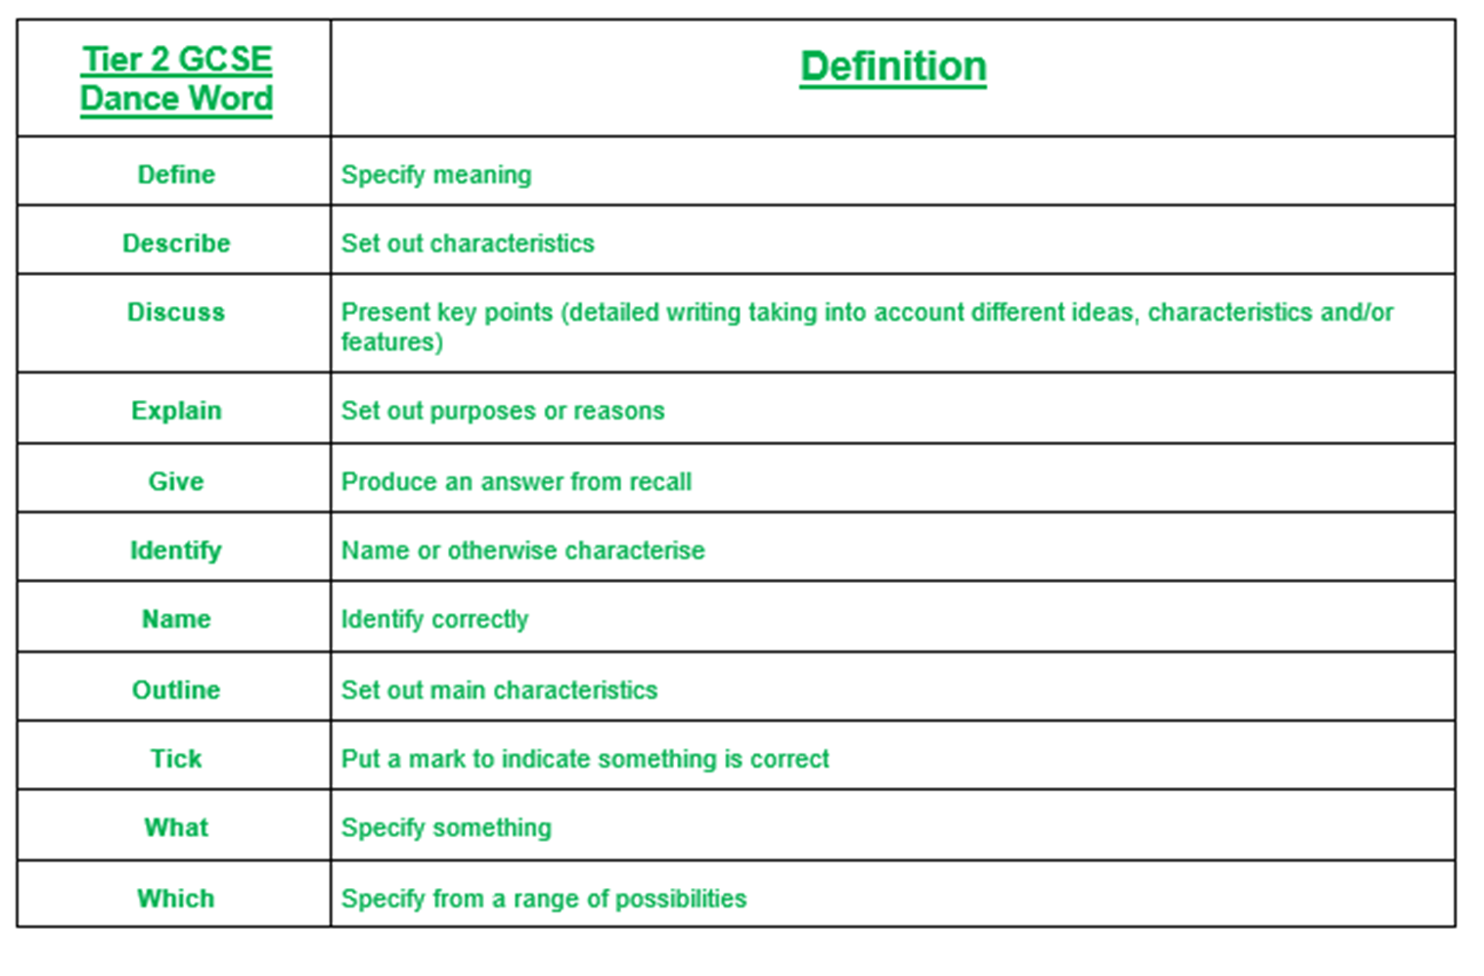

Tier 3 A Linha Curva Vocabulary
Abstract | Dance works without plot or character,
Accompaniment | The sound that you hear during a dance. For example, percussion.
Accumulation | When a dancer performs a series of movements and others join in at different times until all perform in unison.
Appreciation | Recognition and understanding of the qualities of dance.
Climax | The most significant moment of the dance.
Counterpoint | When dancers perform different phrases simultaneously
Critical Appreciation | Evaluation of dance based upon knowledge and understanding, including original insights
Carnival | An annual festival, typically involving processions, music and dancing.
Capoeira | - A system of physical discipline and movement originating among Brazilian slaves, treated as a martial art and dance form.
Development | The way in which movement material is manipulated.
End Stage | A performance space with the audience on one side; also known as ‘end-on’.
Formations | Shapes or patterns created in space by dancers
Improvisation | Exploration or generation of movements without planning.
Interpretation | Finding the meaning that is in the movement or finding the movement that is in the idea.
Manipulation of Number | How the number of dancers in a group is used.
Mysterious | Difficult or impossible to understand, explain, or identify.

