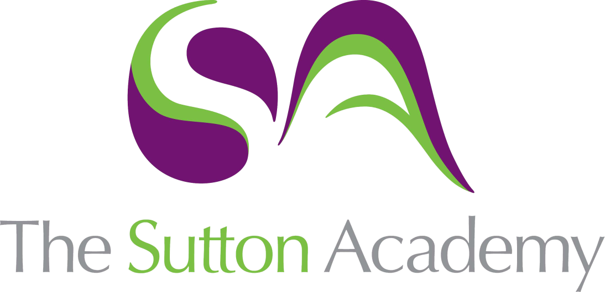

Knowledge Rich Curriculum Plan
Year 10 GCSE Dance
Theory – Shadows

 | Theory Unit: A Linha Curva
Lesson/Learning Sequence | Intended Knowledge:  Students will know that… | Tiered Vocabulary | Prior Knowledge:  In order to know this students, need to already know that… | Assessment
Lesson 1  Daughter’s Solo | - Shadows is a professional dance work choreographed by Christopher Bruce.  - The stimulus for the work is Arvo Part’s Fratres violin and piano.  - The choreographic intent of the work is Bruce invites the audience into the world of a small family, possibly set in Eastern Europe, coming to terms with deprivation, poverty, and the realities of what lies outside their intimate family home.  - There are 4 dancers, Mother, Father, Daughter and Son.  - The dance style is Modern dance techniques with an element of classical and contemporary dance.  - It is set on an end stage.  The piece opens with the four dancers sitting at the table upstage left. They turn their heads to stage right indicating that something/someone is there. The dancers focus returns towards each other. At this point the daughter’s solo begins.  Daughter’s Solo  The daughter begins her solo in close proximity to the table using it within the choreography. She then shifts away from the table towards centre stage, moving continuously and fluidly over numerous levels. The fast and frantic movement tells the audience that she is anxious and acts as a reminder that the family are living in fear. The daughter returns to the table to sit at her stool. The music changes immediately.  The daughter and son look towards each other before the daughter sits on the table, she turns and lies down with her back towards the audience.  How to analyze and critically appreciate the work answering the following questions;  - How might the set design suggest poverty and deprivation?  - What do the table and bench and two stools represent?  - Describe three key actions from the solo and outline how they communicate this character to the audience.  - Discuss the relationship between the aural accompaniment and movement content in the daughter’s solo.  - Describe the lighting at the start of the piece. | See vocab below | Students need to already know that…  - That a stimulus is inspiration for an idea and movement.  - Choreographic intent is the aim of the dance; what the choreographer aims to communicate.  - What choreographic devices are e.g. repetition, contrast, manipulation of number, unison, canon, highlights and climax,  - Mood words such as tender, tense, sombre, isolated, foreboding, mysterious, secretive, hopeful, optimistic, lonely, isolated, suspenseful and confused.  Students need to already know how…  - How to analyze a professional work as they have previously learnt how to do this through Within Her Eyes and A Linha Curva. | End of unit test
Lesson 2:  Mother, Father, Daughter Trio  Father/Mother Duet | Mother, Father, Daughter Trio  The daughter lying down on the table instigates the trio. The parents lift her and lower her gently to the floor. Gradually the three dancers move away from the table, as they do so there are numerous points of contact, insinuating that the parents are also worried but trying to reassure the daughter. The daughter is lifted and supported by both parents during the trio with tender moments between the characters. The parents walk upstage whilst the daughter is being carried by the father on his back.  The daughter then runs back towards the table to re-position herself beside the son.  Father / Mother Duet  The music changes and becomes much smoother as the violin plays. The mother and father begin their duet and through the movement the father is supporting the mother who is also displaying uncertainty. Within the duet there are moments of stillness between the couple. They remain in contact for the vast majority of the duet, and soon find themselves returning to their opening position for the duet facing the back in a crouched position.  The second part of the duet has a different feel; the music and faster and the father supports the mother as she steps on to the table. The mother remains on the table for a few seconds before engaging with the son and daughter briefly, before continuing the duet with the father. Towards the end of this section the mother places her head between the father’s shoulder blades; they have another encounter mimicking a “ballroom pose” before the father leaves the mother and stands facing towards the back of the stage.  How to analyse and critically appreciate the work answering the following questions;  - Compare and contrast the use of dynamics on the choreography between the mother and the daughter. How are the dynamics used to enhance the audience’s understanding of each character?  - Describe actions, space, dynamics and relationships from this section and how they help tell the narrative of this section. | See vocab below | - Shadows is a professional dance work choreographed by Christopher Bruce.  - The stimulus for the work is Arvo Part’s Fratres violin and piano.  - The choreographic intent of the work is Bruce invites the audience into the world of a small family, possibly set in Eastern Europe, coming to terms with deprivation, poverty, and the realities of what lies outside their intimate family home.  - There are 4 dancers, Mother, Father, Daughter and Son.  - The dance style is Modern dance techniques with an element of classical and contemporary dance.  - It is set on an end stage.  - What choreographic devices are e.g. repetition, contrast, manipulation of number, unison, canon, highlights and climax.  - What relationships are e.g. Mirror image, complementary, contrast, contact, formations, accumulation, counterpoint, lead and follow and action reaction.  - Mood words such as tender, tense, sombre, isolated, foreboding, mysterious, secretive, hopeful, optimistic, lonely, isolated, suspenseful and confused.  - How to analyse a professional work as they have previously learnt how to do this through Within Her Eyes and A Linha Curva. | End of unit test
Lesson 3:  Mother’s Solo  Son’s Solo | Mother’s Solo  The mother remains separate from her family as she glides across the stage, key moments within the solo suggest the anxiety she is feeling. Elbows bending inwardly towards the body, changing from a turned-out position in “full plies” to a parallel position, all help to indicate this. Generally, her movement is softer as she is portraying a more maternal character. At the end of her solo she joins the father and with her hand on his left shoulder they crouch down for a third time.  How to analyze and critically appreciate the work answering the following questions;  - Discuss the relationship between the aural accompaniment and movement content in the mother’s solo.  - What effect might the mid intensity, white side lighting achieve?  - In this section, describe how the use of props adds to the mood of this section of the work. What does the Son do with the furniture?  - Discuss how the lighting is used and how it impacts upon the movement content in the son’s solo.  - What is the significance of the upstage left and downstage right areas of the stage?  - What might the shaft of light represent? | See vocab below | - The set, lighting, accompaniment and costume need to be described in detail.  - Props come under the feature of set.  - They need to think critically when analysing the sections of the work justifying why the production features are effective, demonstrate the stimulus and choreographic intent.  - How the movement correlates with the aural setting of the work.  - What choreographic devices are e.g. repetition, contrast, manipulation of number, unison, canon, highlights and climax.  - Mood words such as tender, tense, sombre, isolated, foreboding, mysterious, secretive, hopeful, optimistic, lonely, isolated, suspenseful and confused.  - They need supporting evidence from the work to justify their analysis. | End of unit test
Lesson 4:  6 Mark Question on props | - In the exam they will need to be able to answer 6 and 12 mark questions on the production features, relationships, choreographic devices and movement of the work  - One of the 12 mark questions is comparing two works on one of the production features.  - KER is the technique used to answer all of the 6 and 12 mark questions in dance.  - KER stands for knowledge, example and relate back to the question.  - To identify areas of their knowledge that they know least about.  To apply this information to a 6-mark exam style question on props. | See vocab below | The descriptions of the props:  - Wooden Table  - Wooden Bench  - Two wooden stools  - A coat stand  - 3 suitcases and a bundle.  How the props are used in the dance:  - Table and stools – links to the stimulus of them being a family and aids the narrative.  - Minimal furniture, wooden and basic – suggests the family living in poverty and a sombre mood.  - The table is dragged towards the door, tipped over and used as a barricade. The son then hides behind it. The stools are used as a weapon.  - The coat stand suggests a bygone era.  - The table helps the movements. It is used to create levels when the dancers stand on or lie on it.  To answer exam style questions that are low in marks that have been used as a scaffold to support them in answering the 6 and 12 mark questions. This is through homework and questions in their booklet.  How to green pen their work. | End of unit test
Lesson 5:  Father / Son duet  Quartet  Final Section | Father / Son duet  The father and son remain downstage whilst the mother and daughter move the table back to its original position. Within the duet we can see that the father is trying to alleviate the tension that the son is feeling; he is trying to comfort him. There are moments when the two male dancers break away, both physically doing the same movement before returning to each other – the father taking the sons weight, supporting him to the ground.  Quartet  The penultimate section sees all of the dancers away from the table, there are two sets of duets seen on stage (father /son and mother/daughter). The material they perform is the same but facing opposite directions.  These duets then break up to form a brief trio (mother/father/ daughter), before moving into a different makeup of duets (son/daughter and mother/father) performing complementary actions.  The parents observe their children from stage right before returning to the table. The son and daughter momentarily and then join them. All the dancers are now back at the table in the opening position.  The dancers repeat the look over towards stage left before the mother stands up.  Final Section  The mother makes her way cautiously towards the coat stand, glancing back at the family as she does this. She slowly continues to walk and picks up the son’s oversized coat; she helps him to put it on, before repeating this with the daughter. The father then joins the family whilst they put on shoes and hats, exchanging worried looks at one another. All dancers then pick up a piece of luggage before slowly walking downstage into the light before the piece concludes in darkness.  How to analyze and critically appreciate the work answering the following questions;  - Describe what is meant by the term narrative.  - Discuss how narrative is used in Shadows. What impact does this have on the audience’s understanding of the work.  - Describe the climax in Shadows.  - Why is the climax described above effective?  - What might be the significance of each family member having one suitcase each?  - How is this motif developed in the work?  - What costumes do the dancers put on at the end of the piece?  - Outline how the choice of costumes enhances the audiences understanding of the work, in particular reference to narrative setting and the use of characters on stage.  - At the end of the piece, the lighting drops in intensity until the family are just silhouettes. What effect does this create?  - The music is very quiet, solemn and slow at the end. How might this make the audience feel? | See vocab below | - The set, lighting, use of camera, accompaniment and costume need to be described in detail.  - They need to think critically when analysing the sections of the work justifying why the production features are effective, demonstrate the stimulus and choreographic intent.  - How to answer 6 and 12 mark questions. This will allow them to think actively about the K,E,R knowledge needed. | End of unit test
Lesson 6:  12 mark comparison question on costume | - In the exam they will need to be able to answer 6 and 12 mark questions on the production features, relationships, choreographic devices and movement of the work.  - One of the 12 mark questions is comparing two works on one of the production features.  - KER is the technique used to answer all of the 6 and 12 mark questions in dance.  - KER stands for knowledge, example and relate back to the question.  - To recall the description and effectiveness of the costume for both ALC and Shadows from the previously learnt sections, using images from the knowledge organiser as a prompt.  - To identify areas of their knowledge that they know least about.  - To apply this information to a 12 mark question:  Using your knowledge of the similarities and differences in the costume used in A Linha Curva and Shadows, discuss how the costume is used to enhance our appreciation of these two works. | See vocab below | The descriptions of the Costume  Shadows description:  Mother  - Hair is in a low bun.  - Pink, grey and white short sleeved floral dress. The dress is gathered in at the waist and has puffy sleeves. There is white buttons from the top the waist.  - Bare feet.  Father  - Tucked in, collarless, off-white shirt, with brown stripes and rolled up sleeves. The shirt is open to the chest.  - Brown waistcoat.  - Light grey trousers  - Bare feet.  Daughter  - Hair half up and then in a low ponytail  - Short sleeved off-white shirt with ruffles at the front.  - Light grey, knee length A-line skirt  - Bare feet.  Son  - Collarless off-white shirt with rolled up sleeves that is not tucked in. The shirt is open to the chest.  - Dark grey trousers  - Bare feet.  The costume is effective by:  - Mother wears a floral V neck dress which is long and loose at the bottom. Her costume suggests she is softer and a maternal figure.  - Father wears a beige pinstriped shirt with rolled up sleeves. He also wears a dark grey waistcoat and trousers. The costume suggests his fatherly role with his neatly tucked in shirt.  - The family wears over-sized coats at the end suggesting that they are living in hardship (possibly hand-me-downs)  - Significance – Suggests an era. Mothers dress is a floral design and flares out at the bottom.  - The costume is gender specific – each person has a character within the piece and their costume shows that.  - Status – The colours of the fabric are faded and the cotton suggests low status.  A Linha Curva costume description:  - Black sleeveless tunic  - Coloured Lycra shorts.  - Girl’s tops are backless  - Men’s open at front  - Zip in the same colour as shorts  The costume is effective by:  - Demonstrates the stimulus  - Demonstrates the choreographic intent  - Gender  - Movement  - Modern Era  - Complements the lighting  - Genre of dance  To answer exam style questions that are low in marks that have been used as a scaffold to support them in answering the 6 and 12 mark questions. This is through homework and questions in their booklet.  How to green pen their work. | End of unit test
Lesson 7:  Test Green Pen | - They are now completing a test on everything that has been covered on Shadows.  - They will have been supported in their revision, used the knowledge organisers and other techniques throughout the unit to recall knowledge of the work.  - To answer exam style questions between 1 and 6 marks on Shadows.  To answer a 6 and 12 mark question using the KER structure. | See vocab below | - How to describe the set, lighting, accompaniment and costume.  - How to analyse and critically appreciate the work specially relating to; mood, choreographic intention, stimulus and effectiveness.  - To answer and structure a 12 mark question as they have answered one previously on costume and physical setting and through homework questions. | End of unit test
Lesson 8:  Test Green Pen | - They are now using green pen to correct or add to their test on everything that has been covered on Shadows.  - They need to complete a SSS challenge on an area of their test that needs the most revision.  - Students will know how... -To answer exam style questions between 1 and 6 marks on Shadows.  - To answer a 6 and 12 mark question using the KER structure.  - To green pen their work to highlight any misconceptions or errors in their work. | See vocab below | - How to describe the set, lighting, accompaniment and costume.  - How to analyse and critically appreciate the work specially relating to; mood, choreographic intention, stimulus and effectiveness.  - To answer and structure a 6 and 12 mark question as they have answered one previously in class and for homework about costume and props. | SSS Assessment Point

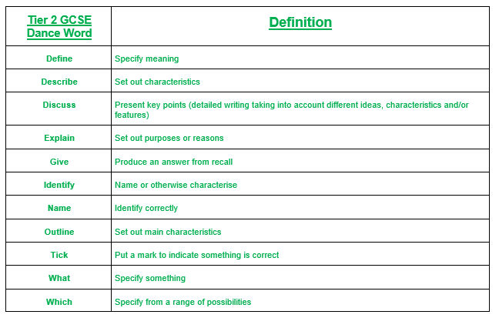

Tier 3 Shadows Vocabulary

Anxious | Feeling or showing worry, nervousness, or unease about something with an uncertain outcome.
Deprivation | An absence or too little of something important.
Distressed | Suffering from extreme anxiety, sorrow, or pain.
Frantic | - Distraught with fear, anxiety, or other emotion  - Conducted in a hurried, excited, and disorganized way
Fear | An unpleasant emotion caused by the threat of danger, pain, or harm.
Intimate | Private and personal.
Minor key | A less jubilant or more restrained mood, atmosphere, or quality.
Minimal | A very small in amount.
Narrative | Dance that tells a story.
Poverty | The state of being extremely poor.
Pathways | Designs traced in space (on the floor or in the air).
Prop | A portable object that is used in a dance, for example a suitcase.
Solemn | Serious and without any humour.

