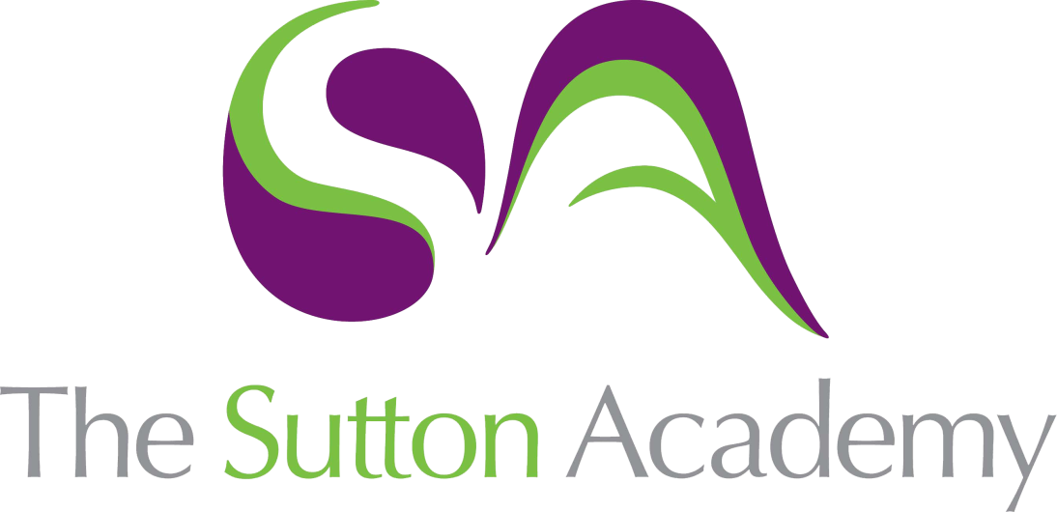

Knowledge Rich Curriculum Plan
Year 9 Music – Unit 1 – Dance Music‘’

Lesson/Learning Sequence | Intended Knowledge:  Students will know that… | Tiered Vocabulary | Prior Knowledge:  In order to know this students, need to already know that… | Assessment
Lesson 1  Line Dancing  (Country and Western music) | * American Line Dance developed from the Contra Dance from New England (which was influenced by English and French folk dances).  * The style of music is most commonly associated with American Line Dancing is Country and Western music.  * Instruments that are typical of American Line Dancing music are Violin, Guitar, Steel guitar, Banjo, Harmonica, Accordion, Drum kit  *Some typical musical features of American Line Dancing music are 4/4 time signature, accents on the 1st and 3rd beats of the bar, two or three chords often chords I and V, regular four-bar phrases, simple verse/chorus structure, steady crotchet movement in the bassline, use of slides in the accompaniment and melody, nasal timbre in vocals, single melody line often harmonised by backing singers.  Students are introduced to Country and Western/Line Dancing music through the music of Billy Ray Cyrus, The Carter Family, Saturday Night Fever. Students are introduced to and questioned on the most typical features of Country and Western Music. | Country and Western music, Contra Dance, folk dance,Line Dancing, violin, banjo, fiddle, steel guitar, harmonica, Drum Kit, accordion, time signature, accent, harmony, chords, nasal timbre, harmonised, accompaniment, single melody line, backing singers. | There exists a genre of music known as country and western. Popular music is built on harmony (they have performed using chords previously. Students have studied time signatures. | Informal cold-calling questions to check understanding.  Retrieval task one set.
Lesson 2  The Tango | * The Tango developed in Argentina in late 19th century. African slaves brought their music and dance to Argentina from 1588. It grew out of the slums of Buonas Aires.  * The tango dance is dramatic and sensuous, it is a paired dance that features serious expressions and quick jerky movements.  * Six instruments that are typical of Tango Music are the bandoneon, violin, cello, double bass, acoustic guitar, piano.  * Typical musical features of Tango music are the 2/4 or 4/4 time signature, often minor tonality, melody and accompaniment texture (homophonic), uses mainly primary chords (I, IV and V).  Students are introduced to the Argentine Tango through various musical examples and video clips. They learn the basic features of both Tango music and Tango dancing. | Country and Western music, Contra Dance, folk dance,Line Dancing, violin, banjo, fiddle, steel guitar, harmonica, Drum Kit, accordion, time signature, accent, harmony, chords, nasal timbre, harmonised, accompaniment, single melody line, backing singers, melody and accompaniment, homophonic, dramatic, sensuous, bandoneon, Buones Aires. | Students have prior listening and appraising experience and have much experience applying their theoretical knowledge to the new pieces of music they hear. | Retrieval task one completed  Retrieval task two set.
Lesson 3  (Club Dance Music) | - The style that began the Club Dance movement was House music. It was influenced by Disco music.  - Music technology is generally used to create Club Dance music.  - Six different styles of club dance music are House, Techno, Jungle, Drum and Bass, UK Garage, Trance, Ambient.  - Four different techniques used by DJs and producers when making dance tracks are Mixing, Scratching, Looping, Digital Effects, Quantising, Sequencing.  Students learn about a variety of Club Dance music styles including House, Techno, Jungle, Drum and Bass, UK Garage, Trance, Ambient. Through a variety of audio examples they gain an understanding of the origins and the development of electronic club music. | Country and Western music, Contra Dance, folk dance,Line Dancing, violin, banjo, fiddle, steel guitar, harmonica, Drum Kit, accordion, time signature, accent, harmony, chords, nasal timbre, harmonised, accompaniment, single melody line, backing singers, melody and accompaniment, homophonic, dramatic, sensuous, bandoneon, Buones Aires, House, Techno, Jungle, Drum and Bass, UK Garage, Trance, Ambient, Mixing, Scratching, Looping, Digital Effects, Quantising, Sequencing, disco | Students have prior listening and appraising experience and have much experience applying their theoretical knowledge to the new pieces of music they hear. | Retrieval task two completed  Retrieval task three set.
Lesson 4  Listening to and performing club dance music. | - Club dance music can be composed of riffs, verses, rap/mc sections, call and response sections, vocal chants.  - Students will improve their reading skills by following along with simple notated riffs. Students will learn how typical club dance tracks can be structured through a listening activity (No Limit by 2 Unlimited).  - Students will learn a simple club dance riff using the keyboards and staff notated music. They will select an appropriate timbre and learn to play the riff with a backing track.  Students will learn how club dance tracks are typically structured and will learn to play a club dance riff on the keyboard making appropriate use of music technology. | Country and Western music, Contra Dance, folk dance,Line Dancing, violin, banjo, fiddle, steel guitar, harmonica, Drum Kit, accordion, time signature, accent, harmony, chords, nasal timbre, harmonised, accompaniment, single melody line, backing singers, melody and accompaniment, homophonic, dramatic, sensuous, bandoneon, Buones Aires, House, Techno, Jungle, Drum and Bass, UK Garage, Trance, Ambient, Mixing, Scratching, Looping, Digital Effects, Quantising, Sequencing, disco | Students have prior keyboard experience and have previously played along to backing tracks. | Retrieval task three completed.
Lesson 5  Disco | - Disco appeared in 1970’s as an individual, IMPROVISED DANCE in clubs from a mix of jazz, funk and soul.  - SIMPLE QUADRUPLE METRE (4/4)  - FAST TEMPO (around 120 BPM)  - FOUR-ON-THE-FLOOR RHYTHM (see E.)  - SYNCOPATED bass line parts.  - Simple CHORD PATTERNS using CHORDS I and V and SEVENTH CHORDS.  - POPULAR SONG FORM with a strong GROOVE (long repeated rhythm section) and fade out endings, and catchy HOOKS/RIFFS.  - GUITARS, VOCALS, DRUMS, STRING/BRASS SOUNDS, SYNTHESISERS, SAMPLES.  Through listening work students will become familiar with the basic features of 1970s Disco music.  Students will continue using the keyboards to learn club dance riffs. | Country and Western music, Contra Dance, folk dance,Line Dancing, violin, banjo, fiddle, steel guitar, harmonica, Drum Kit, accordion, time signature, accent, harmony, chords, nasal timbre, harmonised, accompaniment, single melody line, backing singers, melody and accompaniment, homophonic, dramatic, sensuous, bandoneon, Buones Aires, House, Techno, Jungle, Drum and Bass, UK Garage, Trance, Ambient, Mixing, Scratching, Looping, Digital Effects, Quantising, Sequencing, disco | Students have prior listening and appraising experience and have much experience applying their theoretical knowledge to the new pieces of music they hear. | Ongoing teacher assessment of practical work on keyboards.
Lesson 6 – Written Assessment | Students are assessed on their understanding of all key terms/vocabulary and core concepts from this unit.  - Country and Western music, Contra Dance, folk dance,Line Dancing, violin, banjo, fiddle, steel guitar, harmonica, Drum Kit, accordion, time signature, accent, harmony, chords, nasal timbre, harmonised, accompaniment, single melody line, backing singers, melody and accompaniment, homophonic, dramatic, sensuous, bandoneon, Buones Aires, House, Techno, Jungle, Drum and Bass, UK Garage, Trance, Ambient, Mixing, Scratching, Looping, Digital Effects, Quantising, Sequencing, disco. | Country and Western music, Contra Dance, folk dance,Line Dancing, violin, banjo, fiddle, steel guitar, harmonica, Drum Kit, accordion, time signature, accent, harmony, chords, nasal timbre, harmonised, accompaniment, single melody line, backing singers, melody and accompaniment, homophonic, dramatic, sensuous, bandoneon, Buones Aires, House, Techno, Jungle, Drum and Bass, UK Garage, Trance, Ambient, Mixing, Scratching, Looping, Digital Effects, Quantising, Sequencing, disco | Students have completed end of unit assessments in Year 7 and 8 and should have used Classcharts for revision purposes. | End of unit assessment.

