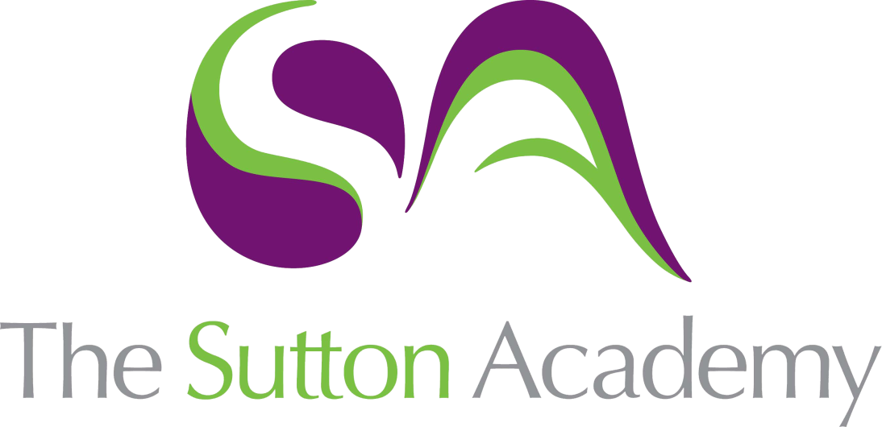

Knowledge Rich Curriculum Plan
SCIENCE- Key Skills

Lesson/Learning Sequence | Intended Knowledge:  Students will know that… | Prior Knowledge:  In order to know this, students need to already know that… | Working Scientifically | Tiered Vocabulary and Reading Activity | Assessment | Support
Converting Units | Students will be able to state the units for distance (metres), time (seconds), mass (g), volume (cm^3) , energy (joules), power (watt) and temperature (degree celsius). State how to convert units for the above. milli is x10^3, centi x 10^2 Kilo x10^3. Students will be able to apply their knowledge and consolidate their conversion skills | Student may have knowledge of the correct units of temperature, time and mass. Students may have had experience doing simple unit conversions for example cm into m. Students will already be able to understand and use measures from their KS2 maths curriculum |  | Volume- The amount of space occupied by a substance.  Conversion- The act of changing from one form, unit, or state to another.  Energy- The ability to do work.  Kilo- 1000  Milli- one thousandth  Centi- one hundredth | Retrieval questions  Simple exam questions  Baseline assessment  Summative assessment 1 | https://www.bbc.co.uk/bitesize/guides/zthsgk7/revision/3#:~:text=To%20convert%20a%20smaller%20unit,to%20a%20larger%20one%2C%20divide.  Knowledge organiser (provided on Teams and in class)
Identifying Variables | Students will be able to state what is meant by independent variable as the thing that is changed in the practical experiment. They will know that the dependent variable is what is being measured and the control variable is what stays the same. Students will be able to identify variables in a range of different scenarios. For example; how the amount of sunlight effects the size of the leaves on the tree. | - Students will be able to perform simple tests, identify what is being changed in the test and what is being kept the same. |  | The independent variable, is what is being changed in the practical experiment.  Dependent variable is what is being measured in the experiment.  The control variable is what is being kept the same. | Retrieval questions  Simple exam questions  Baseline assessment  Summative assessment 1 | Knowledge organiser (provided on Teams and in class)  https://www.bbc.co.uk/bitesize/topics/zsg6m39/articles/zyc9r2p
Interpreting Graphs | Students will be able identify the y axis as the vertical line on the graph and the x axis to be the horizontal line of the graph. Students will be able to label to axis titles correctly, with the independent variable on the x axis and the dependent variable on the y. Students will be able to state what is meant by 'trend' a general direction in which something is developing or changing. Students will be able to state and describe conclusions from a graph, for example if it is increasing, decreasing or staying the same as the variables are being changed. | Students will already be able to make generalisations about the relationships between data. Students will already be able to define independent, dependent and control variables |  | Y axis is the vertical axis where the dependent variable is placed.  X axis is the horizontal axis where the independent is placed.  Trend- pattern in data.  Relationship- trend between the two variables.  Line of best fit- a straight or curved line that is placed near to or through the points on a graph to show the trend within the data.  Increasing- greater.  Decreasing- smaller. | Retrieval questions  Simple exam questions  Baseline assessment  Summative assessment 1 | Knowledge organiser (provided on Teams and in class)  https://www.youtube.com/watch?v=8FVM2JGfoMQ
Working Scientifically | Students will be able to define accuracy to be how close a measurement is to the true or accepted value and precision to be how close measurements of the same item are to each other. Students will be able to define anomaly to be something that deviates from what is standard, normal, or expected. Students will be able to recognise whether diagrams are accurate, precise or both. Students will be able to calculate the mean to be the sum of the data sets divided by the amount of data sets. Students will know not to include the anomalous results when calculating the mean. | Students will be able to calculate the mean from KS2 Maths. Students will be able to recognise the key words but not their context. |  | Anomaly something that deviates from what is standard, normal, or expected.  Deviates-To move away from the standard  Sum- add up.  Accurate-Accuracy refers to how close a measurement is to the true or accepted value.  Precise- Precision refers to how close measurements are to each other.  Mean- The mean is the total of the numbers divided by how many numbers there are. | Retrieval questions  Simple exam questions  Baseline assessment  Summative assessment 1 | Knowledge organiser (provided on Teams and in class)  https://www.bbc.co.uk/bitesize/topics/zsg6m39
Drawing Tables | Students will be able to draw a good results table, with the independent variable and units going on the top left-hand side, the dependent variable and units to be on the top right-hand side. Students will know that the data should be presented downwards and not include units. | Students will know the definitions of independent, dependent and control variables. Students will be able to state the units for temperature, volume, mass and time from prior KS3 lessons. |  | SI Units- the metric system that is used universally as a standard for measurements.  Patterns- A repetition .  Summarise- a brief statement of the main points of something.  Comparison- a consideration or estimate of the similarities or dissimilarities between two things or people. | Retrieval questions  Simple exam questions  Baseline assessment  Summative assessment 1 | Knowledge organiser (provided on Teams and in class)  https://www.youtube.com/watch?v=uTNqOK3fnC0

