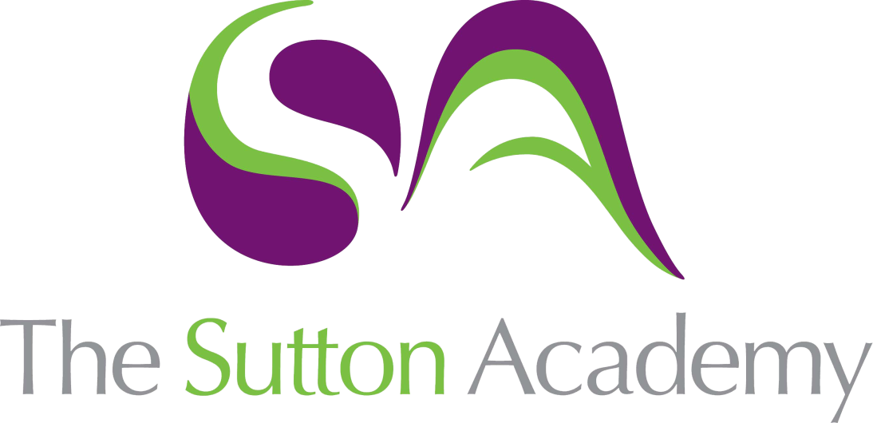

Knowledge Rich Curriculum Plan
Year 11 Term 2

Year 11
Art
Lesson/Learning Sequence | Intended Knowledge:  Students will know that… | Tiered Vocabulary | Prior Knowledge:  In order to know this students, need to already know that… | Assessment
Lesson:  Introduction of Exam  Reading Activity | - Students will know how to share ideas and brainstorm the exam questions and themes.  - Students will know how to interpret one word in numerous ways to gain understanding and exploration. | Creative Mind Map: A creative mind map is a diagram with words and illustration used to visually organize information into a hierarchy, showing relationships among pieces of the whole. | - Students need to already know how to brainstorm ideas and themes.
Lesson:  Research  Reading Activity | - Students will know how to research into themes and ideas.  - Students will know how to sources relevant research and knowledge surrounding their themes.  - Students will produce a mind map and mood board to present their initial thoughts and ideas on their chosen theme. | Contextual Understanding: Develop ideas through investigations, demonstrating critical understanding of sources.  Coherent research: logically or aesthetically ordered or integrated. | - Students need to already know how to brainstorm ideas and themes.  - Students will know how to research around their themes.
Lesson:  Primary and Secondary research. | - Students will know how to draw upon primary research to inform their thoughts and ideas.  - Students will know how to draw in a range of ways, e.g. Continuous line, contour, layering, tonal drawing.  - Students will know how to experiment with a range of materials when drawing from their primary research. | Primary Research: primary sources are usually considered to be items like personal letters, diaries, records or other documents created during the period under study. But primary sources can also include photographs, jewellery, works of art, architecture, literature, music, clothing, and other artefacts.  Secondary Research: A resource that discusses a previously created artwork or monument or prior period/event from an academic or research or layperson perspective.  Sustained: Continuing for an extended period or without interruption. | - Students need to already know how to draw from first hand observation.  - Students will know how to take a set of photos or create a still life to draw from.
Lesson:  Primary and Secondary research. | - Students will know how to draw upon primary research to inform their thoughts and ideas.  - Students will know how to draw in a range of ways, e.g. Continuous line, contour, layering, tonal drawing.  - Students will know how to experiment with a range of materials when drawing from their primary research. | Highly Relevant: Something that is relevant to a situation or person is important or significant in that situation or to that person.  Extensive research: A large and broad amount of research carried out from various sources.  Coherent research: Coherence is the quality by which we can tell that there is some sort of deliberate and meaningful and intelligent purpose behind the form of a thing. | - Students need to already know how to draw from first hand observation.  - Students will know how to take a set of photos or create a still life to draw from.
Lesson:  Artist research  Reading Activity | - Students will know how to research and source artists relevant to their theme or ideas.  - Students will know what inspires the artists, designer or crafts person to create their work.  - Students will know how to write about the artist’s work and explain how they will use the work of others to inform their own ideas. | Rigorous: extremely thorough and careful.  Critical Analysis: responding to, interpreting meaning, and making critical judgments about specific works of art. | - Students need to already know how to research artists.  - Students will know how to write about the work of other.
Lesson:  Artist copies and interpretations | - Students will know how to work in the way of the artists through application of materials.  - Students will create a range of copies to consolidate their knowledge and understanding of the artist.  - Students will know how to use the artist style in their work and their own drawings. | Consolidate: make (something) physically stronger or more solid.  Interpretation: the action of explaining the meaning of something. | - Students need to already know how to about the artist work and the use of materials.  - Students will know how to interpret the work of others.
Lesson:  Experimentation. | - Students will know how to explore a range of materials, techniques and processes. e.g. clay, print, paint, 2D and 3D etc.  - Students will know how to explore colour experiments and processes.  - Students will know how to carefully select successful experiments.  - Students will know how to record their thoughts and ideas. | Creative Making: Refine work by exploring ideas, selecting and experimenting with appropriate media, materials, techniques and processes. | - Students need to already know how to explore a range of different media.  - Students will know how to experiment with different colours.
Lesson:  Development and refinement. | - Students will know how to develop successful experiments through exploring compositions, colour schemes, mediums etc.  - Students will know how to create development pages to show clarity and personal journey in their work.  - Students will know how to carefully select successful developments and refine ideas further through practice of materials, techniques and processes.  - Students will know how to record their thoughts and ideas. | Refinement: the process of removing impurities or unwanted elements from something. | - Students need to already know how to compare and contrast ideas.  - Students will know how to annotate their work and thought processes.
Lesson:  Design Ideas. | - Students will know how to reflect on their journey and create a set of design ideas for their final 10-hour exam.  - Students will know how to test materials and explore compositions.  - Students will know how to label and annotate ideas and thought processes.  - Students will know how to clear connections between the artist work and their personal journey.  - Student will know how to plan and prepare their resources and order for their 10-hour exam. | Design Ideas: a method of human expression that follows a system of highly developed procedures in order to imbue objects, performances, and experiences with significance. Like all art forms, design has the potential to solve problems | - Students need to draw upon their development and experimentation work.  - Students will know how to annotate their work and thought processes.  - Students will know how to plan and prepare for their final piece.
Lesson:  10-hour exam and evaluation. | - Students will know how to carry out their 10-hour exam successfully.  - Students will know how to use all their learning and reflection to complete an imaginative and personal final piece.  - Students will know how to evaluation their work and reflect on the strengths and weaknesses of their project.  - Students will know how to clear connections between the artist work and their personal journey. |  | - Students need to have carefully planned and prepared their final 10-hour piece.  - Students will know how to reflect and evaluate their work.

