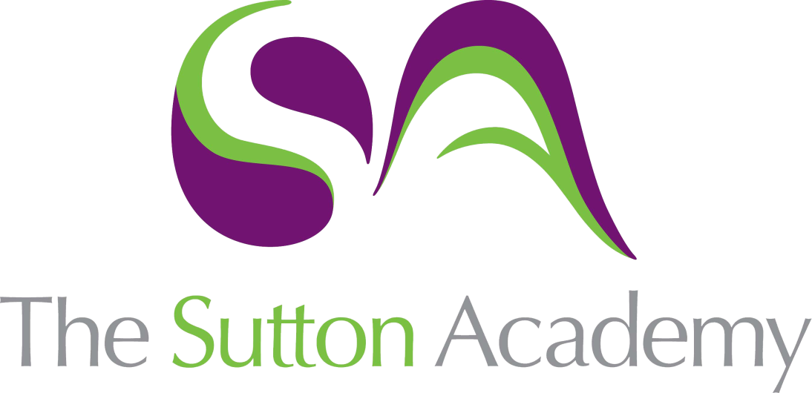

Knowledge Rich Curriculum Plan
Year 9: Portraiture
Term 3

Lesson/Learning Sequence  Formal Elements | Intended Knowledge:  Students will know that… | Tiered Vocabulary | Prior Knowledge:  In order to know this students, need to already know how… | Assessment
Lesson 1: Facial Features- Tone | - How to draw facial features in proportion.  - How to apply a range of tones with pencil to create a realistic eye and nose drawings. | Mixed media: A term used to describe artworks composed from a combination of different media or materials.  Proportion: Proportion refers to the dimensions of a composition and relationships between height, width and depth. How proportion is used will affect how realistic or stylised something seems. Proportion also describes how the sizes of different parts of a piece of art or design relate to each other. | - How to apply tone to objects.  - How to use 2D material successfully.
Lesson 2: Facial Features- Biro Pen | - How to draw facial features in proportion.  - How create texture using collage papers  - How to apply a range of tones using line and mark making with a biro pencil to create realistic eye and lips drawings. | Accuracy: he quality or state of being correct or precise.  Experimental: a more explicit desire to extend the boundaries of the art in terms of materials or techniques. | - To produce sketches ideas.  - To know how to apply tone using biro pen.  - To know how to apply mark making.
Lesson 3: Facial Features- Watercolour | - How to draw facial features in proportion.  - How to apply a range of tones using watercolour to create realistic eye and lips drawings.  - How to apply watercolour successful with the appropriate amount or water and colour. | Blend: It is the technique of gently intermingling two or more colours or values to create a gradual transition or to soften lines. | - To know how to apply colour theory to my painting  - To create a range of tones using watercolour
Lesson 4: Facial Features- Colour pencil | - How to draw facial features in proportion.  - How to apply a range of skin tones with colour pencil to create a realistic eye and nose drawings.  - How to apply colour pencils in a range of ways to create texture. | - Realistic: representing things in a way that is accurate and true to life. | - To know how to blend using colour pencils.  - To know what texture is.
Lesson 5: Grid system Portrait | - How to portraits can evoke emotion.  - How to use the grid system to draw their portrait in proportion.  - How to add detail to their portrait such as hair, freckles, glasses. | Composition: is the way in which different elements of an artwork are combined  Portrait/Self-portrait: a representation of a particular person. A self-portrait is a portrait of the artist by the artist. | - To draw in proportion.
Lesson 6: Understanding the artist – Melissa Wilcox | - To understand the work of Melissa Wilcox.  - To discuss her work and form an opinion about her work.  - To understand how to interpret her work into a personal project.  - To understand how to create layers using collage and print. | Collage: describes both the technique and the resulting work of art in which pieces of paper, photographs, fabric and other ephemera are arranged and stuck down onto a supporting surface.  Annotate: are written explanations or critical comments added to art or design work that record and communicate your thoughts. | - How to form their own opinion of the artists work.  - Talk about artists work using subject  - vocabulary with their peers.  - To apply layers to my work.
Lesson 7: Understanding the artist – Van gogh | - To understand the work of Van Gogh and traditional fine art portraits.  - To discuss his work and form an opinion about his work.  - To understand how to interpret her work into a personal project.  - To understand how create tones and layering using acrylic paint. | Interpretation: Interpretation in art refers to the attribution of meaning to a work.  Mark making: describes the different lines, dots, marks, patterns, and textures we create in an artwork.  Post impressionism: Post-Impressionists learned all about using shadows, light, and colors from their predecessors, the impressionists. They took their techniques and made them their own by adding in their vision for new subjects, shapes, and perspectives to express how they wanted to portray the world around them. | - To the identify the difference between acrylic and watercolours.  - To apply layers using acrylic paint,  - To apply texture to my work.
Lesson 8: Understanding the artist – Deb Weirs | - To understand the work of Deb Weirs.  - To discuss her work and form an opinion about her work.  - To understand how to interpret her work into a personal project.  - To understand how to distort facial features in an abstract way.  - How to apply water and pen wash to my portrait. | Abstract: art that does not attempt to represent an accurate depiction of a visual reality but instead use shapes, colours, forms and gestural marks to achieve its effect.  Manipulate: to handle, esp. with skill or dexterity; to turn, reposition, reshape, etc.  Distortion: to describe any change made by an artist to the shape, size or visual character of a form to express an idea, convey a feeling or enhance visual impact. | - What abstract expressionism is?  - To form my own opinion of the work.  - How to apply variation of line to my work.
Lesson 9-12 : Final outcome | - How to reflect on artist interpretations and identify how to improve.  - Refine skills from interpretation work and apply my final outcome.  - Apply artist techniques with skilful control | Refine: is the improvement of the idea. | - To reflect on their work and their strengths and weaknesses.  - Identify what they want to improve and how to improve.

