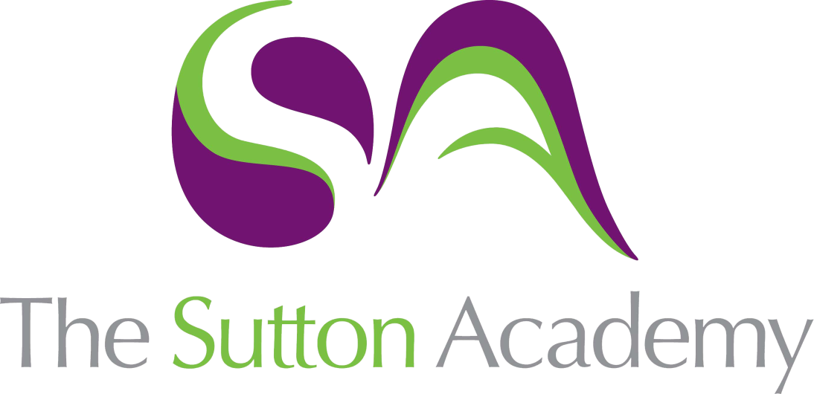

Knowledge Rich Curriculum Plan
Year 13 – Term 1

Lesson/Learning Sequence  Formal Elements | Intended Knowledge:  Students will know that… | Tiered Vocabulary | Prior Knowledge:  In order to know this students, need to already know how… | Assessment
Realising Intentions | How to demonstrate clearly how you have achieved them and how well you accomplished this. | Artistic intention or motivation ultimately determines the end product that we consider as artwork. | - How reflect on their work and review successes and failure to date within their work.
Connections | How to make the connections between the different parts of your work explicit before executing final outcome showing thorough and rigorous planning.  - Students will know how to clear connections between the artist work and their personal journey. |  | - The work of their artists,  - To meet the assessment objectives.  - To clearly convey intentions through their written work.
Design Ideas and final testing | - Students will know how to reflect on their journey and create a set of design ideas for their final piece.  - Students will know how to test materials and explore compositions.  - Students will know how to label and annotate ideas and thought processes.  - Student will know how to plan and prepare their resources and order for their final piece. |  | - Students need to draw upon their development and experimentation work.  - Students will know how to annotate their work and thought processes.  - Students will know how to plan and prepare for their final piece.
Final outcome | - Students will know how to carry out their final piece successfully.  - Students will know how to use all their learning and reflection to complete an imaginative and personal final piece.  - Students will know how to evaluation their work and reflect on the strengths and weaknesses of their project.  - Students will know how to clear connections between the artist work and their personal journey . | ‘Personal’ has several definitions including ‘done in person without the intervention of another’ and ‘referring to the character, conduct, motives of an individual’. | - Students need to have carefully planned and prepared their final piece.  - Students will know how to reflect and evaluate their work.
Personal Presentation | How to present your work in an easy-to-follow order, making the context in which it has been produced clear and in a format that is both suited to its purpose and interesting for anyone who views. | ‘Meaningful’ can simply be defined as ‘having meaning or significance’ or, perhaps more appropriately, ‘expressive, having a purpose, worthwhile’. Your response should be meaningful to anyone engaging with it, but especially to yourself. | - To skilfully materials and processes that have been developed and refined through time.

