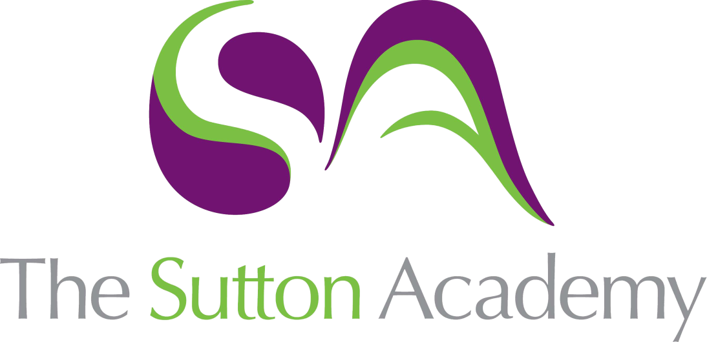

Knowledge Rich Curriculum Plan
Construction
Unit 1: The Built Environment

Year  Construction | Unit 1: Safety and Security in Construction (External Assessment)  The purpose of our curriculum is to inspire our students to think creatively about solving problems, rather than dwelling on solutions. They will be exposed to a variety of key Construction trades, skills and knowledge that will afford them the opportunity to actively develop their skills team work, project and time management which are all key aspect for future employment in this industry. In addition, our aim is to develop the personal skills of each student by teaching them about resilience and kindness when working towards a career in Construction.
Lesson/Learning Sequence | Intended Knowledge:  Students will know that… | Tiered Vocabulary | Prior Knowledge:  In order to know this students, need to already know that… | Assessment
Lesson:  Responsibilities | - Students will know the definition of employee: a person employed for wages or salary, especially at non-executive level  - Students will know the definition of employer: a person or organisation that employs people  - Students will know the responsibilities of the employee: follow site instructions, wear correct PPE, maintain tools and equipment, report site incidents  - Students will know the responsibilities of the employer: risk assess sites prior to start, set rules for tool usage, act upon site incident reported, provide appropriate PPE | Salary – A yearly wage allocated to person for a specified job role  Incident – An event that normally leads to injury | - Students will need to know basic PPE: hard hats, goggles, hi vis jackets, steel toe boots  - Students need to already know what a responsibility is: the state or fact of having a duty to deal with something or of having control over someone  - Students will need to know what is meant by the term 'risk' (being exposed to danger)  - Students will have a basic understanding of the roles within the working environment | Recall/activate starter  Cold call questioning  SSS assessment
Lesson:  Legislation (Health & Safety at Work Act) | - Students will know what a risk assessment is (The act of assessing the level of risk and likelihood of danger occurring before an activity is carried out) and how they are carried out  - Students will know what the Health and Safety at Work Act is (legislation to ensure places of work are safe for intended use) and why it was introduced (to reduce the number of accidents and injury in the work place)  - Students will know how to identify hazards and potential risks in a workshop environment | Legislation – A written law that should be adhered to  Hazard – An object of event that leads to a risk of injury | - Students need to already know what is meant by the term 'legislation' (a law or a set of laws that have been passed by Parliament)  - Students need to already know how risk (a situation involving exposure to danger) and danger (the possibility of suffering harm or injury) differ | Recall/activate starter  Cold call questioning  SSS assessment
Lesson:  Legislation (Reporting of Injuries, Diseases and Dangerous Occurrences  Regulations 1995 (RIDDOR)) | - Students will know how reporting injuries can reduce the risk of reoccurrence in the future (proactive identification of risk allowing for intervention)  - Students will know how the law protects workers (by allowing them to work in an environment meeting the basic level of safety as a minimum requirement)  - Students will know how to identify situations that would require reporting | Reoccurrence – The repetition of an event that has happened previously | - Students need to already know what proactive means (creating or controlling a situation rather than just responding to it after it has happened)  - Students need to already know what a risk is (a situation involving exposure to danger) | Recall/activate starter  Cold call questioning  SSS assessment
Lesson:  Legislation (Control of Substances Hazardous to Health Regulations 2002  (COSHH) | - Students will know how COSHH law protects people working with dangerous substances  - Students will know the type of substances that are covered by the COSHH law (gas, liquid, oil, paint, asbestos, dust)  - Students will know the dangers associated with using these substances (respiratory, burns, irritation, poisoning and death) | Substances – Items containing gas, liquid, oil, paint, asbestos and dust used in the construction industry  Associated – Connected with something else | - Students need to already know basic dangers associated with using chemicals and toxic substances (science)  - Students need to already know the basic workshop rules associated with substances in the school workshop | Recall/activate starter  Cold call questioning  SSS assessment
Lesson:  Legislation (Provision and Use of Work Equipment Regulations 1998 (PUWER)) | - Students will know how the PUWER law was introduced to ensure tools and machinery in the work place are maintained to the minimum expectation of safety requirement  - Students will know the types of tools and machinery associated with this law (all workshop hand tools, all battery/power hand tools, all workshop machinery and extraction)  - Know the difference between an isolation switch (turns off one machine) and an emergency stop switch (turns off power to the full workshop) | Isolation – Singular or individual  Provision – providing or supplying something for use | - Students need to already know what is meant by isolated (far away from other places, buildings, or people)  - Students need to already know a range of work shop tools and machinery | Recall/activate starter  Cold call questioning  SSS assessment
Lesson:  Legislation (Manual Handling Operations Regulations 1992) | - Students will know the maximum load you can carry under the law (25KG)  - students will know the stages for moving objects around the work place (plan, bend, lift, move and place)  - Students will know the dangers associated with incorrect manual handling (strains, RSI, breaks) | Load – Heavy or bulky items to be lifted  Operation – An organised event involving a number of people | - Students need to already know what is meant by manual in this context (relating to or done with the hands) | Recall/activate starter  Cold call questioning  SSS assessment
Lesson:  Legislation (Personal Protective Equipment at Work Regulations 1992 (PPER)) | - Students will know which parts of the body need protecting on the construction site  - Students will know how to identify risks and the associated PPE required | Equipment – items used as part of everyday work | - Students need to already know who is responsible for providing equipment  - Students need to already know basic examples of PPE (goggles, gloves, masks) | Recall/activate starter  Cold call questioning  SSS assessment
Lesson:  Legislation (Working at Heights Regulation 2005) | - Students will know how to correctly work at height using different platforms (ladder, scaffold, tressel, roof ladder)  - Students will know how to work at heights safely using protective equipment (harnesses, barriers and gates) | Platform – A raised area to work on to elevate working position | - Students need to already know the definition of platform (a raised level surface on which people or things can stand)  - Students need to already know how to identify risk when working at height (Risk assessments) | Recall/activate starter  Cold call questioning  SSS assessment
Lesson:  Legislation (Asbestos) | - Students will know how Asbestos can become a dangerous substance when broken and particles are released into the atmosphere  - Students will know how to correctly dispose of Asbestos  - Students will know the laws and appropriate signage when working around Asbestos | Atmosphere – the wider working environment that people work in  Particles – microscopic parts of a substance that become airborne | - Students need to already know the appropriate definition of 'atmosphere' in this context (the air in any particular place)  - Students need to already know what is meant by the term 'particle' (a minute portion of matter) | Recall/activate starter  Cold call questioning SSS  assessment
Lesson:  Safety Signs | - Students will know the different colours and the meanings associated to each sign (red: prohibited, blue: mandatory, yellow: warning, green: first aid/safety, orange: dangerous substance  - Students will know the different shape of signs and the associated meanings (circle: order/command, triangle: warning, rectangle: information)  - Students will know how to identify types of signs using visual cues  - Students will know where to position signs in a workshop environment | Prohibition – Something that is banned or must not be done  Mandatory – Something that must be done | - Students need to know what is meant by the term 'associated' (connected with something else)  - Students will already know basic workshop signage (wear goggles, do not touch) | Recall/activate starter  Cold call questioning  SSS assessment
Lesson:  Fire Extinguishers | - Students will know the different types/colour of extinguisher and the associates fire types (water, foam, CO2, dry powder, vaporising liquids, wet chemical, fire blanket  - Students will know the elements of the fire triangle (heat, fuel and oxygen)  - Students will know how to reduce risk of fire using the fire triangle | Elements – smaller components in a larger process or formula | - Students need to know what is meant by the term 'extinguish' (cause (a fire or light) to cease to burn or shine)  - Students will already know the oxygen is an element that causes fire | Recall/activate starter  Cold call questioning  SSS assessment
Lesson:  Role of the Health and Safety Executive | - Students will know what the Health and Safety executive does (ensure safety in all working environments)  - Students will know the roles of the H&SE when in breach of legislation (site closures, temporary closures, prosecution)  - Students will know the roles of the H&SE when providing support (advise on improving safety, direct to information that will provide support) | Breach – The act of breaking the law  Prosecution - institution and conducting of legal proceedings against someone in respect of a criminal charge | - Students need to know what is meant by the term 'role' (the function assumed or part played by a person or thing in a particular situation)  - Students will need to know what is meant by the term 'prosecution' (legal proceedings against someone in respect of a criminal charge) | Recall/activate starter  Cold call questioning  SSS assessment
Lesson:  Understanding Risks in Different Situations | - Students will know how to identify risks associated with different construction contexts (site, heights, chemicals, materials, machinery and poor training)  - Students will know the associated risks with substructure (Below ground) and superstructure (above ground) including trips, falls, crushing, inhalation, material and weather.  - Students will know the associated risks with working in a workshop, an office or travelling between sites (fire, repetitive strains, machinery injury, crashes and stress) | Associated – Linked to  Inhalation – Breathing in (linked to bad substances) | - Students need to know what is meant by the term 'risk' (a situation involving the exposure to danger)  - Students will need to know basic risk and hazards associated with workshop settings (slips, trips, falls) | Recall/activate starter  Cold call questioning  SSS assessment
Lesson:  Describing Potential Hazards of Different Situations | - Students will know the effects associated to different construction situations (physical, psychological, financial and environmental)  - Students will know the key stakeholders who could be affected by the hazards in different construction situations (self, others working in the area, employer, local community, environment and users | Stakeholders – Individuals or groups associated with a given task | - Students will need to know what is meant by the term effect (the result of a change in situation)  - Students will need to know basic risk and hazards associated with workshop settings (slips, trips, falls) | Recall/activate starter  Cold call questioning  SSS assessment
Lesson:  Explaining the Risk of Harm in Different Situations | - Students will know how to carry out a risk assessment on different construction activities (fire, machinery, site, heights, travel and security)  - Students will be able to use the risk assessment to effectively the likelihood, severity and how risk is measured (high medium and low risk scale) | Likelihood – The chance of something occurring  Severity – a scale in which we measure how serious an event is/could be | - Students will need to know what is meant by the term likelihood (the state or fact of something being likely)  - Students will have a basic understanding of workshop safety and the associated risks/hazards | Recall/activate starter  Cold call questioning  SSS assessment
Lesson:  Minimising Risk in Construction (control measures) | - Students will know the existing control measures in place in any given construction setting (method statements, safe systems of work, work permits, competent persons, PPE) and know where and when they should be used.  - Students will be able to recommend health and safety control measures in different situations including: locations, changes in work practice, equipment, scale, individual/business responsibilities | Competent – A person with sufficient knowledge or training required to carry out a task | - Students will need to know what is meant by the term 'competent' (having the necessary skill, ability or knowledge to do something successfully)  - Students will be able to suggest basic control measures based on using a risk control scale of high to low. | Recall/activate starter  Cold call questioning  SSS assessment
Lesson:  Security in Construction | - Students will knowhow to identify risks to security in  - construction in different situations, including that of tools and equipment, personal belongings, sensitive information  - Students will be able to describe measures used in construction to minimise risk to security, including those implemented by employers and employees | Risk – The potential outcome of a hazardous/dangerous situation  Sensitive – Personal data that could be weaponised in the wrong hands | - Students will need to have some basic awareness of cyber security  - Students will be able to know the meaning of sensitive in this context (keep secret or with restrictions on disclosure to avoid endangering security) | Recall/activate starter  Cold call questioning  SSS assessment

