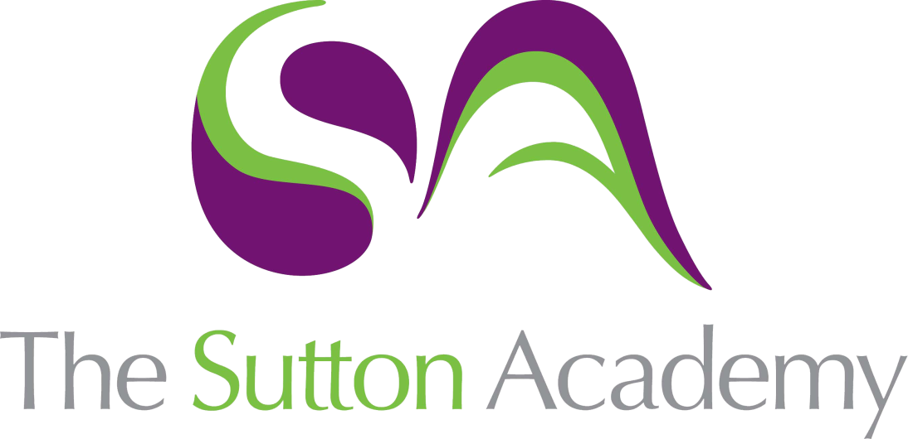

Knowledge Rich Curriculum Plan
Year 12- Term 2

Lesson/Learning Sequence  Formal Elements | Intended Knowledge:  Students will know that… | Tiered Vocabulary | Prior Knowledge:  In order to know this students, need to already know how… | Assessment
Review & Evaluate | - To review year 12 work and produce a plan against the A0’s to ensure deeper understanding into their themed work.  - The various ways in which artists, craftspeople and designers may have thought about their work and how they produced it in the place and time that they were working. | Review: assess (something) formally with the intention of instituting change if necessary.  Processes: where the process of its making art is not hidden but remains a prominent aspect of the completed work, so that a part or even the whole of its subject is the making of the work. | - Students need to already know that it is important to research into a theme or project before we begin.  - Students need to already know how to brainstorm an idea, thought or theme.  - Students need to already know to present information creatively.  - Students need to already know how to write about how the topic or research can influence their work.
Explain | - Using your own words and images, how you think about and approach your work, making relevant connections with the work of others. | Connections: In the conceptual framework for the national core arts standards, the artistic process of connecting is defined as “relating artistic ideas and work with personal meaning and external context.” This definition delineates the process of connecting to do entities: one's personal life, and the lives of others. | - Students need to already know how to form basic shapes.  - Students need to already know how to draw to scale.  - Students need to know their color theory
Understand | - Understand that artists, craftspeople and designers have different intentions when they produce pieces of work and that these artefacts are made for various purposes. | Intentions: a thing intended; an aim or plan. | - Students need to already know their colour theory.  - Students need to already know how to create graduated tones.  - Students need to know their color theory
Convey | - The purpose of your own work and clearly state what your intentions are in producing it. | Application: Applied art is any form of art created with a specific practical purpose in mind. This type of art can be found in various mediums, such as design, decoration, and even advertising. Applied art is often used for commercial or utilitarian purposes, such as product design or architecture. | - Students need to already know how to map out their sketchbook pages.  - Students need to already know the places the visits and the artists they were inspired by.
Apply analytical and critical skills | - Analytical skills involve closely examining something in order to find its true nature, actual content and particular structure, such as the different elements of content, form, process and mood that make up a complex picture. These skills are particularly effective when used to compare and contrast different contextual sources. Critical skills are used to ask the right questions and probe deeply to find answers, recognising different kinds and qualities of information such as biographical, descriptive and evaluative details, in order to reach well-informed judgements. This is sometimes mistakenly thought to be about making negative observations. |  | - Students need to already know that annotations must be presented creatively.  - Students need to already know how to describe a piece of work.  - Students need to already know how to describe an artist work.  - Students need to already know how to present an artist page using TWISBOQ.  - Students need to already know the work of the artist.  - Students need to already know how to create work in her style.
Select | - Thoughtfully and sensitively from your explorations, so that what you choose is well-suited to what you are producing. | Perceptive: having or showing sensitive insight. | - Students know how to identify and use their reflective skills to purposefully select materials and successes to realise their intentions.
Reflect | - What you are recording as it progresses as part of reflective learning. This requires you to pause and take time to think about your work, and review what you have learned in producing it.  - Use reflection in your research and enquiry to delve deeper into the meaning and purpose in what you are doing.  - Gather, select, organise and communicate visual and other information.
Essay | - How to produce an extended written element of 1000 words minimum, which must clearly relate to practical and theoretical work using an appropriate working vocabulary and specialist terminology. |  | - Students need to already know the context of their projects and how to write about what they have completed.
* Tier 2 & 3 vocabulary will be bespoke to the themes students have chosen to study e.g. Climate change, relationships, Structures etc.

