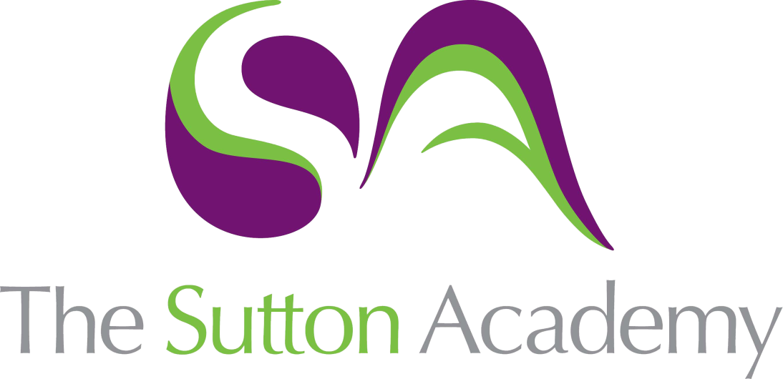

Knowledge Rich Curriculum Plan
GCSE Design Core
Specialist Technical Principles – Unit: Non Examined Assessment

GCSE Design Core | Specialist Technical Principles  Unit: Non Examined Assessment
Lesson/Learning Sequence | Intended Knowledge:  Students will know that… | Tiered Vocabulary | Prior Knowledge:  In order to know this students, need to already know that… | Assessment
Lesson:  Investigation | - Students will know how to investigate their chosen contextual challenge  - Students will know the different type of factors that can affect a products investigation  - Students will know how to research and investigate their chosen contextual challenge  - Students will know how to analyse their research findings  - Students will know to analyse different factors to investigate their chosen contextual challenge | Investigation: the action of investigating something or someone; formal or systematic examination or research.  Contextual: depending on or relating to the circumstances that form the setting for an event, statement, or idea.  Analysis: detailed examination of the elements or structure of something. | - Students need to already know the term investigate  - Students need to already know how to investigate a problem  - Students need to already know the term research  - Students need to already know how to use computers to research different task  - Students need to already know the different types of materials available for products  - Students need to already know the properties of different types of products | How can we use investigation methods to answer the contextual challenge?  How can we use investigation to help solve the needs and wants posed?
Lesson:  Work of others/Product analysis | - Students will know how to analyse an existing product  - Students will know how to identify the positive and negatives of a product  - Students will know how to provide alternatives to a products design and materials | Identify: establish or indicate who or what (someone or something) is.  Alternative: (of one or more things) available as another possibility or choice. | - Students need to already know how to identify a products flaw  - Students need to already know how products can change for better or worse  - Students need to already know to develop an existing product  - Students need to already know the different types of materials | Comparing different types of products can aid our development, how?  Can the analysis of products help develop our investigation?
Lesson:  User profile | - Students will know how to identify a potential client for their product  - Students will know how to use Primary and Secondary data to inform decisions  - Students will know Primary data is information collected by yourself  - Students will know Secondary data is information collected by others | Primary: a methodology used by researchers to collect data directly  Secondary: a methodology used by researchers to collect data from a third party  Client: the entity that has commissioned the design project | - Students need to already know how to identify a client  - Students need to already know how to identify a client’s needs  - Students need to already know to how analyse data to produce findings  - Students need to already understand a client’s needs and wants | How does applying a client to our problem help guide our product?  How can primary data help us understand the clients needs?

