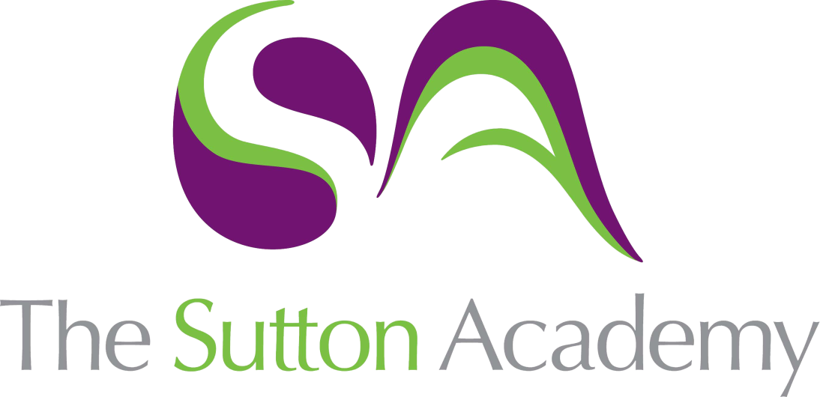

Knowledge Rich Curriculum Plan
Year 8 USB Light Project

Lesson/Learning Sequence | Intended Knowledge:  Students will know that… Students will know how to… | Tiered Vocabulary | Prior Knowledge:  In order to know this students, need to already know that… | ADT Interleaving Opportunities | Assessment
Developing a Specification | - Develop a specification using a series of focus points including: Aesthetics, function, materials, consumer, performance, environment and ergonomics  - A products success will depend on how thorough the specification is  - The definition of SPECIFICATION: A detailed list of requirements that must be included in the final product or design  - Identify which specification points are applicable to designing for people with physical disability (Consumer, ergonomics and function) | Consumer: a person who purchases goods and services for personal use  Aesthetic: giving or designed to give pleasure through beauty  Ergonomics: the study of people's efficiency in their working environment | The simple stages of the design process (research, investigate, design, make, evaluate)  Products are designed for a specific person or market | Food – reference the nature of an ingredients list and how a recipe could be unsuccessful if one was missing | Recall/activate starter  Application plenary
Practical 1: Cutting the lamp parts | - Measure and mark out a cutting list using the appropriate tools (steel rule, try square and pencil)  - Cut out the lamp parts using traditional woodwork tools (tenon saw, bench hook)  - Sand and file the edges of the material to ‘ease’ (soften) newly cut material | Accurate: correct in all details | The basic safety and marking processes for a woodwork activity |  | Recall/activate starter  Cold call questioning
Electrical Components | - The definition of COMPONENT in this context: A device that forms part of a completed circuit by effecting electrons in different ways  - The functions of a variety of components including: Resistors, USB power supplies LEDs, speakers, light dependant resistors and switches  - A simple process (input – process- output) works  - The difference between passive, input and output components work | Dependant: contingent on or determined by  Components: a part or element of a larger whole, especially a part of a machine or vehicle  Passive: containing no source of electromotive force | Basic knowledge of electrons from KS3 science  Power moves from one place to another to turn lights on | Food – continuing the theme of ingredients being individual PARTS of a recipe that help make an end product | Recall/activate starter  Cold call quiestioning  SSS assessment
Practical 2: Drilling the lamp parts and knock down fittings | - To use a marking gauge to mark out consistent drill points  - How templates and jigs are used to help consistency in the manufacturing process  - How semi permanent fixings are used in flat pack furniture: Nuts and bolts/cam fixings | Semi-Permanent: not permanent, but involving some stability or endurance  Jigs: a device that holds a piece of work and guides the tool operating on it  Fixings: screws, bolts, or other items used to fasten or assemble building material, furniture, or equipment | Basic safety knowledge from using workshop machinery | Art - know how a template is an object you can draw around to create a consistent pattern | Recall/activate starter  Cold call questioning
Design Development | - Know how to develop a design using a 2nd functions focussed on a chosen consumer  - Know how to design in isometric perspective  - Know how to correctly render (apply finishes to a drawing using a selection of drawing media) a design drawing | Perspective: the art of representing three-dimensional objects on a two-dimensional surface so as to give the right impression of their height, width, depth, and position in relation to each other.  Render: process (an outline image) using colour and shading in order to make it appear solid and three-dimensional  Isometric | Know that some products will often perform more than one job | Art - Have basic mark making and tonal control when rendering | Recall/activate starter  Application plenary
Practical 3: Soldering the PCB | - Correctly populate a PCB with components (LEDs, USB power, resistors) by placing things in the correct place considering polarity (positive and negative direction of some components)  - Use a soldering iron safely (holding handle, using heat mat, wet towel to hand, hair/lose clothing secured)  - Solder components to the PCB (printed circuit board) with correct solder technique (5 seconds to warm up the solder pad, minimum solder use to complete volcano shaped joints.  - MISCONCEPTION – extra solder doesn’t make the joint more secure, it will over heat the area and burn the component or PCB | Populate: fill  Polarity: the relative orientation of poles; the direction of a magnetic or electric field | Be able to identify products that will have a PCB in them (PS5 controller, hair dryer, remote control)  Understand that heat can cause serious injury (food)  Know that a battery has a positive and negative end | Food – how over heating an ingredient can spoil the recipe | Recall/activate starter  Cold call questioning
Design Development: Final Idea | - To decide the best aspects of their initial ideas to produce a final solution  - Know how aesthetics can impact on the final sale point/target market of a design  - How to annotate an idea to help communicate developments to a client (clear/detailed instruction or information about materials, dimensions, important parts) | Dimensions: a measurable extent of a particular kind, such as length, breadth, depth, or height | Know what is meant by the term aesthetic  Have used annotation on diagrams in other subject areas |  | Recall/activate starter  Application plenary
Practical 4: Soldering the PCB (continued) | - Correctly populate a PCB with components (LEDs, USB power, resistors) by placing things in the correct place considering polarity (positive and negative direction of some components)  - Use a soldering iron safely (holding handle, using heat mat, wet towel to hand, hair/lose clothing secured)  - Solder components to the PCB (printed circuit board) with correct solder technique (5 seconds to warm up the solder pad, minimum solder use to complete volcano shaped joints.  - MISCONCEPTION – extra solder doesn’t make the joint more secure, it will over heat the area and burn the component or PCB | Component: a part or element of a larger whole, especially a part of a machine or vehicle | Be able to identify products that will have a PCB in them (PS5 controller, hair dryer, remote control)  Know that a battery has a positive and negative end | Food – how over heating an ingredient can spoil the recipe | Recall/activate starter  Cold call questioning
Practical 5: Construct the lamp | - How to construct a product using knock down fittings (aligning holes and fitting nuts and bolts)  - Use a screw and driver to join the head to the frame  - Use a screw and driver to fit acrylic sheet to cover the LED unit  - Complete final checks and quality assurance the lamps function as expected | Align: place or arrange (things) in a straight line  Quality assurance: the maintenance of a desired level of quality in a service or product | Have a basic understanding of workshop safety and processes |  | Recall/activate starter  Cold call questioning
Practical 6: Apply second functions and aesthetic detail | - How to modify a product (2nd Function) using existing skills from over the previous projects  - Use laser cutter to apply any 3D aesthetic features to their designs  - How CAM (computer aided manufacture) supplements the design process  - Advantages of CAM (accurate, consistent, easy to edit/correct) | Advantages: a favourable or desirable feature  Supplement: a thing added to something else in order to complete or enhance it  Manufacture: make (something) on a large scale using machinery | Be able to use Techsoft 2D Design to create laser cut files  How to compile a list of advantages and disadvantages |  | Recall/activate starter  Cold call questioning
Assessment | - Students will complete an assessment based on the highlighted intended knowledge within the map | N/A | All highlighted knowledge from the above map. |  | Final formative assessment

