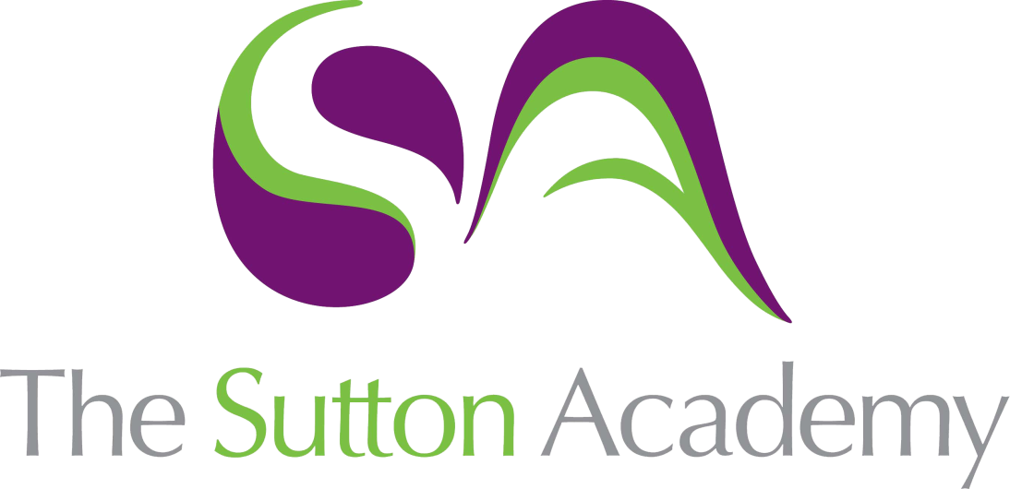

Knowledge Rich Curriculum Plan
GCSE Design Core
Specialist Technical Principles - 2.9 Surface treatments and finishes

GCSE Design Core | Specialist Technical Principles  2.9 Surface treatments and finishes
Lesson/Learning Sequence | Intended Knowledge:  Students will know that… | Tiered Vocabulary | Prior Knowledge:  In order to know this students, need to already know that… | Assessment
Lesson:  Surface treatments and finishes | - Students will know the term finish  - Students will know the term finish refers to a type of final stage applied to a timber product  - Students will know the 4 types of wood finishes are Stain, Oil, Varnish and Paint  - Students will know that a stain is used for colour only and does not protect the timber  - Students will know that oil is used to repel moisture  - Students will know that varnish can help protect timber when applied  - Students will know that paint can help protect timber and change its colour | Finish: complete the manufacture or decoration of (an article) by giving it an attractive surface appearance.  Stain: colour (a material or object) by applying a penetrative dye or chemical.  Oil: a protective and decorative wood finish that can be applied directly to bare wood and timber.  Varnish: resin dissolved in a liquid for applying on wood, metal, or other materials to form a hard, clear, shiny surface when dry.  Paint: a coloured substance which is spread over a surface and dries to leave a thin decorative or protective coating. | - Students will already know the finish of paint and how it is applied  - Students will already know the finish of varnish and will have seen it used before | Compare the different types of wood finishes, which is more suitable for the chosen product?  Which of these wooden finishes are more suitable for indoor use?  How can the methods differ for each wood finish?

