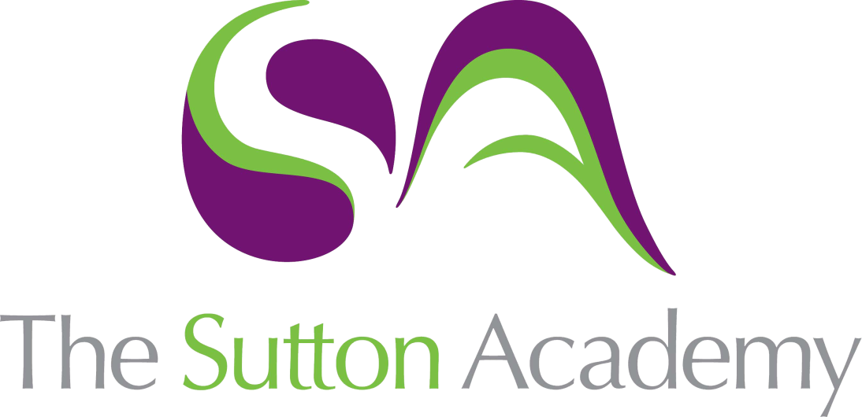

Knowledge Rich Curriculum Plan
Year 11 Term 1

Year 11
Art
Lesson/Learning Sequence | Intended Knowledge:  Students will know that… | Tiered Vocabulary | Prior Knowledge:  In order to know this students, need to already know that… | Assessment
Lesson:  Experimental and creative making.  Reading Activity | - Students will know that they must experiment with a range of idea and think about various outcomes.  - Students will know how experiment with successful outcomes and pieces in their work.  - Students with know how to experiment with scale, composition and a range of techniques and processes both 2D and 3D. | Exploited: make full use of and derive benefit from (a resource).  Perceptive: having or showing sensitive insight.  Discriminate: recognize a distinction or difference; differentiate. | - Students need to already know that experiments must link and connect to their theme and artists.  - Students need to already know how to execute a range of experiments.
Lesson:  Selecting successful experiments.  Reading Activity | - Students will know that they must experiment with a range of idea and think about various outcomes.  - Students will know how experiment with successful outcomes and pieces in their work.  - Students with know how to experiment with scale, composition and a range of techniques and processes both 2D and 3D. | Mixed media: artworks composed from a combination of different media or materials.  Creative Making: Refine work by exploring ideas, selecting and experimenting with appropriate media, materials, techniques and processes. | - Students need to already know that experiments must link and connect to their theme and artists.  - Students need to already know how to execute a range of experiments.
Lesson:  Selecting and refining. | - Students will know that they must experiment with a range of idea and think about various outcomes.  - Students will know how experiment with successful outcomes and pieces in their work.  - Students with know how to experiment with scale, composition and a range of techniques and processes both 2D and 3D. | Translate: express the sense of (words or text) through art or drawing.  Rigorous Selection: A test, system, or procedure that is rigorous is very thorough and strict. | - Students need to already know that experiments must link and connect to their theme and artists.  - Students need to already know how to execute a range of experiments.
Lesson:  Developing and refining  Reading Activity | - Students will know that they must choose three successful experiments to develop further and respond to.  - Students will know how to develop the work through different compositions, refining materials and techniques and exploring colour.  - Students with know how to be resilient to focusing into three ideas to develop and refine. | Develop: Development is about selecting ideas, visual elements, compositions and techniques from this initial work and using them in new ways.  Refine: Refinement is the improvement of the idea. It does not involve radical changes, but is about making small changes which improve the idea in some way. | - Students need to already know that they will produce unsuccessful work at times and to be resilient.  - Students need to already know how to reflect on their work and draw upon their experiences and thoughts.
Lesson:  Developing and refining | - Students will know that they must choose three successful experiments to develop further and respond to.  - Students will know how to develop the work through different compositions, refining materials and techniques and exploring colour.  - Students with know how to be resilient to focusing into three ideas to develop and refine. | Reflective recording: Record ideas, observations and insights relevant to intentions as work progresses.  Personal Presentation: Present a personal and meaningful response that realises intentions and demonstrates understanding of visual language. | - Students need to already know that they will produce unsuccessful work at times and to be resilient.  - Students need to already know how to reflect on their work and draw upon their experiences and thoughts.
Lesson:  Design Ideas | - Students will know to produce three design ideas that is personal and meaningful in its response.  - Students will know how to develop the work through different compositions, refining materials and techniques and exploring colour.  - Students with know how to be resilient to focusing into three ideas to develop and refine. | Design Ideas: a method of human expression that follows a system of highly developed procedures in order to imbue objects, performances, and experiences with significance. Like all art forms, design has the potential to solve problems | - Students need to already know that they will produce unsuccessful work at times and to be resilient.  - Students need to already know how to reflect on their work and draw upon their experiences and thoughts
Lesson:  Final Outcome | - Students will know how to produce final outcome that is relevant to their intentions and shows clear connections to their artists.  - Students will know how to evaluate their work by realising intentions, strengths and weaknesses.  - Students with know how to be resilient and complete their portfolio to the best of their ability. | Connections: a relationship in which a person or thing is linked or associated with something else.  Intentions: a thing intended; an aim or plan. | - Students need to already know that they will produce unsuccessful work at times and to be resilient.  - Students need to already know how to reflect on their work and draw upon their experiences and thoughts

