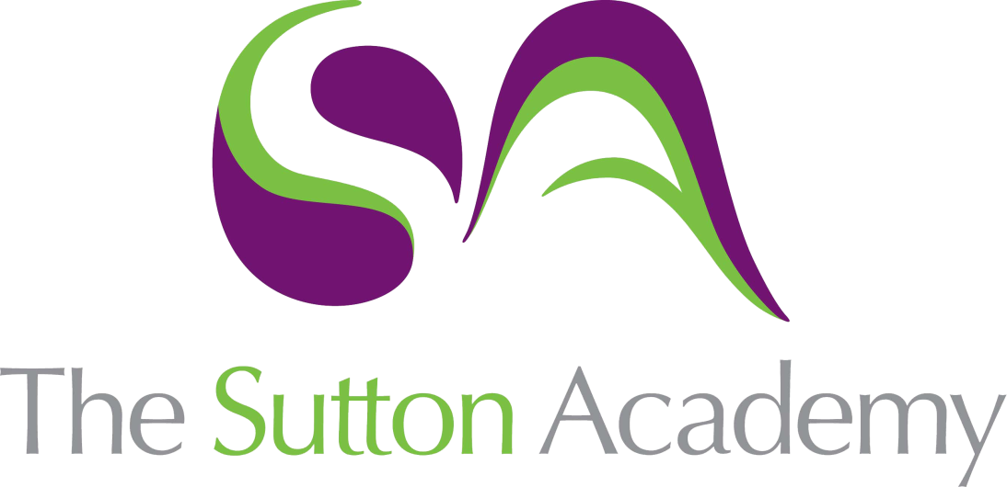

Knowledge Rich Curriculum Plan
Computer Science
Year 10

Unit 1:
Data Representation
Lesson/Learning Sequence | Intended Knowledge:  Students will know that… | Tiered Vocabulary | Prior Knowledge:  In order to know this students, need to already know that… | Assessment
Lesson 1:  Boolean Logic | - Students will know that logic diagrams and truth tables. Combine Boolean logical operators to solve problems.  - Students will know how to create logic diagrams and truth tables. | DIV:  MOD and related terms: | - Students need to already know that logic diagrams can be used to solve a range of problems. Truth tables can be combined to resolve complex scenarios.  - Students need to already know how mathematic operators can be used to solve problems and data can be represented in a number of forms. Problem solving skills and a good working knowledge of mathematical operators. | Knowledge Check Quiz  SSS Task  Retrieval Task  Worksheet
Lesson 2:  Data Representation | - Students will know that binary digits can be used to represent other forms. How the binary number system can be used to represent a range of objects, such as: Numbers (in different forms), Characters, Sounds, Images  - Students will know how to construct information using binary data | Bit  Nibble  Byte  KB - Kilobyte  MB – Megabyte  GB - Gigabyte  TB - Terabyte  PB - Petabyte | - Students need to already know that most computers use binary data only  - Students need to already know how to count in a base 10 number system. Have a sound working knowledge of the denary number system | Knowledge Check Quiz  SSS Task  Retrieval Task  Worksheet
Lesson 3:  Number Systems and conversions | - Students will recognise different number systems including: Denary, Binary and Hexadecimal  - Students will be able to convert (both ways) between each number system | Base 2  Base 10  Base 16 | - Students need to already know that data can be presented in a variety of ways  - Students need to understand how the Base 10 number system works | Knowledge Check Quiz  SSS Task  Retrieval Task  Worksheet
Lesson 4:  Data Storage | - Students will recognise the need for both primary and secondary storage in a computer system and the properties, advantages/disadvantages of each type of media including magnetic, optical and solid state | Volatile  Non – Volatile  Optical  Magnetic  Solid State | - Students need to already know that data must be stored in order for it to be processed | Knowledge Check Quiz  SSS Task  Retrieval Task  Worksheet
Lesson 5:  Algorithms | - Students need to be able to recognise an overarching problem and decompose it into the various elements that need to be overcome to create a full solution. | Computational thinking  Decomposition  Abstraction | - Students need t already know that a sequence or instructions can be used to solve a given problem. | Knowledge Check Quiz  SSS Task  Retrieval Task  Worksheet
Lesson 6:  Programming Fundamentals | - Students need to understand the key concepts including sequence, selection and iteration  - Students need to be able to recognise both syntax and logic errors and use these to debug programs to make them run effectively | Sequence e  Selection  Iteration  Syntax  Logic | - Instructions must be run in a correct order to work effectively | Knowledge Check Quiz  SSS Task  Retrieval Task  Worksheet
Lesson 7:  Practical Programming skills | - Students should be able to write programs using a high level language (Python) | Python  IDE (iDLE)  High Level Language  Low Level Language | - Students should be able to use an IDE such as IDLE to write their code and use the compile function to test and debug their code | Knowledge Check Quiz  SSS Task  Retrieval Task  Worksheet
Lesson 8:  Additional programming techniques | - Students will learn more advanced programming techniques utilising 2D and 3D data structures such as Lists, Tuples and Dictionaries | Lists  Tuples  Dictionaries | - Students will know that data can be store as a variety of data types and the suitability of each | Knowledge Check Quiz  SSS Task  Retrieval Task  Worksheet
Lesson 9:  Advanced programming techniques | - Students will be able to search through data stored in Lists are any similar data structures to extract the required information in the most appropriate sequence. | Iteration  For  While | - Students will have a basic understanding of how data may be searched and sorted. | Knowledge Check Quiz  SSS Task  Retrieval Task  Worksheet
Lesson 10:  Advanced data storage | - Students will be able to use complex data structures such as dictionaries to categorise information and locate specific details using a dictionary key | Dictionary  Key | - Students will have come understanding of how data may be stored and then accessed. | Knowledge Check Quiz  SSS Task  Retrieval Task  Worksheet
Lesson 11:  Architecture of the CPU | - Students will know the features of the Von Neumann architecture and their role in the function of the processor | CPU  ALU  Control unit  Registers | - Students will know the role of the processor in the function of a computer system. | Knowledge Check Quiz  SSS Task  Retrieval Task  Worksheet
Lesson 12:  CPU Performance | - Students will recognise the factor that effect the speed of the CPU, including: clock speed, number of cores and cache size | Clock Speed  Cores  Cache | - Students will know that CPUs can come in a variety of speeds | Knowledge Check Quiz  SSS Task  Retrieval Task  Worksheet
Lesson 13:  Embedded Systems | - Students will recognise the properties of an embedded system and identify a range of examples along with their uses. | Embedded System | - Students will know that some devices have an embedded system built into them. | Knowledge Check Quiz  SSS Task  Retrieval Task  Worksheet
Lesson 14:  Primary Storage | - Students will know the purpose of Primary Storage and the role of both ROM and RAM as part of a computer system. | ROM  RAM  Volatile  Non- Volatile | - Students will know that computer systems require storage devices in order for them to function. | Knowledge Check Quiz  SSS Task  Retrieval Task  Worksheet
Lesson 15:  Secondary Storage | - Students will know the purpose of secondary storage and why it is required as part of a computer system. | Magnetic  Optical  Solid State | - Students will know that computer systems require storage devices in order for them to function. | Knowledge Check Quiz  SSS Task  Retrieval Task  Worksheet
Lesson 16:  Networks and Topologies | - Students will know what a computer network is and why networks are produced. | Network  Bus  Ring  Star  Mesh | - Students will be able to identify the advantages and disadvantages of computer networks.  - Students will recognise several network topologies and the advantages and disadvantages of each topology. | Knowledge Check Quiz  SSS Task  Retrieval Task  Worksheet
Lesson 17:  Wired and Wireless networks, protocols and layers | - Students will know that networks can be created using wired or wireless technologies | TCP  IP  Layers  Application  Transport  Network/Internet  Data Link  Physical | - Students will be able to identify the advantages and disadvantages of both wired and wireless connectivity methods.  - Students will be able to successfully identify the name od purpose of each layer in the TCP/IP model | Knowledge Check Quiz  SSS Task  Retrieval Task  Worksheet
Lesson 18:  Practical Programming skills revision | - Students will be able to identify the core programming skills of Sequence, Selection and Iteration and apply these concepts when creating a program to solve a problem | Sequence  Selection  Iteration | - Students will be able to successfully apply Computation thinking to solve a problem, including the concepts of decomposition and abstraction | Knowledge Check Quiz  SSS Task  Retrieval Task  Worksheet

