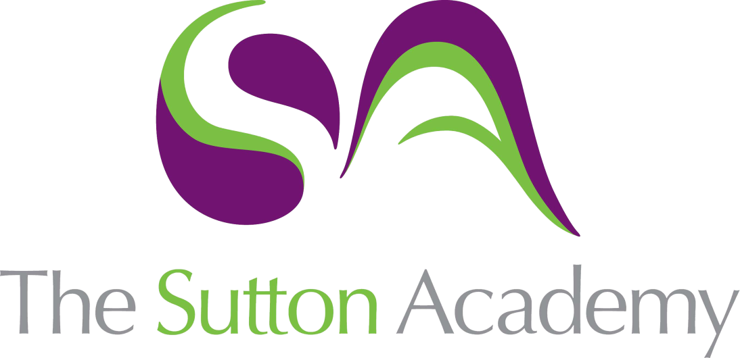

Knowledge Rich Curriculum Plan
I.T
Year 13

Unit1:
Global Information
Lesson/Learning Sequence | Intended Knowledge:  Students will know that… | Tiered Vocabulary | Prior Knowledge:  In order to know this students, need to already know that… | Assessment
Lesson:  Holders of information  LO1 - Understand where information is held globally and how it is transmitted. | - Students will know that information can be held by a range of different holders for a range of purposes  - Students will know how information can be accessed across the globe including access issues caused by the global divide |  | - Students need to already know that information can be used for different purposes  - Students need to already know how information can be accessed from different areas.
Lesson:  1.2 Types of information storage media | - Students will know that information can be stored on a range of media and devices and the characteristics of these.  - Students will know how different storage media and devices can display a number of advantages and disadvantages depending on a given context. |  | - Students need to already know that information can be stored in a number of ways.  - Students need to already know how some storage media is appropriate for storing certain types of information.
Lesson:  1.3 Types of information access and storage devices | - Students will know that the internet is a WAN and the  - characteristics of internet connections.  - Students will know how different network technologies work and their characteristics |  | - Students need to already know that networks allow devices to share information and resources.  - Students need to already know how devices may be connected together.
Lesson:
1.4 The internet
Lesson:
1.5 World Wide Web technologies
Lesson:
1.6 Information formats
Lesson:
1.7 Advantages
Lesson:
1.8 Disadvantages

