Knowledge Rich Curriculum Plan
Year 10 Foundation – Geometry 3

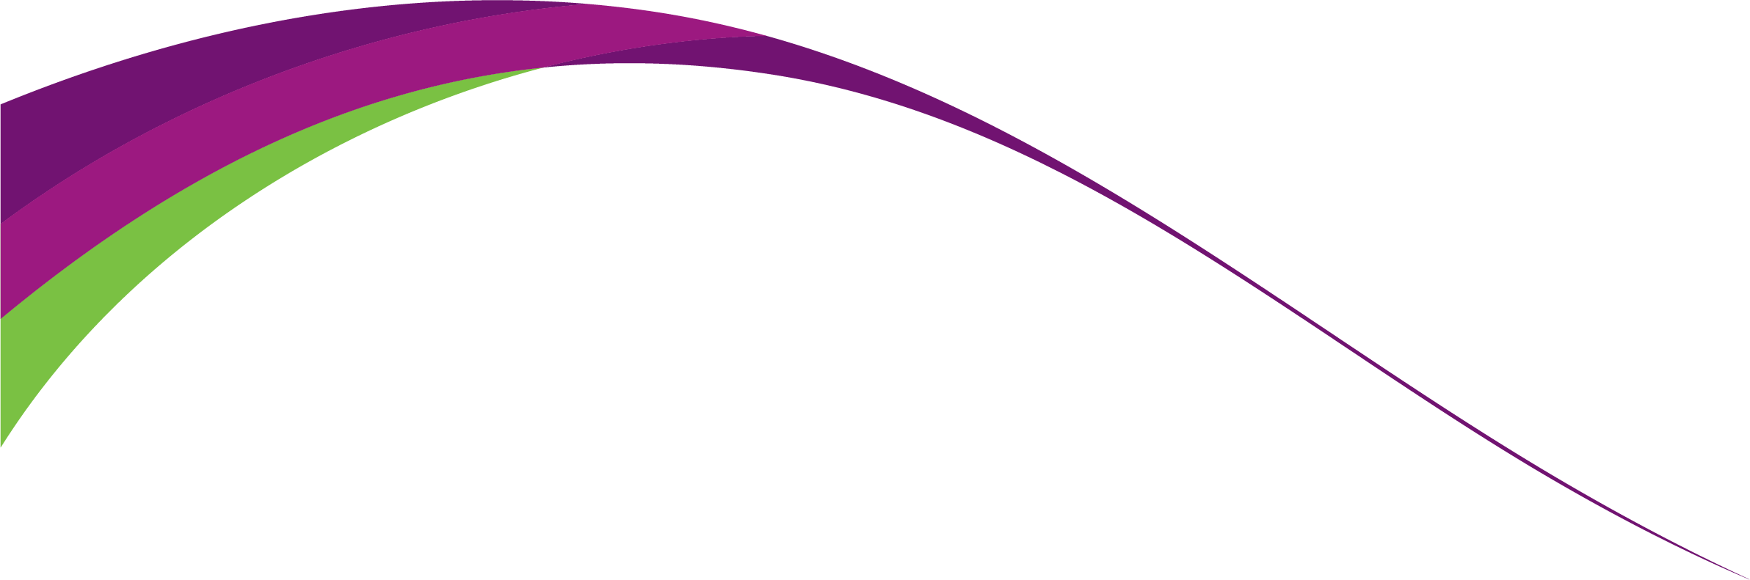

Lesson/Learning Sequence | Intended Knowledge:  Students will know that… | Tiered Vocabulary | Prior Knowledge:  In order to know this, students need to already know that… | Assessment
To learn how to calculate the surface area of prisms | - Students will know how to find the surface area of prisms including cubes, cuboids and triangular prisms  - Students will know how to find the surface area of other prisms including compound prisms.  - Students will know how to solve problems involving the surface area of prisms  - Students will know how to find the surface area of cylinders. Students will know how to calculate this in terms of π as well as by using a calculator.  - Students will know how to solve problems involving the surface area of cylinders | Surface area - the total area of all of the faces of a 3D solid added together  Prism – A solid object with two identical ends and flat sides  Compound Solid - a solid that is made up of 2 or more solids. | - Students need to know how to calculate the area of squares, rectangles, triangles and compound shapes  - Students need to know how to calculate area and circumference of circles
To learn how to find the surface area of pyramids, cones and spheres | - Students will know how to find the surface area of pyramids.  - Students will know how to find the surface area of cones.  - Students will know how to find the surface area of sphere and hemi-spheres. |  | - Students need to be able to substitute into formulae.  - Students need to be able to find the area of circles.  - Students need to know that π = 3.142 and be able to use the π button on the calculator.
To learn how to identify and draw plans and elevations from shapes and draw shapes from plans and elevations | - Students will identify front, side and plan elevations of 3D solids. Students will know that an elevation means a 2D drawing of a 3D shape from different viewpoints.  - Students will draw the front, side and plan elevations of 3D solids.  - Students will know how to sketch a 3D solid using the front, side and plan elevations.  - Students will know how to use isometric grids to sketch 3D solids. | Plan – A drawing of something as viewed from above  Elevation – the view of a 3D shape when it is looked at from the side or from the front. | - Students need to be able to recognise 2D shapes
To learn how to calculate the volume of prisms | - Students will know that: Volume of a Prism = Area of Cross Section x Length  - Students will know how to find the volume of cubes, cuboids, triangular prisms and compound prisms by calculating the area of the cross-section and multiplying it by the length of the prism  - Students will know how to solve problems involving the volume of prisms  - Students will know how to find the volume of cylinders. Students will know how to leave their answers for this in terms of π.  - Students will know how to work backwards from the volume of a cylinder to calculate its height or the radius/diameter  - Students will know how to solve problems involving the volume of cylinders | Volume – the amount of space inside a 3D object  Prism – A solid object with two identical ends and flat sides  Compound Solid - a solid that is made up of 2 or more solids. | - Students need to be able to calculate the area of squares, rectangles, triangles and compound shapes  - Students need to be able to calculate the area of circles
To learn how to calculate the volume of pyramids, cones and spheres. | - Students will know how to find the volume of pyramids.  - Students will know how to find the volume of cones.  - Students will know how to find the volume of spheres and hemi-spheres. |  | - Students need to be able to use basic mathematical operations such as multiplication.  - Students need to be able to substitute into formulae.  - Students need to know that π = 3.142 and be able to use the π button on the calculator.
To learn calculate how to find mass, density and volume | - Students will know how to convert between units of density.  - Students will know how to calculate mass, density or volume using two variables. Students will know that density means a measure of how much matter is in a certain volume.  - Students will know how to find the mass or density given one of the variables and by working out the volume. Students will know that a variable means a symbol for a value we do not know yet. It is usually a letter like x or y. |  | - Students need to be able to use basic mathematical operations such as multiplication.  - Students need to be able to substitute into formulae.  - Students need to be able to find the volume of a prism, including cylinders.
To learn how to calculate speed, distance and time | - Students will know that $Speed=\frac{distance}{time}$  - Students will know that $Time= \frac{distance}{speed}$  - Students will know that $Distance=Speed×Time$  - Students will know the formula triangle for speed, distance and time  - Students will know how to solve basic SDT problems where the time is an integer number of hours and all units correspond  - Students will know how to make simple conversions for minutes to decimal hours - they will know that 30 minutes is 0.5 hours and 15 minutes is 0.25 hours  - Students will know how to calculate speed, distance or time given the two other variables including where the time needs to be converted into a decimal number of minutes or hours  - Students will know how to calculate speed, distance or time using two variables where they need to convert time written in hours and minutes to a decimal  - Students will know how to calculate average speed given distance and time for multi-stage journeys  - Students will need to know how to solve more complex problems involving speed, distance and time | Speed – the rate at which someone or something moves or operates or is able to move or operate. | - Students should already know how to convert from minutes to hours and minutes
To learn how to draw and interpret distance-time graphs | - Students will know how to draw distance–time graphs.  - Students will know how to work out time intervals for graph scales.  - Students will know how to find the total time taken of individual sections of a distance-time graph.  - Students will know how to find the speed of individual sections of a distance-time graph.  - Students will know how to find the total distance in individual sections of a distance-time graph.  - Students will know how to interpret information presented in a range of linear and non-linear graphs;  - Students will know how to interpret graphs with negative values on axes;  - Students will know how to interpret gradient as the rate of change in distance–time and speed–time graphs, graphs of containers filling and emptying, and unit price graphs. | Gradient – the change in height divided by the horizontal distance. | - Students need to know how to find the difference between two times

