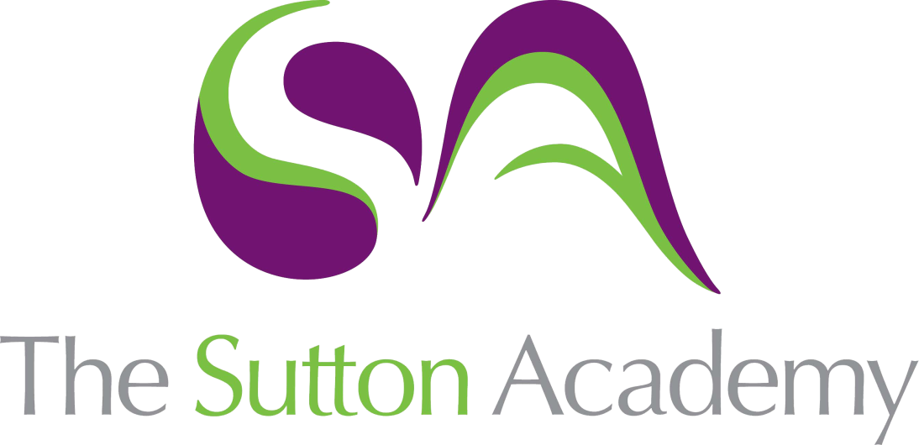

Knowledge Rich Curriculum Plan
Year 10 Intermediate – Percentages

Lesson Objective | Intended Knowledge:  Students will know that… | Tiered Vocabulary | Prior Knowledge:  In order to know this, students need to already know that… | Assessment
To learn how to solve problems involving percentages using a calculator | - Students will know how to calculate a percentage of a quantity or measurement with a calculator - they will know how to locate and use the percentage button  - Students will know how to increase and decrease an amount of measurement by a percentage with a calculator  - Students will know how to solve more complex worded problems involving fractions and percentages using a calculator  - Students will be able to calculate simple interest |  | - Students will need to know how to find fractions and percentages of amounts
To learn how to express one amount as a percentage of another and calculate percentage change | - Students will know how to express a given number as a percentage of another number by first writing as a fraction and then converting to a percentage. Students will know how to do this both with and without a calculator.  - Students will know how to calculate percentage change |  | - Students will need to know how to convert a fraction into a percentage both with and without a calculator
To learn how to calculate percentage profit and loss | - Students will know how to calculate the value of a profit or loss and use it to determine percentage profit or loss  - Students will know that $percentage profit=\frac{profit}{expense}×100$  - Students will know that $percentage loss=\frac{loss}{expense}×100$ | Profit – a financial gain, the difference between the amount earned and the amount spent in buying, operating, or producing something  Expense – the cost incurred in or required for something. | - Students will need to know how to calculate how much profit or loss has been incurred
To learn how to solve problems involving reverse percentages | - Students will know how to find the original amount given the final amount after a percentage increase or decrease (reverse percentages), including VAT both with and without a calculator (as appropriate) | VAT – Value Added Tax – a tax that is applied to the purchase price of certain goods, services and other taxable supplies that are bought and sold within the UK. Standard VAT is 20%. | - Students will need to know how to multiply by 100
To learn how to calculate with compound interest and depreciation. | - Students will know how to calculate compound interest and depreciation.  - Students will know how to solve problems involving compound interest and depreciation | Interest - a fee paid for borrowing money or other assets or an amount earned by saving money in a bank account that pays it  Compound Interest – the interest on a loan or deposit that accrues on both the initial principal and the accumulated interest from previous periods.  Depreciation – a decrease in the value  Accumulated – built up over time  Accrued – received  Initial – starting/original amount  Annum – year | - Students will need to know how to increase by a percentage  - Students will need to know how to convert percentages into decimals

