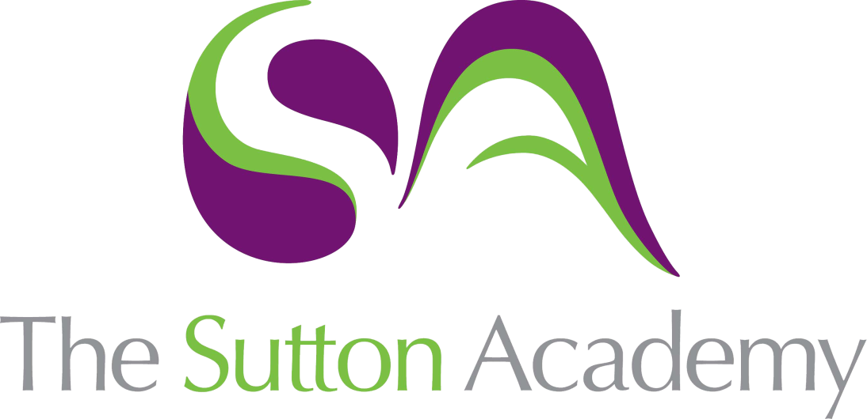

Knowledge Rich Curriculum Plan
Year 11 Foundation+ Geometry 4

Lesson/Learning Sequence | Intended Knowledge:  Students will know that… | Tiered Vocabulary | Prior Knowledge:  In order to know this, students need to already know that… | Assessment
To learn how to calculate the surface area of prisms | - Students will know how to find the surface area of prisms including cubes, cuboids and triangular prisms  - Students will know how to find the surface area of other prisms including compound prisms.  - Students will know how to solve problems involving the surface area of prisms | Surface area - the total area of all of the faces of a 3D solid added together  Prism – A solid object with two identical ends and flat sides  Compound Solid - a solid that is made up of 2 or more solids. | - Students need to know how to calculate the area of squares, rectangles, triangles and compound shapes
To learn how to calculate the surface area of cylinders | - Students will know how to find the surface area of cylinders. Students will know how to calculate this in terms of π as well as by using a calculator.  - Students will know how to solve problems involving the surface area of cylinders |  | - Students need to know how to calculate area and circumference of circles
To learn how to calculate the surface area of pyramids, cones and spheres | - Students will know how to find the surface area of pyramids.  - Students will know how to find the surface area of cones.  - Students will know how to find the surface area of sphere and hemi-spheres. |  | - Students will need to know how to find missing lengths using Pythagoras’ theorem
To learn how to calculate the volume of prisms | - Students will know that: Volume of a Prism = Area of Cross Section x Length  - Students will know how to find the volume of cubes, cuboids, triangular prisms and compound prisms by calculating the area of the cross-section and multiplying it by the length of the prism  - Students will know how to solve problems involving the volume of prisms | Volume – the amount of space inside a 3D object  Prism – A solid object with two identical ends and flat sides  Compound Solid - a solid that is made up of 2 or more solids. | - Students need to be able to calculate the area of squares, rectangles, triangles and compound shapes
To learn how to calculate the volume of cylinders | - Students will know how to find the volume of cylinders. Students will know how to leave their answers for this in terms of π.  - Students will know how to work backwards from the volume of a cylinder to calculate its height or the radius/diameter  - Students will know how to solve problems involving the volume of cylinders |  | - Students need to be able to calculate the area of circles
To learn how to calculate the volume of pyramids, cones and spheres | - Students will know how to find the volume of pyramids.  - Students will know how to find the volume of cones.  - Students will know how to find the volume of spheres and hemi-spheres. |  | - Students will need to know how to substitute into formulae
To learn how to calculate Density, Mass and Volume | - Students will know how to calculate mass, density or volume using two variables.  - Students will know how to combine the densities, mass and volumes of two materials/liquids to make a third material/liquid. Students will know how to find missing values from a liquid using the density, mass or volumes for the other liquids.  - Students will know how to solve more complex problems involving density, mass and volume | Density – a measurement of the amount of a substance contained in a certain volume  Mass – the weight of an object | - Students need to be able to convert units for mass  - Students need to be able to convert units for length and understand how to convert units for volume

