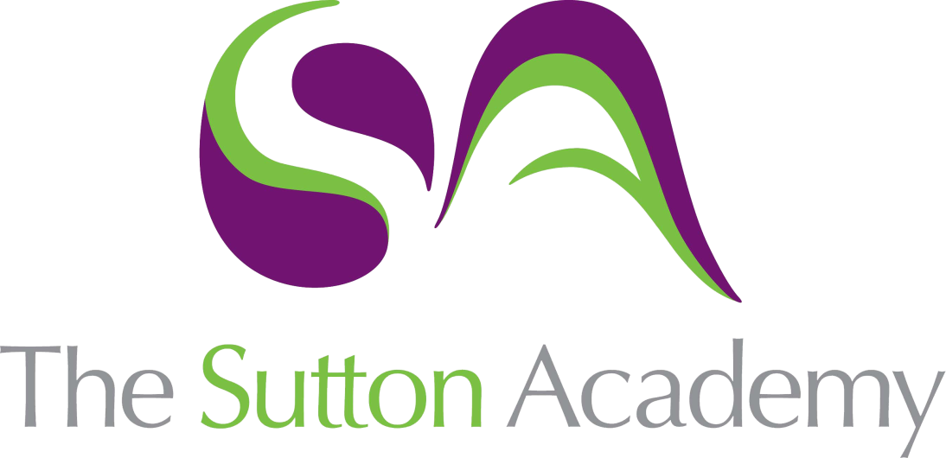

Knowledge Rich Curriculum Plan
Y9 Unit 4
La rutina diaria
Focus Skill: Reading

Lesson/Learning Sequence | Intended Knowledge:  Students will know… | Tiered Vocabulary | Prior Knowledge:  In order to know this students, need to already know… | Assessment  Home learning
Lesson 1  La rutina diaria | - How to tell the time in Spanish  - 3 time phrases – see KO  - 12 daily routine verbs – see KO | Reflexive verb  Daily | - Numbers 1-30 | Speaking tasks
Lesson 2  La rutina diaria - reflexives | - How to conjugate 7 reflexive verbs |  | - 7 daily routine verbs | Reading tasks  Listening tasks
Lesson 3  El día escolar | - How to form the preterite tense using daily routine verbs | Disappointing | - How to form the preterite tense | MWBs  Translation tasks
Lesson 4  Fui al colegio | - How to describe a day in school using the preterite tense  - El recreo = break time  - La hora de comer = lunch time  - Después de colegio = after school | Goal attack | - How to form the preterite tense  - Verbs related to a day at school  - School subject – see KO  - Time frames in the past  - Vocabulary linked to school routine. | MWBs  Translation tasks
Lesson 5  Parar y pensar | - TBC |  | - TBC
Lesson 6  Cuando comes | - 7 food/drink infinitives/present tense 1st person form – see KO | Consume | - Food and drink vocabulary  - Daily routine time phrases | Whole Class Feedback –  Reading tasks  Translation tasks
Lesson 7  Comidas y bebidas | - 14 adjectives to describe food/drink – see KO  - How to conjugate the verb soler to say what you usually do  - The verb soler is followed by an infinitive |  | - Food and drink vocabulary  - Daily routine infinitives | Reading tasks  Listening tasks  Translation tasks
Lesson 8  Qué te gusta comer | - How to compare different types of food and drink | Paella  Superlative  Sour | - How to form a comparative and a superlative using más and menos  - Food and drink vocabulary  - Positive and negative opinion phrases | Writing tasks
Lesson 9  La semana próxima | - How to say what their future plans are using the near future tense  - Voy a = I am going to + infinitive  - Me gustaría = I would like to + infinitive  - Me encantaría = I would love to + infinitive  - Tengo la intención de = I intend to + infinitive  - How to use 5 subjunctive phrases with the conditional tense – see KO | Immediate  Indicate | - How to form the near future tense  - Food and drink vocabulary  - Daily routine infinitives  - How to form the conditional tense | MWBs  Whole Class Feedback –  Reading tasks
Lesson 10  Parar y pensar | - TBC |  | - TBC

