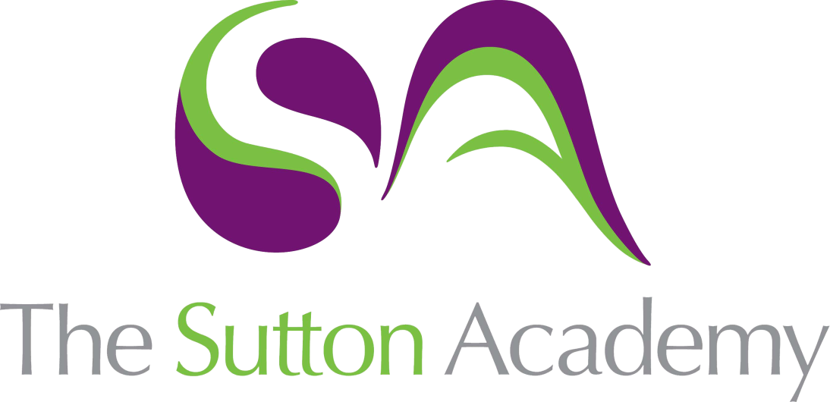

Knowledge Rich Curriculum Plan
Y7 Unit 5
En mi colegio
Focus Skill: Listening

Lesson/Learning Sequence | Intended Knowledge:  Students will know… | Tiered Vocabulary | Prior Knowledge:  In order to know this students, need to already know… | Assessment
Lesson 1  En mi mochila | - 15 pieces of vocab relating to what can be found in their pencil – see KO  - ¿Qué tienes en tu mochila? = What is in your school bag?  - How to create a response to the question ¿Qué tienes en tu mochila? |  | - Connectives – see KO  - Tengo = I have / No tengo = I don’t have  - Indefinite articles – un / una  - How to create a negative sentence in Spanish | Listening tasks  Reading tasks
Lesson 2  Las asignaturas | - 20 pieces of vocab relating to school subjects – see KO  - ¿Qué estudias en tu colegio? = What do you study in your school?  - How to create a response to the question ¿Qué estudias en tu colegio? |  | - Connectives – see KO  - Difference between masculine and feminine nouns (el/la/un/una)  - Be able to form the present tense | MWBs  Reading tasks
Lesson 3  Las opiniones | - 6 higher level opinion openers – see KO  - ¿Cuál es tu opinión de …? = What is your opinion of…?  - How to create a response to the question ¿Cuál es tu opinión de …?  - 7 adjectives |  | - Connectives – see KO  - The rule for adjective agreements – o/a/os/as  - Opinion phrases – see KO  - School subjects from lesson 2 | MWBs  Writing tasks
Lesson 4
Parar y pensar
Lesson 5  El imperfecto | - The imperfect tense is used to describe a repeated action in the past  - How to conjugate the imperfect tense  - How to conjugate 2 irregular verbs in the imperfect tense (ser and ir)  - ¿Qué estudiabas en tu escuela primaria? = What did you used to study in primary school…?  - How to create a response to the question ¿Qué estudiabas en tu escuela primaria? |  | - School subjects from lesson 2  - Adjectives from lesson 3  - Adjectives to describe personality  - Opinion phrases – see KO  - Connectives – see KO | MWBs  Whole Class Feedback –  Listening tasks
Lesson 6  Cuando era joven | - How to use the imperfect tense with verbs related to education (ir = to go; estudiar = to study; escuchar = to listen to; escribir = to write; leer = to read; hablar = to talk/speak; comer = to eat; beber = to drink; jugar = to play) |  | - How to conjugate the imperfect tense from lesson 6  - How to use llevarse to describe past relationships | Writing tasks
Lesson 7  Parar y pensar | - TBC |  | TBC
Lesson 8  Los profesores | - How to describe their teachers  - How to use correct sentence structure e.g. the teacher of…  - Students will know 3 qualifiers (muy = very; bastante = quite; un poco = a bit)  - Describe tus profesores = Describe your teachers  - How to create a response to Describe tus profesores |  | - Opinion phrases – see KO  - Adjectives to describe personality  - School subjects from lesson 2  - The rule for adjective agreements – o/a/os/as | Listening tasks  Reading tasks
Lesson 9  Los comparativos | - Comparatives are used to compare things  - How to structure a comparative in Spanish  - más (adjective) que = more (adjective) than  - menos (adjective) que = less (adjective) than |  | - School subjects from lesson 2  - Adjectives to describe personality  - The rule for adjective agreements – o/a/os/as | Translation tasks  MWBs
Lesson 10  La hora | - How to tell the time (Spanish)  - es is used from 12:31 until 13:30  - son is used for all other times  - When telling the time, y = past (the hour)  - When telling the time, menos = to (the hour)  - y cuarto = quarter past  - y media = half past  - menos cuarto = quarter to  - mediodía = midday  - medianoche = midnight  - 6 adverbs of time – see KO  - ¿Qué hora es? = What time is it?  - How to create a response to the question ¿Qué hora es? |  | - How to tell the time on an analogue clock (English)  - Numbers 1-30 | MWBs  Whole Class Feedback –  Listening tasks
Lesson 11  Parar y pensar | - TBC |  | - TBC

