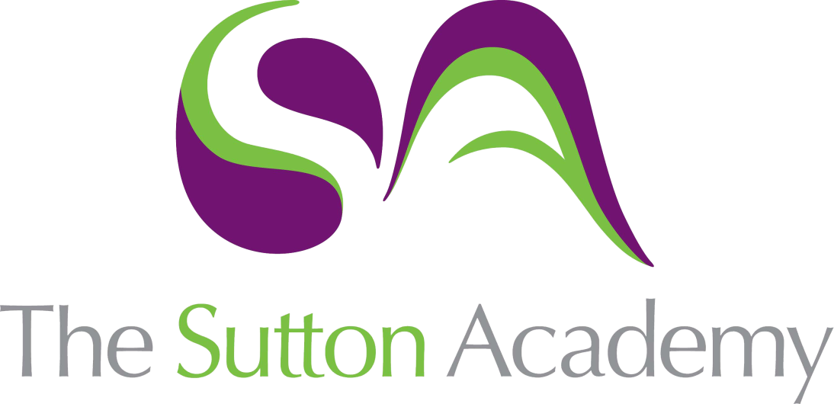

Knowledge Rich Curriculum Plan
Y7 Unit 1
Introduction to MFL – The toolkit
Focus Skill: Speaking

Lesson/Learning Sequence | Intended Knowledge:  Students will know… | Tiered Vocabulary | Prior Knowledge:  In order to know this students, need to already know… | Assessment
Lesson 1  Intro to MFL | - 7 pieces of vocab relating to asking questions in the classroom.  - 9 key instructions for use in the classroom  - Classroom expectations and routines (including class greeting in Spanish)  - Useful website/ appls to support learning – Quizlet / SpanishDict / Word reference  - Phonics – 10 key important sounds in Spanish |  |  | Where is Spanish spoken?  Do you already know any Spanish vocab?
Lesson 2  El alfabeto | - How to pronounce the letters of the alphabet in Spanish  - Students will be able to correctly spell words by listening to letters aloud.  - How the accent on ‘ñ’ affects the pronunciation of this letter. |  | - The different sounds made by letters in Spanish – Phonics from lesson 1. | What are some ways we can greet each other in Spanish?  ¿Como se escribe tu nombre?
Lesson 3  Basic greetings | - 8 greetings in Spanish  - ¿Cómo te llamas? = What is your name?  - How to create a response to the question ¿Cómo te llamas? – Me llamo – my name is  - ¿Qué tal / Cómo estas? = How are you?  - How to create a response the question ¿Qué tal / Cómo estas?  - 7 adjectives |  | - Greetings – see KO  - Adjectives – see KO | ¿Cómo te llamas?  Me llamo…  ¿Cómo estas?  Estoy bien/mal/estupendo
Lesson 4  Numbers | - Numbers 1- 100  - How to pronounce the numbers correctly using phonics. |  | - Phonics from lesson 1 | Uno + tres  Tres + dos  Dos + cuatro
Lesson 5  Numbers and age | - ¿Cuántos años tienes? = How old are you?  - In Spain, we use ‘Tengo’ to say how old you are i.e. ‘tengo once años’  - Cultural Capital: ‘San Fermín’ and will use a song to practise numbers |  | - Numbers from lesson 4  - Phonics from lesson 1 | Whole class feedback – students receive a list of 10 words that they have to write out phonetically and their meaning  - Hola  - Me llamo  - Qué  - Años  - Días  - Cinco  - Cuatro  - Doce  - Quince  - Veinte
Lesson 6  Parar y pensar | - TBC |  |  | Uno + tres  Tres + dos  Dos + cuatro  ¿Cómo te llamas?  Me llamo…  ¿Cómo estas?  Estoy bien/mal/estupendo  What are some ways we can greet each other in Spanish?  ¿Como se escribe tu nombre?  Where is Spanish spoken?  Do you already know any Spanish vocab?
Lesson 7  Days and months | - 7 days of the week  - 12 months of the year  - ¿Cuándo es tu cumpleaños? = When is your birthday?  - How to create a response the question ¿Cuándo es tu cumpleaños? – Mi cumpleaños es el … de ….  - ¿Cuál es la fecha de hoy? = What is the date today?  - How to create a response the question ¿Cuál es la fecha de hoy? – lunes el dos de marzo |  | - Numbers from lesson 4 | ¿ Cuándo es tu cumpleaños?  ¿Cuál es la fecha de hoy?
Lesson 8  Birthday | - How to have a conversation with another person  - Students will talk with fluency and accuracy.  - Cultural Capital: La Quinceañera |  | - Phonics from lesson 1  - Greetings lesson 2  - ¿Cómo te llamas? = What is your name?  - Me llamo = my name is  - ¿Qué tal / Cómo estas? = How are you?  - Numbers from lesson 4  - ¿Cuántos años tienes? = How old are you?  - ¿Cuándo es tu cumpleaños? = When is your birthday?  - Days and months from lesson 7 | ¿ Cuándo es tu cumpleaños?  ¿Cuántos anos tienes?
Lesson 9  Vivir | - ¿Dónde vives? = Where do you live?  - How to create a response the question ¿Dónde vives? – Vivo en…  - There are 3 different verb endings in Spanish ‘AR/ER/IR’  - The verb ‘Vivir’ means ‘To live’  - The verb ‘Vivir’ is an ‘IR’ verb  - To conjugate the verb ‘Vivir’ | To Conjugate | What the present tense is and when we use the present tense. | ¿Dónde vives?
Lesson 10  Dictionary lessons | - What a bilingual dictionary is  - How to use a bilingual dictionary  - ‘El/ La’ – definitive articles = The  - ‘Un/Una’ – indefinitive articles – A | Bilingual | - The alphabet from lesson 2  - How to use a dictionary  - Definitions for :  - Adjectives  - Verb  - Noun  - Masculine  - Feminine  - Singular  - Plural  - Infinitive | Whole class feedback –  students have a general conversation with each other based upon 5 questions. This is performed aloud in class and they receive feedback on – pronunciation/ intonation/ fluency  - ¿Qué tal?  - ¿Cómo te llamas?  - ¿Cuántos años tienes?  - ¿Cuándo es tu cumpleaños?  - ¿Dónde vives?
Lesson 11  Parar y pensar | - TBC

