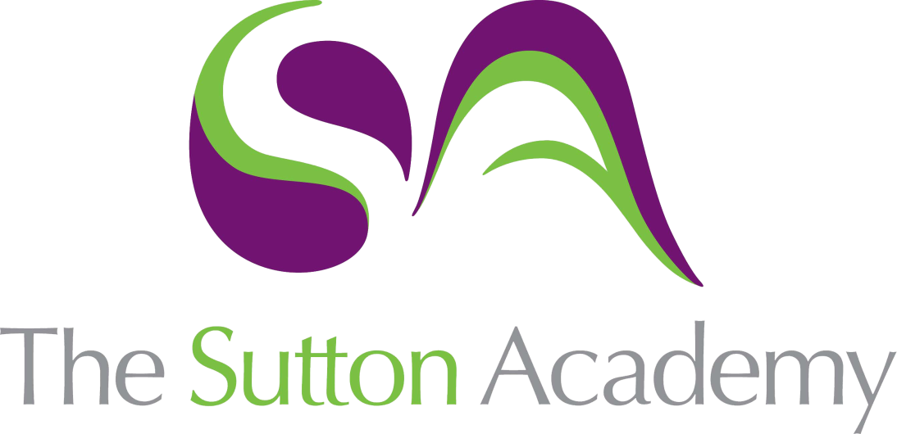

Knowledge Rich Curriculum Plan
Y7 Unit 6
La comida y la bebida
Focus Skill: Speaking

Lesson/Learning Sequence | Intended Knowledge:  Students will know… | Tiered Vocabulary | Prior Knowledge:  In order to know this students, need to already know… | Assessment
Lesson 1  La comida y la bebida | - How to say what they eat and drink using the verbs comer, beber, desayunar, merendar and cenar  - 12 items of food/drink – see KO |  | - Noun gender and plurality  - 9 time adverbs | Listening tasks
Lesson 2  El imperfecto | - How to say what they used to eat and drink using the verbs comer, beber, desayunar, merendar and cenar |  | - How to conjugate the imperfect tense  - Items of food and drink | MWBs
Lesson 3  Comida y bebida cuando era joven | - Consolidate the use of the imperfect tense within the topic of food and drink |  | - How to conjugate the imperfect tense  - Items of food and drink | Whole Class Feedback –  Speaking tasks
Lesson 4  Parar y pensar | - TBC |  | - TBC
Lesson 5  Las diferencias entre Inglaterra y España | - The main cultural differences in terms of food/drink between Spain and England  - A range of Spanish food/drink – see KO |  | - English food/drink stereotypes | Reading tasks  Listening tasks
Lesson 6  En el restaurante | - 15 food/drink items – see KO  - 3 verbs in the future/conditional tense – me gustaría (I would like), quisiera (I want), voy a (I am going to) + infinitive  - How to order food in a restaurant (role play situation) |  | - Infinitive verbs related to food/drink – comer, beber, , desayunar, merendar, cenar, tomar | Speaking tasks
Lesson 7  Recetas españolas | - 7 cooking/kitchen items – see KO  - Ingredients for making paella – see KO  - Cooking verbs – see KO |  | - Items of food and drink  - A range of vocabulary related to food/drink/cooking | Reading tasks  Translation tasks
Lesson 8  Vamos a cocinar | - 7 cooking/kitchen items – see KO  - Ingredients for making paella – see KO  - Cooking verbs – see KO |  | - Items of food and drink  - A range of vocabulary related to food/drink/cooking | Listening tasks  Whole Class Feedback –  Translation tasks
Lesson 9  Vamos a probar | - TBC |  | - TBC
Lesson 10  Parar y pensar | - TBC |  | - TBC

