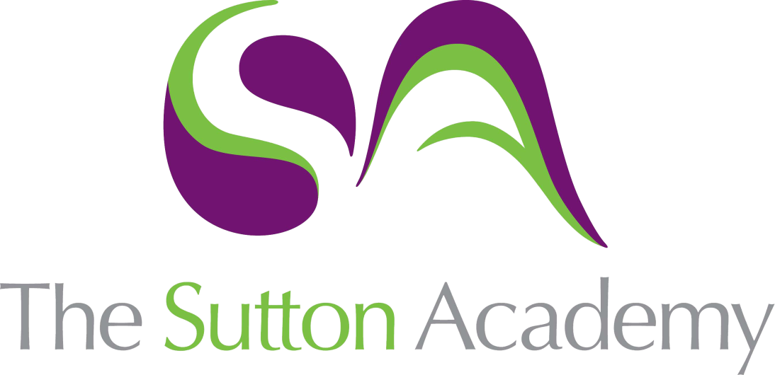

Knowledge Rich Curriculum Plan
Y8 Unit 1
La Vida Sana
Focus Skill: Reading

Lesson/Learning Sequence | Intended Knowledge:  Students will know… | Tiered Vocabulary | Prior Knowledge:  In order to know this students, need to already know… | Assessment
Lesson 1  El cuerpo | - 15 body parts – see KO | Cerebral  Corpse | - Noun rules (masculine, feminine, singular, plural) | Reading tasks  MWBs
Lesson 2  Me duele | - How to conjugate the verb doler (to hurt)  - To use desde hace and desde to say how long something has been hurting for/since | Reflexive verb | - Noun rules (masculine, feminine, singular, plural) | Translation tasks  Reading tasks
Lesson 3  Pasánadalo mal | - 15 illnesses – see KO | Ailment | - How to conjugate the verbs doler, estar and tener | Whole Class Feedback –  Reading tasks
Lesson 4  Los remedios | - 6 remedies – see KO | Remedy | - How to conjugate the verbs doler, estar and tener | Translation tasks
Lesson 5  Parar y pensar | - TBC |  | - TBC
Lesson 6  Tienes una dieta sana | - 14 items of food and drink – see KO | Nutritious  Diet  Protein | - How to conjugate the verbs comer and beber  - Verbs relating to eating/drinking/mealtimes  - Time phrases – see KO | Speaking tasks  Reading tasks
Lesson 7  Tenías una dieta sana | - How to say what their diet used to be like using the imperfect tense | Vegetarian  Consumption | - How to conjugate the imperfect tense | Reading tasks  Listening tasks  MWBs
Lesson 8  Voy a tener una dieta sana | - How to say what their diet is going to be like using the near future tense  - 11 future tense time phrases – see KO | Monotonous | - How to conjugate the near future tense | Whole Class Feedback –  Reading tasks  Listening tasks  MWBs
Lesson 9  Una vida sana (tres tensos) | - How to say what their diet is like in 3 tenses (imperfect, present, near future) | Conjugate | - How to conjugate the imperfect, present and near future tenses | Writing tasks
Lesson 10  Para llevar una vida sana | - How they are going to lead a healthier life using the verb llevar  - 5 positive lifestyle changes – see KO  - 5 negative lifestyle changes – see KO  - How to conjugate the verb deber to say what they should do to improve their lifestyle |  | - How to conjugate the near future tense  - Lifestyle infinitives and nouns – see KO | Speaking task  MWBs
Lesson 11  Vamos a escribir | - How to complete a short writing task based on 4 bullet points  1. qué comes y bebes  2. tienes una dieta sana  3. que comías y bebías cuando eras joven  4. qué vas a hacer para llevar una vida sana |  | - How to conjugate the imperfect, present and near future tenses  - Verbs relating to eating/drinking/mealtimes/lifestyle  - Time phrases – see KO | Writing tasks
Lesson 12  Parar y pensar | - TBC |  | - TBC

