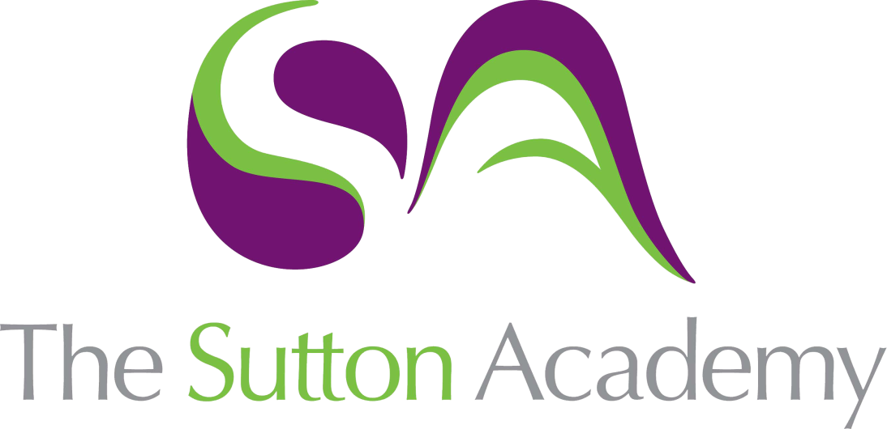

Knowledge Rich Curriculum Plan
Y11 HT1
Los trabajos

Lesson/Learning Sequence | Intended Knowledge:  Students will know that… | Tiered Vocabulary | Prior Knowledge:  In order to know this students, need to already know that… | Assessment
Lesson 1 – Los trabajos | - 15 types of jobs – see KO  - Different techniques to tackle reading papers | Vocation  Gastronomy | - Different work places | Past paper reading questions
Lesson 2 – Los trabajos – escuchar | - 8 adjectives to describe working personalities – see KO  - 6 adjectives to describe different types of jobs – see KO  - Approaches to apply to positive and negative listening style questions | Client  To vend  Monotonous  Responsibility | - Different types of jobs | Listening questions
Lesson 3 – Los trabajos – leer | - 12 phrases that people do in relation to different jobs – See KO  - Approaches to true or false reading style questions and gap fill activities | Preterite tense  Exploilted  Charity | - Different jobs and adjectives to describe those | Reading questions
Lesson 4 – Parar y pensar
Lesson 5 – Ambiciones - educación | - How to describe their plans for future education  - 6 keys phrases to use that link to the future follow by the infinitive – See KO | Future tense  Conditional tense | - How to form the conditional tense  - How to use subjunctive phrases | Translation tasks
Lesson 6 – Ambiciones – trabajo | - How to describe their plans for future work / jobs / career aspirations  - 8 key phrases – See KO | Future tense  Conditional tense | - Different jobs  - Opinions to describe different jobs  - How to form the future tense  - How to form the conditional tense | Listening task  Translation task
Lesson 7 – Exam practise | - Reading exam focus – Theme 3 – School and Education  - Students will practise different skills to be able to tackle the varied range of reading questions on the GCSE reading exam. |  | - School subjects  - Adjectives to describe their school building  - Adjectives to describe their teachers | Whole class feedback  Past paper reading questions
Lesson 8 – Exam practise | - Listening exam focus – Theme 3 – School and Education  - Students will practise different skills to be able to tackle the varied range of reading questions on the GCSE reading exam. |  | - School subjects  - Adjectives to describe their school building  - Adjectives to describe their teachers | Whole class feedback  Past paper Listening questions
Lesson 9 – Exam practise | - Speaking exam focus – deliberate practise of photo cards and role play style questions |  | - School subjects  - Adjectives to describe their school building  - Adjectives to describe their teachers | MWB  Oral assessment.
Lesson 10 – Exam practice | - Translation focus – deliberate practise of translation tasks – 5 sentences for foundation and a paragraph translation for higher. |  | - School subjects  - Adjectives to describe their school building  - Adjectives to describe their teachers  - The preterite tense  - The imperfect tense  - The future tense  - The conditional tense | Whole class feedback  Translation tasks,

