Year 7 - Rounders
Unit aim | To become more competent and confident when using batting techniques.
Lesson outcomes | Demonstrate a basic bowling technique that reaches the batter for a good ball. | Demonstrate correct batting stance and develop technique to make good contact. | Develop batting techniques to counter different bowl placement | Demonstrate correct technique to be able to bat for distance (transfer of weight) | Demonstrate awareness when batting to outwit the fielders
Intended Knowledge | Students will know…  1. How to bowl the ball with correct technique  Bowl – how the ball is delivered to the batter  2. What is classed as a good bowl and that a no ball is above the head, below the knee, wider than the batters reach or bowled at the batter’s body.  4. The importance of bowling to the backstop  Backstop – the player who stands behind the batter if they miss or hit the ball behind. | Students will know…  1. How to perform a basic batting technique  2. Why you swing across the body and not up or down  3. Basic rules including; do not drop the bat or step outside the batting box and run on the outside of posts  Batting box – where the batter has to stand to bat  Posts – the 4 points of the pitch that batters must reach (anticlockwise) | Students will know…  1. The importance of being ready to react  2. How moving your feet can help you respond to a different bowl  Respond – how you react to something  3. That you must touch 4th post to score a rounder. This can be with your hand or your bat.  4th post – the last post that makes up the pitch. | Students will know…  1. How to add more power to their strike  Strike means hit, as in hit the ball.  2. The importance of transferring weight in your feet.  Transfer of weight – putting all your weight on one foot then moving to the other foot.  3. How hitting further increases chance of scoring. | Students will know…  1. How to adjust feet in response to ball placement  Adjust – alter or move something  Ball placement – where the ball is aimed for  2. The importance of aiming for the gaps to outwit fielders  Outwit – get the better of the team, outsmart them.  Retrieve – bring something back from somewhere (ball)  3. The basic scoring system (only after their bat: 1/2 for getting to 2nd, 1 for getting to 4th, ½ for getting to 4th without hitting ball)  4. That fielders can stump the post the batter is running towards to get them out and only one batter should be waiting on a post.  Stump – hit the ball against the post.
Prior knowledge | Students will know that rounders is a striking and fielding game involving two teams.  They will know the game involves batting, bowling and fielding. | Students will know how to perform a basic bowling technique.  Students will know what counts as a ‘good ball’. | Students will know how to perform a basic batting technique.  They will know that the bat is held with only one hand and you must be in the batting box.  Students will know that they must not drop the bat and carry to with them. | Students will know that batters have to run anticlockwise around 4 posts of the pitch.  They will know that you must contact the post you are running to/waiting at. | Students will know how to add power to their hits by transferring weight and using a full swing.  Students will know how to use a basic scoring system of getting a rounder ff you reach 4th post and half if you reach 2nd post after their bat.

Lesson 1 – Basic bowling technique
Do now | What are striking and fielding games?  What striking and fielding games can you name?  How do you bowl in rounders?
Teacher exposition  (I do) | Context  Bowling is one of the fundamental skills in rounders. It is how every ball is started when a new batter comes in to bat so is an extremely important skill to master. A bowler should aim to reach the backstop so if the batter misses, the back stop can immediately throw the ball without having to retrieve it.  - Face target, ball in thumb and finger tips  - Swing straight arm back  - Step forward on non-throwing leg whilst swinging arm forward  - Release ball in front  - Point to target aiming for back stop  - Use an underarm action  - A no ball is above the head, below the knee, wider than the batters reach or bowled at the batter’s body.
Learning task (We do / you do)

Practice – bowling for distance  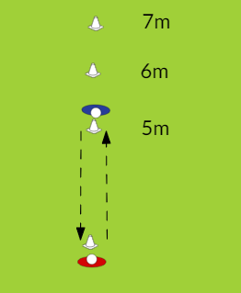  - In pairs start bowling over 5m  - Must perform 10 each accurate bowls before moving back. |  |  | Application – bowling game  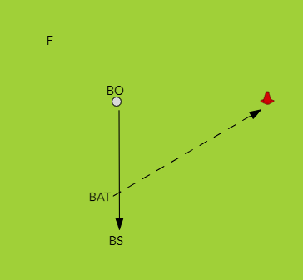  - 4s - BO, BAT BS, F (on a rotation)  - Bowling distance appropriate for group  - Batter hits, F collects  - Batter runs round first and back to score  - Bowler scores if batter misses  - 5 bats each, using bowling rules
Responsive adaptations | Developing  - Use tennis ball  - Shorter distance to bowl and to post  - Use larger bat | Securing  - Use rounders ball and bat  - Progress an extra metre to reach backstop (10.5m) |  | Mastering  - Full bowling distance (to backstop)  - Begin varying type of bowling action  - Full distance to first
Progress check questions | - What is the technique used to bowl in rounders? Underarm, ball in fingers, straight arm swing back and forward, step on opposite foot, release ball out in front  - Why do we aim for the backstop? To get the ball to reach the batter and because the bowler wants the batter to miss.  - How can the bowler outwit the batter? Vary the bowling style, be in their box with the ball to stop the batter progressing around the posts.
Errors or misconceptions to look out for | Ball low – not stepping in, not extending arm out, releasing ball too early  Ball flicks up and falls short - ball stuck in palm  Ball high – releasing too high or too late  Ball wide or at the body – arm not pointing at target  Staying in the bowling box - You can step out of the box as long as one foot is kept in when bowling. Bowler can come out of box during play.

Lesson 2
Do now | What is a good bowl?  How many hands are used to hold a rounders bat?
Teacher exposition  (I do) | Context  Batting is a fundamental skill in rounders. It is important to learn the correct technique as other striking and fielding games use different techniques for batting. Making good contact with the ball is key to increasing the chances of making it round the 4 posts. Swinging across encourages good contact. Swinging up would increase the chances of being caught, and swinging down would result in the ball being hit into the ground close by.  - Side on stance  - Feet shoulder width apart, knees slightly bent  - Bat pointing up with arm held back at chest height  - Swing arm across body as you twist torso  - Watch ball onto bat, as you make contact
Learning task (We do / you do)

Practice – batting drill  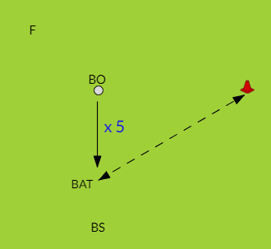  - 4s - BO, BAT BS, F (on a rotation)  - 5 consecutive good balls each  - Point for every ball hit  - Fielders collects balls after 5th ball |  |  | 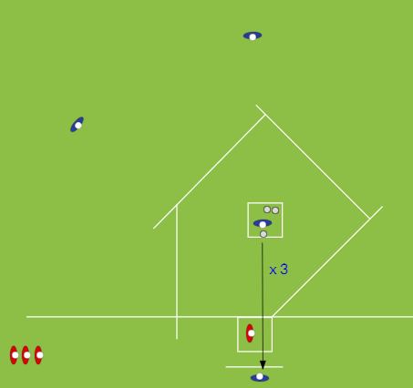  Application – 3 ball rounders  - Two teams of 4  - Bat 3 consecutive good balls  - Fielders move after 3rd bowl  - Aim to reach 4th to score  - Fielders return balls to bowling square  - Use basic rules
Responsive adaptations | Developing  Use hand first to bat  Use paddle bat/racket  Use batting tee  Game: Smaller pitch, reduce bowling distance | Securing  Use rounders bat and balls  Drill: run to first and back whilst balls collected. Point every time they return to batting cone.  Game: Full size pitch  Introduce targets to aim for |  | Mastering  Encourage to hit with power  Start to vary bowl for batter to react to.  Use targets to aim for.  Start to vary placement.  Bonus point if batter can get to first post after completing a rounder.
Progress check questions | - What is the basic technique for batting? Side on stance, bat held right back and pointing upwards, swing across your body  - Why should you not swing up or down? Swinging down means ball hits ground sooner and doesn’t travel as far, hitting up has a risk of being caught out  - How can the batter outwit the fielders? Aim for the gaps, add more power so the ball travels further.
Errors or misconceptions to look out for | - Standing square on to bowler – stand side on  - Holding batting arm down – no time to lift bat and swing  - Ball missed – not ready, swing too early/late  - Ball goes into ground – batter swings downwards  - Ball goes up in the air - batter’s arm close to body and swings upwards  - Balls all thrown to bowler at once – lack of communication, backstop staying in position (can move)

Lesson 3
Do now | What are the different ways a bowl can be called as a no ball?  What could you do to react to different bowls e.g. by your head/waist/slightly wider?
Teacher exposition  (I do) | Context  The ball will approach the batter in many different ways; flat, looped, angled, spun and at speed. It is important to be able to judge a ball and know how to move the feet in response to the bowl quickly. This will increase the chances of the batter making good contact.  - Side on stance, point shoulder to batter  - Feet shoulder width apart, knees slightly bent  - On balls of feet ready to react  - As ball approaches, move feet so you can still swing and make contact  - E.g. Ball high- step back, ball low – step forward towards the ball  - Make sure one foot is kept in the batting box at all times.
Learning task (We do / you do)

Practice – batting drill  - 4s - BO, BAT BS, F (on a rotation)  - 5 consecutive good balls each  - Fielders collects balls after 5th ball  - Run round first post and back whilst balls collected. Point scored for each shuttle completed. |  |  | Application – 3 ball rounders  - Two teams of 4  - Bat 3 consecutive good balls  - Fielders move after 3rd bowl  - Aim to reach 4th to score  - Fielders return balls to bowling square – must be inside the square but can still be moving  - Use basic rules
Responsive adaptations | Developing  Use paddle bat/racket  Use batting tee  Game: Smaller pitch, reduce bowling distance | Securing  Use rounders bat and balls  Game: Full size pitch  Encourage aiming for gaps (may use targets) |  | Mastering  Encourage to hit with power  Vary bowl for batter to react to (intentionally).  Use targets to aim for.  Bonus point if batter can get to first post after completing a rounder.
Progress check questions | 1. What is classed as a ‘good ball’? Not above head, not below knee, not at the body, not wider than the bat length away.  2. Why must the batter be on their toes before the bowl? To react to different styles of bowl e.g. fast, donkey drop, angled.  3. How would the batter react if the ball was lower/higher/wider? Lower – step forward on to ball, Higher – step backwards to give more time, however make sure the batter stays in the box.
Errors or misconceptions to look out for | - Not in batting stance – get in correct stance immediately after you reach the batting square  - Ball missed/limited distance – flat footed, not moving feet quick enough  - Stepping out of the batting square – starting too close to the edges  - Out even if past 4th – didn’t touch 4th

Lesson 4
Do now | What are the rules a batter must follow?  How can you get the ball to travel further when batting?
Teacher exposition  (I do) | Context  Being able to transfer weight from the back leg to the front is key to applying more power to the ball when batting. If this can be achieved, the ball is likely to travel further and increase the chances of scoring because there will be more time to reach each post as the fielders take longer to retrieve the ball.  - Batting stance – weight on back foot (foot closest to the backstop)  - As you swing bat, transfer weight to front foot using a rocking motion  - Twist hips towards target  - Snap wrist to add more power  - Follow through to target
Learning task (We do / you do)

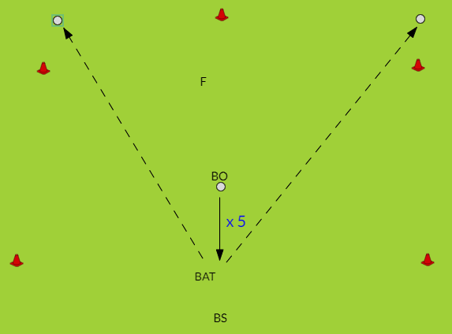  Practice –Batting for distance  - 4s - BO, BAT BS, F (on a rotation)  - 5 good balls each  - Set up boundary using cones (approx. 15-20m)  - Point for every ball hit beyond it |  |  | 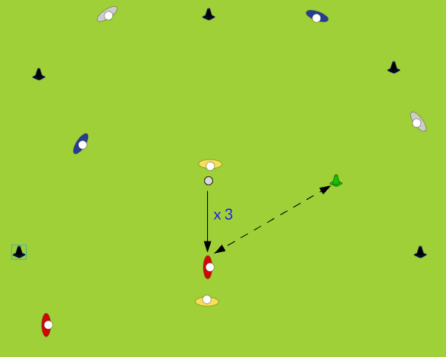  Application – Boundary game  - Four teams of 2 (on a rotation)  - 2 bat, 2 BS/BO, 4 fielders  - Batter hits 3 consecutive good balls then runs to first post and back – point for each shuttle completed  - Fielders return balls to bowling cone after 3rd bowl  - 3 turns each, using basic rules.
Responsive adaptations | Developing  Use paddle bat  Use batting tee –others extra fielders  Shorter boundary  First post closer | Securing  Use rounders bat and balls  Increase boundary distance  One fielder must start outside boundary  May use full pitch to run around. |  | Mastering  Increase boundary distance  More fielders outside boundary  so have to hit with power AND aim for gaps  Use full pitch to run round.  Vary bowl for batter to react to
Progress check questions | - What does ‘transfer your weight’ mean when batting? Weight starts on back foot then move weight to front foot as you bat which allows the batter to add more force when they contact the ball.  - Why will hitting the ball further help the batter? Further ball is hit, longer it will take for fielders to return the ball so batter can make more progress around the posts.  - How might the fielders outwit the batting team? Spread out in the field, try to predict where the ball will be hit e.g. right handers more likely to their left, back other fielders up if ball is hit far.
Errors or misconceptions to look out for | Limited distance on strike – not enough speed in swing and not snapping wrist  Stepping out of the batting square – starting too close to the edges and becoming unbalanced

Lesson 5
Do now | Why is it important to vary where you hit the ball?
Teacher exposition  (I do) | Context  When playing rounders, the batting team are more likely to score if they can aim the ball into the gaps where the fielders are not positioned. This allows more time to run around the posts and increases the chances of scoring. It is also beneficial to vary where you hit the ball so the fielders can’t predict where you will aim and cover that area.  - Normal batting stance  - As ball approaches, quickly move feet so non-batting shoulder is pointing at target  - Follow through swing so bat points at target  - Stand at back of batting square to have more time to react
Learning task (We do / you do)

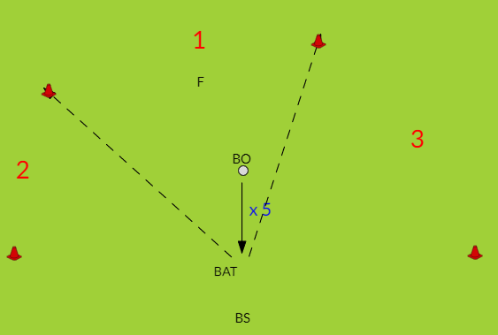  Practice – Target practice  - In 4’s bowler, batter, backstop, fielder  - Set up three target zones worth points  - 5 good balls each, highest points wins  - Fielder decides where they stand  - Switch if left handed |  |  | 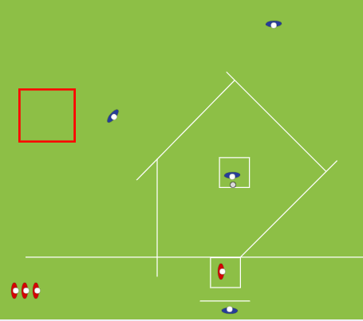  Application – Target game  - Two teams of 4 – use basic rules  - Reduced pitch rounders game  - Batters select a 5m x 5m target area (clear of posts)  - No fielder allowed in target  - If ball is hit in area, bonus rounder scored  - 2nd innings – fielders decide target area and switch positions
Responsive adaptations | Developing  Use batting tee first –others extra fielders  Use paddle bat  Smaller pitch  Game: Larger target  Batters always chose target | Securing  Use rounders bat and balls  Drill - Make middle zone larger  Game: Larger pitch |  | Mastering  Introduce backhand off a tee  Drill: Extra points if hit to fielder who acts as a smaller target  Game: Fielders decide targets  Smaller target
Progress check questions | - What is the best place to hit the ball in Rounders? Aim for the gaps where fielders are not stood.  - How will this allow the batters to outwit the fielders? Ball going into gaps means it will travel past the fielders so they have to retrieve it which gives batters more time to get around the posts.  - Why is it important to vary where you hit the ball? Harder for fielders to predict where ball will go.
Errors or misconceptions to look out for | Hitting in the same area – not adjusting feet quickly enough  Running a team mate out – not looking to see what team mate in front is doing  Not maintaining contact with post – encourage holding post at all times when waiting

