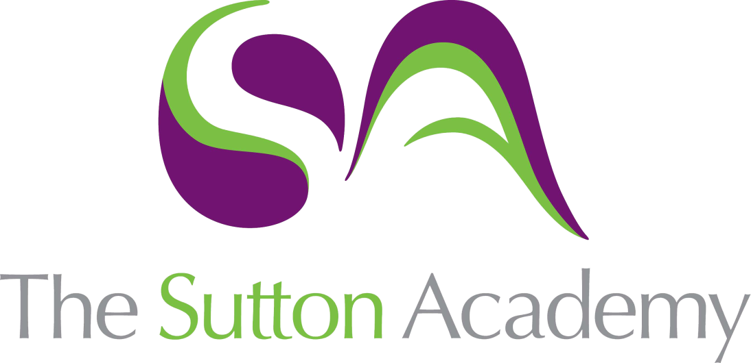

Knowledge Rich Curriculum Plan
BTEC Sport Unit 3

Lesson/Learning Sequence | Intended Knowledge:  Students will know that… | Tiered Vocabulary | Prior Knowledge:  In order to know this students, need to already know that… | Assessment
A Understand the career and job opportunities in the sports industry  Lesson 1 - 2 | A1 Scope and provision of the sports industry  The size, breadth and geographic spread of the sports industry, locally and nationally and factors that affect sports provision and employment opportunities.  • Sport and recreation industry data, economic significance, number of jobs.  • Geographical factors – location, environment, infrastructure, population.  • Socio-economic factors – wealth, employment, history, culture, fashion and trend.  • Season factors, e.g. swimming pools that only open in the summer, summer camps, holiday sports clubs, competition seasons, training camps. | Geographical  Socio-economic  Industry  Employment | Students will be aware of jobs within the sporting industry having covered some content and level 2 and 3.  Students will be aware of their community and what sports jobs are available.  Students will know what sports are available to them locally and at what times of the year.
A Understand the career and job opportunities in the sports industry | A2 Careers and jobs in the sports industry  • Key pathways – coaching, sports science (e.g. nutritionist, sport psychology, sports therapy and injury management in sport performance, exercise and fitness), sports development (e.g. sports development officers, National Governing Body (NGB) officers, sports administrator) leisure management (e.g. facility management, grounds keeping, activity coordinator) education, sports journalism.  • Sectors – public, private, voluntary, third sector, public/private partnerships.  • Local employers – public, private, voluntary, third sector, public/private partnerships.  • National employers – public, private, voluntary, third sector.  • Sources of information on careers in sports.  • Definitions of types of employment and practical examples across different sports sectors and career pathways, locally and nationally:  o full time  o part time  o fixed-term contract o self-employment (independent, subcontracted)  o zero-hours contract  o apprenticeships. | Therapy  Coordinator | Students will be aware of some key pathways to have a career in the sports industry. Students will know how to find that chosen career pathway through their knowledge of UCAS.  Students will know some of the different sectors in careers/employment.  Students will know what types of employment are available in most careers.
A Understand the career and job opportunities in the sports industry | A3 Professional training routes, legislation, skills in the sports industry  • Career pathways – progression routes and successive jobs in different pathways:  o coaching, e.g. NGB awards different disciplines, disability sport, working with children, safeguarding awareness  o sports science – specialisms, e.g. nutritionist, sport psychology, sports therapy and injury management in sport performance, exercise and fitness  o sports development, e.g. sports development officer, NGB leads, sports administration, talent pathway leads  o leisure management, e.g. lifesaving, facilities management/maintenance, health and safety, customer service, marketing and promotion, finance, management activities  o education pathways, e.g. Level 2 and Level 3 specialist qualifications, higher education.  • Job descriptions and personal specifications for sports industry jobs.  • Industry standards – safeguarding (Disclosure and Barring Service (DBS)), codes of practice, e.g. Register of Exercise Professionals (REPs), Sports Coach UK, organisational policies and procedures.  • Safeguarding – DBS: self-disclosure, enhanced disclosure, regulations and requirements.  • Sector-specific legislation that impacts on job roles.  • Qualification and professional bodies, e.g. REPs, Sports Coach UK, Minimum Standards for Active Coaches, NGBs, Chartered Institute for the Management of Sport and Physical Activity (CIMSPA), Adventure Activities Licensing Authority (AALA). |  | Students will have knowledge of training routes into some careers from their own experiences (i.e. applying for university courses etc).  Students will have knowledge of safeguarding in the sports industry (especially schools).  Students will be aware of qualifications that can be obtained in the sport industry (e.g. coaching qualifications).
A Understand the career and job opportunities in the sports industry | A4 Sources of continuing professional development (CPD)  Maintaining professional development in specific career pathways.  • Memberships of professional bodies: fees, qualification, logs of CPD.  • Required updates to professional competences, e.g. first aid, safeguarding.  • Career progression training – specific to sector, higher levels of qualification, management training sector specific, business or generic management, higher education FdSc, BA, BSc.  • Gaining knowledge and experience through cross-sector opportunities, e.g. participation in cross-sector organisation board working groups, elite performance programmes. |  | Students knowledge in this area may be limited.
B Explore own skills using a skills audit to inform a career development action plan | B1 Personal skills audit for potential careers  Producing a personal skills audit against a chosen career pathway.  • Interests and accomplishments.  • Qualities – reliability, organisational skills, commitment, resilience, empathy.  • Basic skills – literacy, numeracy and IT.  • Experience, e.g. sporting, leadership, work, travel.  • Qualifications – educational and sector specific.  • Generic employability skills – teamwork, cooperation, communication, problem solving.  • Specific technical skills, e.g. coaching, instructing, leading, administering test protocols.  • Using SWOT (strengths, weaknesses, opportunities, threats) analysis. |  | Students will be able to explain their own and also that of a career specific examples of personal skills in the sports industry.  Some students will have had access to a SWOT analysis previously.  Students will have an understanding of qualifications from A3.
B Explore own skills using a skills audit to inform a career development action plan | B2 Planning personal development towards a career in the sports industry  • Use of personal skills audit to produce an action plan towards a sports and recreation industry career.  • Identification of key timescales, e.g. immediate actions, next year, two years, five years, and ten years.  • Identification of training/educational/experiential aims at these key times and processes to achieve these goals.  • Careers guidance and support available and education choices.  • Career development action plan (CDAP) – definition; higher levels, specialism and diversification, aims, milestones, measures.  • Professional development activities – workshops, training, job shadowing, self-reflection. |  | Students knowledge in this area may be limited.
B Explore own skills using a skills audit to inform a career development action plan | B3 Maintaining a personal portfolio/record of achievement and experience Personal portfolio/record of achievement:  • educational certificates  • sport-specific awards  • sporting achievements  • testimonials  • press cuttings  • work experience  • volunteering  • any other relevant evidence  • CVs targeting sports industry jobs. |  | Students will have created a CV in sixth form.
C Undertake a recruitment activity to demonstrate the processes that can lead to a successful job offer in a selected career pathway | C1 Job applications Selection of a job role in a suitable career pathway, identified from skills audit and CDAP and then preparation of all the relevant documents:  • a job advertisement giving suitable examples of where it could be placed  • job analysis  • job description  • person specification  • application form  • personal CV  • letter of application |  | Students will have created a CV in sixth form.  Students will know how to find job advertisements.  Students will know how to navigate from a job advertisement to gain an understanding of the job description, PS and job analysis.
C Undertake a recruitment activity to demonstrate the processes that can lead to a successful job offer in a selected career pathway | C2 Interviews and selected career pathway-specific skills  • Communication skills required for interview situations: body language and listening skills, professional approaches, formal language, skills and attitudes of interviewee, role play, body language, dress, interview questions.  • Presentation skills – for micro-teach, for micro-coach.  • Career pathway-specific technical knowledge/skills displayed, e.g. coaching, instructing, leading, handling equipment, following testing protocols.  • Interview feedback form.  • Observation form.  • Reviewing applications from peer group.  • Submitting applications to peer group.  • Demonstration of a work-related competence (interviewing and being interviewed), analysis of how the activity worked, if the correct questions were asked to achieve the desired outcome, if the advertisement, job description and person specification led to the application form and covering letter being completed with the right level of information; adherence to equal opportunities legislation. |  | Students will have a basic understanding of interviews. They will have been involved in one to be accepted at sixth form.  Students will have access to the following in C1:  • job analysis  • job description  • person specification  • application form
D Reflect on the recruitment and selection process and your individual performance | D1 Review and evaluation  • Role-play activity.  • Individual appraisal of own roles in being interviewed, interviewing and observing.  • Review of communication skills.  • Review of organisational ability.  • Assessment of how the skills acquired support the development of employability skills. |  | Students will have knowledge of reviewing and evaluation their own performance from numerous subject areas.
D Reflect on the recruitment and selection process and your individual performance | D2 Updated SWOT and action plan  • SWOT analysis on individual performance in the role-play activities.  • Self-critique of the events and documentation prepared and how it supported the activity.  • Review of how effective the process was and how learners feel they may need to develop skills further to be able to conduct and participate in interviews more effectively.  • Action plan to highlight how to address any weaknesses in skill set.

