Year 8 - Rugby
Unit aim | To become more competent and confident when performing core attacking and defending skills in Rugby
Lesson outcomes | To Learn the tackling techniques for both front and side tackling and be able to apply these skills effectively and safely. | To learn how defensive skills are used in numbers to make tackling more effective.  (2 v 1) | Retrieval – To understand how tackling can be used to prevent offloads at the tackle | To learn how to creativity in attack can be used to beat a defender through footwork.  (1 v 1) | To learn the options of a last tackle play and be able to use decision making to exploit the opposition, in particular a punt, bomb or grubber kick.
Intended knowledge | Learn how to tackle in particular from the side.  Learn the importance of safety during the tackle.  Learn the rules surrounding the tackle. | How and why to overload defenders.  Using other players to support during a tackle/defence. | How to tackle correctly (basic technique)  How to offload at the tackle  How to tackle and work as a team | Learn the importance of attack.  Learn how to create set plays.  Learn how to attack as a team. | Students will learn how and when to kick.  Importance of timed and controlled kicking.  What to do during increased pressure and a last tackle.
Prior knowledge | The students will know how to correctly carry and pass a Rugby ball.  The students will understand why tackling is used in Rugby League  Students will know the rules and regulations of Rugby League. | Students will know how to tackle both front and side on safely and effectively.  Students will understand how tackling can be used to slow down the game.  Students will know why tackling is important in Rugby League. | Students will understand the importance of communication in defence.  Students will know how to correctly use team work to tackle an opponent.  Students will know how to correctly tackle an opponent safely and effectively. | Students will understand the importance of working together in defence.  Students will know why it is important to wrap the ball up when in contact.  Students will know how to communicate effectively when tackling the opposition. | Students will be able to use footwork to beat a defender.  Students will understand why footwork is important in Rugby League.  Students will know how creativity in attack can be used to exploit space in the opposition’s defensive line.

Lesson 1 - To Learn the tackling techniques for both front and side tackling and be able to apply these skills effectively and safely.

Do now | How do you tackle correctly?  How do you ensure safety in the tackle?  What should the rest of the team do during a tackle?
Teacher exposition  (I do) | Context: Tackling in rugby is one of the most important skills to learn and there are a range of techniques that a player can use when tackling both individually and in groups. The aim of a tackle to bring the opposition player down on their back with their head facing their own try line to prevent a quick play the ball.  Front on Tackle:  - Eyes up looking at man  - Dominant leg positioned in between opponents legs  - Knees bent when contact is made  - Push up through quadriceps to gain power  - Arms wrapped around man and ball with head in tight and squeeze.  - Finish tackle on top of man.  Side on Tackle:  - Cheek to cheek (head on opponents bottom)  - Arms wrapped around knees with shoulder making contact with opponent’s quadriceps.  - Squeeze knees together and finish on top of the players legs.  http://news.bbc.co.uk/sport1/hi/rugby_union/skills/4198712.stm
Learning task (We do / you do)

Practice  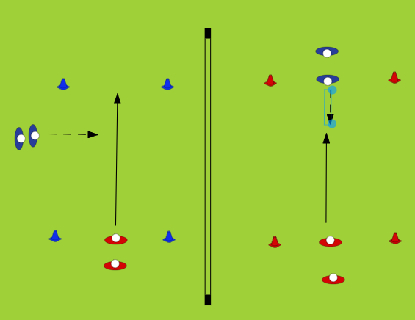  - 1 v 1 from the side and then the front  - 5m rectangle |  |  | Application  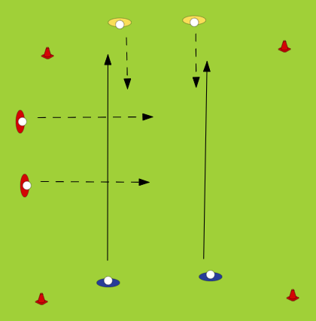  - 2 v 4 “bulldog”  - Tackle from side and also front  Rotate positions each time
Responsive adaptations | Developing  Can attempt a basic tackle if a controlled situation | Securing  Can tackle confidently in a controlled situation |  | Mastering  Can tackle confidentially during game situation using the correct technique throughout
Progress check questions | What is the correct head position when tackling an opponent from side on?  Why do we make contact with our shoulders when tackling in rugby?  How long can you lie on top of the attacker before you get penalised by the referee?
Errors or misconceptions to look out for | Not letting go in the tackle.  Letting go too early.  Timing of the tackle.  Positioning of others not involved in the tackle.  Tackling too high.  Wrong head positioning risking injury  Not wrapping the ball up correctly  Not finishing on top of opponent after tackle is complete

Year 8 - Rugby
Lesson 2 - To learn how defensive skills are used in numbers to make tackling more effective.
(2 v 1)

Do now | Why is important to defend in numbers?  Why is there need to defend in numbers?  How do we tackle correctly?
Teacher exposition  (I do) | Context: The aim of numbered tackling in rugby is to help your teammates tackle a player that they may not be able to without support. This is commonly used in the middle of the pitch were forwards are tackling each other as these players are usually the biggest and strongest on the pitch.  - Consider previous tackles covered in unit including year 7.  - Show timing of the 2nd defending entering the tackle.  - 2nd defender going for the legs while 1st defender wraps the ball up.  - First contact is always high and wrapping the ball, while second contact goes for the legs  - Communication is key  .
Learning task (We do / you do)

Practice  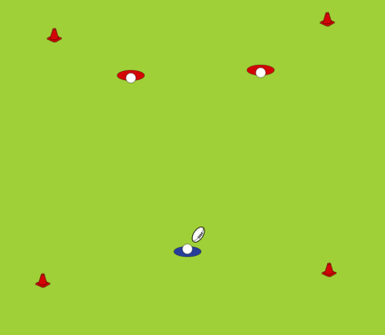  - 2 v 1  - 5 x 5 m square  - Could introduce more numbers |  |  | Application  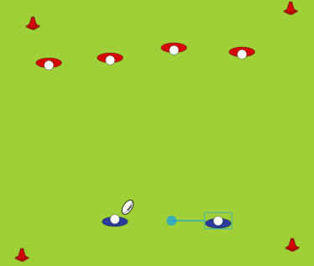  - Small sided gave (6 players)  Must overload defenders 4 v 2 etc
Responsive adaptations | Developing  Attempts to work as part of a team for tackling during a controlled drill | Securing  Can work as part of a team and defend correctly during a controlled drill |  | Mastering  Can defend effectively during a game
Progress check questions | What is the benefit in ‘defending in numbers’?  Why is communication important when tackling in numbers?  How do we tackle correctly and safely?
Errors or misconceptions to look out for | More than 2 v 1.  Offsides (coming round from the side or behind).  Too many people involved in the tackle would leave the defence open to a quick counter.  Lack of communication (2 players going for the legs)  Making contact with the knee instead of the hamstring (serious injury concern and illegal in the game)

Year 8 - Rugby
Lesson 3 - Retrieval – To understand how tackling can be used to prevent offloads at the tackle

Do now | - How do we tackle correctly?  - What is the importance of tackling including safety?  Passing during a tackle?
Teacher exposition  (I do) | Context: Tackling in rugby is extremely important to stop the opposition scoring and making yardage. The aim of a successful tackle is to wrap up the ball as well as the man to ensure that no offload can be performed.  - Approach the attacker  - Go in to wrap the ball up  - Wrap arms around opponent tight to secure ball cannot be offloaded  - Squeeze and drive at player to off balance them  - Ensure defender is in control to land on top of opponent  - Introduce a second defender if required in the tackle to go for the legs
Learning task (We do / you do)

Practice  Set up  Introduce tackle bags first to ensure technique is correct  Students can then move onto 1v1 in small area  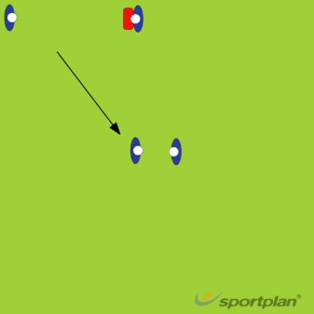 |  |  | Application  Set up  2 v 2 or 3 v 3 small sided games  Pitch size can vary  Emphasis on introducing tackling to a game situation  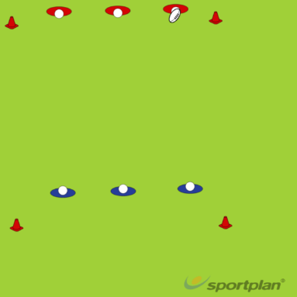
Responsive adaptations | Developing  - Walking pace if required  - Tackling starting on keens | Securing  - Tackling on the move  - Introduce 2nd defender for support |  | Mastering  - Turning into the tackle to allow for quick offload  - Tackling on the move
Progress check questions | - What is the technique required for tackling?  - Why should the first tackler go for the ball?  - How can preventing offloads from the opposition help the defensive team tactically?
Errors or misconceptions to look out for | - Releasing the ball under pressure (i.e. not holding onto it)  - Not completing a tackle  - Incorrect technique that could lead to injury  - Not wrapping the ball when making a tackle
Year 8 - Rugby
Lesson 4 - To learn how to creativity in attack can be used to beat a defender through footwork.
(1 v 1)

Do now | Why is attacking important in Rugby?  How should a team set up to attack?
Teacher exposition  (I do) | Context: In rugby, creativity is of a great importance as it allows attacking teams to create space, make yardage and ultimately score tries. The aim of being creative is to fool the opposition or create specific plays that creates space and try scoring opportunities.  Teacher to discuss and explore basic footwork technique (side step, show and go etc.) and change of direction.  This section can be done practically and can explore different games such as chase/follow the leader/cops and robbers etc. Emphasis on changing direction.
Learning task (We do / you do)

Practice  - Students will be put into small teams (4, 5 ,6 depending on numbers)  - There should be 4 teams in total.  - Students should be given time to create some set plays to outwit opponents that they will try out in a game. |  |  | Application  - Teams will now play against another with an emphasis on their set plays only.  Students should be allowed the time to try out their set plays.
Responsive adaptations | Developing  Can show basic attack instinct during control drill | Securing  Is able to lead attack during a controlled drill |  | Mastering  Is able to lead attack and show competent skill during a game situation
Progress check questions | What is meant by changing the angle of attack?  Why is it important to not be predictable when attacking?  How do we attack as part of a team?  How are we using set plays to outwit an opponent?
Errors or misconceptions to look out for | Make the plays over complicated.  Not using certain players to the strengths.  Not allowing the use of all positions on a pitch to explore.  Lack of organisation.

Year 8 - Rugby
Lesson 5 - To learn the options of a last tackle play and be able to use decision making to exploit the opposition, in particular a punt, bomb, kick pass or grubber kick.

Do now | How many tackles are allowed during a normal game?  What happens after the 5th tackle?
Teacher exposition  (I do) | Context: A last tackle play can create a range of advantages for an attacking team. There are three main types a kick that is used on the last tackle. There is a grubber, a punt and bomb. All of these kicks have advantages but is important to know when it is appropriate to use which kick and which kick is most beneficial at that particular point in a game.  https://www.rugbycoachweekly.net/rugby-drills-and-skills/kicking-catching/rugby-coaching-tips-to-improve-kicking-from-hand-skills/
Learning task (We do / you do)

Practice  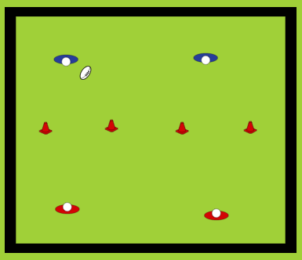  - Kick tennis  - 2 v 2  - 5 x 5m pitch (make this bigger if required)  - First to 5 wins  - If the ball drops on the floor on opponents side then the other team wins  - Kick must be over head height |  |  | Application  - Conditioned game of 4 v 4 or 5 v 5 depending on numbers.  - Large pitch to allow for kicking.  2 tackles only then the kick.
Responsive adaptations | Developing  Can demonstrate basic kicking skill | Securing  Can adapt kicking during a drill and often in games |  | Mastering  Is able to show good kicking skill during a game situation and show good timing
Progress check questions | - What are the teaching points when performing a kick pass/bomb?  - What are the teaching points when performing a grubber kick?  - Why might you choose to use a bomb kick in a game?  - How is the grubber kick used in a game?
Errors or misconceptions to look out for | - Kicking too early during a game/phase.  - Kicking the ball into touch?  - Using the incorrect technique for a kick  - Holding a ball in the wrong position

