Year 8 – Rounders
Unit aim | To become more competent and confident when using the skills required when playing as part of the triangle.
Lesson outcomes | Developing accuracy when performing batting technique. | Developing bowling technique for accuracy | Improve techniques used and awareness required in the bowler to backstop partnership | Improve techniques used and awareness required in the backstop to first base partnership | Improve techniques used and awareness required when responding to the backward hit
Intended Knowledge | Students will know…  1. That the batter doesn’t have to run on a no ball but can do if it would benefit their score  2. The importance of varying where you aim the ball  3. That you must keep hold of the post you are waiting on. | Students will know…  1. How to add power to the bowl to cover 10.5m to get to the backstop  2. That the ‘triangle’ is made up of the bowler, backstop and first post player  3. The importance of not giving away ½ rounders by bowling two consecutive no balls  Consecutive – following each other continuously | Students will know…  1. How to perform the correct backstop technique  2. To always be in line with the bowler  3. That if the bowler has the ball in the box, batters must wait at the post they are approaching. | Students will know…  1. Where to aim the ball when throwing from backstop to first  2. The benefits of throwing straight to first if the batter misses.  3. The obstruction rule  Obstruction – to block the run of the batter | Students will know…  1. That if the ball is hit backwards, the batter has to wait at first post until the ball crosses back into play  Backward Hit – when the ball is hit and lands behind the line of the main playing area  2. To calmly collect a backward hit and accurately throw from the batting square.  3. The benefits of throwing straight to second if the batter hits behind.
Prior knowledge | Students will already know…  1. How to perform rounders batting technique  2. How to score in rounders  3. Batting rules e.g. don’t drop the bat, must be in the batting box | Students will already know…  1. How to perform rounders bowling technique  2. Bowlers must bowl from the bowling square  3. What is classed as a ‘good’ ball. | Students will already know…  1. Backstop stands behind the batting square.  2. The backstop’s main role is to field the ball if it goes behind the batting square.  3. How to perform underarm throwing technique. | Students will already know…  1. That a batter is out if a fielder stumps a post before they do.  2. The importance of being ready to react when fielding. | Students will already know…  1. That a batter can score ½ a rounder if they reach 2nd post  2. How to perform an overarm throwing technique to allow the backstop to reach 2nd post.

Lesson 1
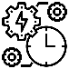  Do now | What are the key coaching points when batting in Rounders?
Teacher exposition  (I do) | Context  Recapping batting technique and effective tactics are key to development in rounders. If a no ball is called but the batter has made good contact/hit to a gap, they can take the ball and run. This needs to be judged by the team at the time so improves their decision making skills.  - Side on stance  - Feet shoulder width apart, knees slightly bent  - Bat pointing up with arm held back at chest height  - Swing arm across body as you twist torso  - Watch ball onto bat, as you make contact
Learning task (We do / you do)
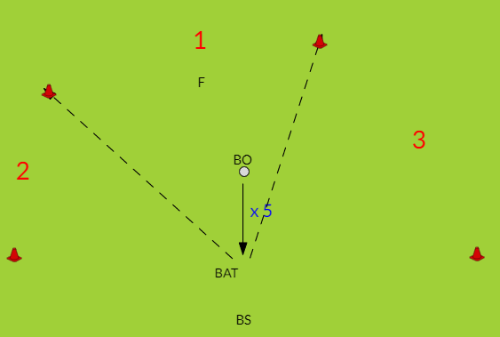  Practice – target practice with boundary  - In 4’s bowler, batter, backstop, fielder  - Set up three target zones/ boundary worth points. (Switch if left handed)  - Bonus point for hitting beyond boundary  - 5 good balls each, then rotate  - Fielder decides where they stand |  |  | 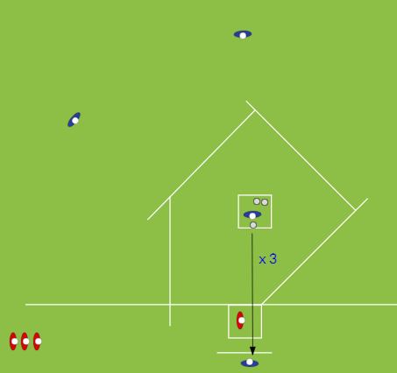  Application – 3 ball rounders game  - Two teams of 4  - Bat 3 consecutive good balls  - Fielders move after 3rd bowl  - Aim to reach 4th to score. Can stop on posts  - Bonus rounder if performed in one go.  Fielders return balls to bowling square
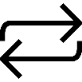  Responsive adaptations | Developing  Use batting tee first –others extra fielders  Use paddle bat  Smaller pitch and shorter boundary | Securing  Use rounders bat and balls  Drill - Make middle zone larger  Introduce backhands off a tee – bowler is an extra fielder  Game: Larger pitch |  | Mastering  Drill: Extra points if hit to fielder who acts as a smaller target  Encourage backhands – bonus point scored  Continuous rounders – keep running round pitch until all balls returned, score bonus rounder for every extra post reached
Progress check questions | 1. What is the basic technique for batting? Side on stance, bat held right back and pointing upwards, swing across your body  2. Why will hitting the ball further help the batter? Further ball is hit, longer it will take for fielders to return the ball so batter can make more progress around the posts.  3. How might the fielders outwit the batting team? Spread out in the field, try to predict where the ball will be hit e.g. right handers more likely to their left, back other fielders up if ball is hit far.
Errors or misconceptions to look out for | Ball missed – not in correct stance, swing too early/late  Limited distance on strike – not enough speed in swing and transferring weight  Hitting in the same area – not adjusting feet quickly enough  Running a team mate out – not looking to see what team mate in front is doing  Not maintaining contact with post - encourage holding post at all times when waiting

Lesson 2
Do now | What are the key coaching points when bowling in Rounders?  What is classed as a good bowl?
Teacher exposition  (I do) | Context  It is important to be able to cover the full bowling distance and reach the backstop. If bowls aren’t accurate a no ball is called. Two consecutive no balls awards ½ a rounder to the batting side so accuracy is vital.  - Face target, ball in thumb and finger tips  - Swing straight arm back  - Step forward on non-throwing leg whilst swinging arm forward. The step and speed of swing will affect the power behind the bowl.  - Release ball in front  - Point to target aiming for back stop
Learning task (We do / you do)
Practice – bowling hoop drill  - In pairs, perform bowling action over correct distance  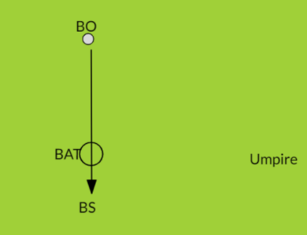  - 4s - BO, BAT BS, umpire (on a rotation)  - 5 bowls to backstop  - Batter holds hoop as target  - 1pt – good bowl 2pts – through hoop  - Umpire scores |  | Application – bowling game  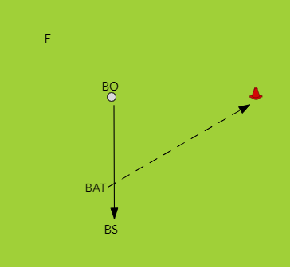  - 4s - BO, BAT BS, F (on a rotation)  - Batter hits, F collects  - Batter runs round first and back to score  - Bowler scores if batter misses  - 5 bats each
Responsive adaptations | Developing  - No hoop  - Use tennis ball  - Use shorter distances  - Use larger bat |  | Securing  - Use rounders ball and bat  - Full bowling distance to reach backstop (10.5m)  - Full distance to first | Mastering  - Smaller hoop  - Begin varying type of bowling action
Progress check questions | 1. What is the distance from bowler to backstop? 10.5m  2. Why is it important to be an accurate bowler? Don’t give away no balls and therefore half rounders to the other team  3. How might applying power to the bowl benefit the bowler? 10.5m distance covered and can reach the back stop. More power results in a quicker bowl which the batter is more likely to miss. This means they have to get to 4th to score which is more difficult if you don’t hit the ball.
Errors or misconceptions to look out for | Ball low – not stepping in, not extending arm out, releasing ball too early  Ball flicks up and falls short - ball stuck in palm  Ball high – releasing too high or too late  Ball wide or at the body – arm not pointing at target,

Lesson 3
Do now | What is the role of the back stop in Rounders?
Teacher exposition  (I do) | Context  The backstop plays an important role in the ‘triangle’. The aim is for a bowl to be missed by the batter and caught by the backstop. One option for the backstop is to throw to the bowler to stop any batters running on to progress. Reaction catching and throwing accurately is key because if a backstop is ineffective, the batter has more time to reach 4th and score ½ a rounder.  - Stand in line with bowler  - Knees bent and on toes ready to react, one foot slightly forward  - Hands out in front ready to catch the ball  - Watch flight of the ball so hands can meet it accurately  - Be ready to throw the ball immediately.
Learning task (We do / you do)

Practice – backstop to bowler drill  - Practice reaction drills e.g. one hand catching, back to feeder then catch on command  - In pairs one bowler one backstop  - Set up two cones over full distance of 10.5 metres  - Bowler bowls to backstop  - Backstop returns ball to bowler using overarm throw technique  - Swap roles after 20 successful catches |  | 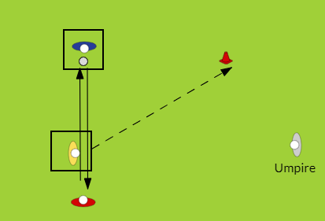  Application – backstop to bowler game  - 4s - BO, BAT BS, umpire (on a rotation)  - 5 bowls to backstop  - Batter is passive and lets ball pass them before running to first  - Backstop quickly returns ball to bowler. Point to whoever makes their target first.  Umpire scores and calls no balls
Responsive adaptations | Developing  - Use tennis ball  - Shorter distances  - Umpire can field too (back up bowler) |  | Securing  - Use rounders ball  - Full bowling distance to reach backstop (10.5m)  - Full distance to first | Mastering  - Batter is active using cone/hand to hit ball  - Umpire becomes a fielder  - Begin varying type of bowling action
Progress check questions | 1. What is the technique used when being backstop? Stand in line with bowler, hands up ready to catch, knees bent ready to react  2. Why does a backstop need to be a good catcher? To catch the ball if the batter misses. If they dropped the ball, it will take longer to get the ball to the other fielders.  3. How could the backstop outwit the batter? Throw to the bowler to stop them progressing to the next post or throw directly to 1st post to try and get the batter out.
Errors or misconceptions to look out for | Ball missed by backstop – not stood in line with batter to receive ball directly  Ball bounces before reaching backstop – stood too far back from batter  Ball dropped – hands not ready, not closing fingers round ball  Ball not reaching bowler – not turning body and stepping into throw so lacks power

Lesson 4
Do now | Who could the backstop throw to if the batter misses?
Teacher exposition  (I do) | Context  The best scenario is for the backstop to throw to 1st post quickly and accurately so the batter can be stumped out. If thrown to the right of 1st post, this may cause the post player to obstruct the batter awarding ½ a rounder. This is when a fielder is on the outside of the posts and blocks a batter’s path. Also, incorrect power to the throw may also cause a misfield.  - Stand in line with bowler  - Knees bent and on toes ready to react, one foot slightly forward  - Hands out in front ready to catch the ball  - On catching, take arm back immediately and step onto opposite foot towards first post  - Throw to first, aiming just to the left of the post.
Learning task (We do / you do)
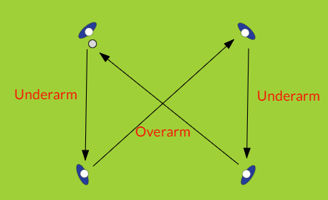  Practice – figure of 8  - In 4s in a square, throw and catch using a figure of 8 pattern. Diagonal throws are overarm, straight throws are underarm  - Rotate a position after 12 catches. |  | Application – backstop to first post game  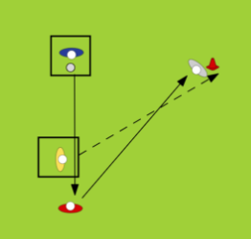  - 4s - BO, BAT BS, 1st (on a rotation)  - 5 bowls to backstop  - Batter is passive and lets ball pass them before running to first  - Backstop quickly throws ball to first.  Point to whoever makes their target first
Responsive adaptations | Developing  - Use tennis ball  - Shorter distances |  | Securing  - Use rounders ball  - Full bowling distance to reach backstop (10.5m)  - Full distance to first  - Apply obstruction rule | Mastering  - Batter is active using cone/hand to hit ball  - Introduce 2nd post that must be covered by fielders  - Begin varying type of bowling action
Progress check questions | 1. What is the obstruction rule? When a fielder blocks the path of a batter by standing on the outside of the posts or when they are running to a post.  2. Why would the backstop choose to throw to first instead of the bowler? To get the batter out on 1st post.  3. How can the backstop and 1st post player work together to not cause obstruction? The backstop should throw slightly to the left of 1st post so the post player doesn’t need to step in the way of the batter. Post player should call for the ball in that position.
Errors or misconceptions to look out for | Ball missed by backstop – not stood in line with batter to receive ball directly  Ball bounces before reaching backstop – stood too far back from batter  Ball dropped – hands not ready, not closing fingers round ball  Ball not reaching first – not turning body and stepping into throw so lacks power  Obstruction rule broken – backstop throws to right of first post so player has to obstruct to catch the ball.

Lesson 5
Do now | Who should the backstop throw to if the batter misses?
Teacher exposition  (I do) | Context  If a batter hits backwards the backstop could catch this to get the player out. If not, the batter has to wait at 1st post until the ball crosses over the line then can run on to 2nd where they can start scoring. Therefore, it is important that a backstop can calmly collect the ball and accurately throw to 2nd post to stop any attempts by the batter. Communication between backstop and 2nd post is important. This rule stops the batter hitting the ball backwards on purpose where there aren’t any fielders.  - Stand in line with bowler  - Knees bent and on toes ready to react, one foot slightly forward  - Hands out in front ready to catch the ball  - On catching, take arm back immediately and step onto opposite foot towards second post  - Throw to second, aiming just in front of the post.
Learning task (We do / you do)
Practice – backstop to 2nd drill  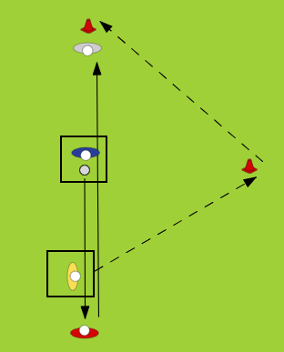  - In 4s, BO, BS, BAT, 2nd  - Bowl to backstop  - Batter lets ball pass then runs to 2nd  - Backstop reacts and aims to throw to 2nd who stumps post before batter touches it.  - Rotate after 5 bowls. |  | 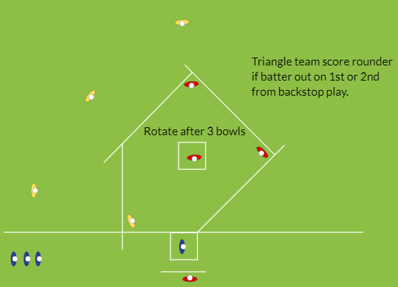  Application – backstop bonus game  - Three teams of 4, batters and triangle + 2nd, deep fielders  - BO, BS, 1st, 2nd – 3 bowls then rotate positions. Then rotate team in bat.  If batter out on 1st or 2nd from a backstop throw, or caught by backstop, triangle team score a rounder.  If ball is hit behind, backstop should retrieve ball and walk to the front of the batting box (shortest distance), communicate with 2nd post to check they are ready to catch.
Responsive adaptations | Developing  - Drill: Throw to bowler first then second  - Game: Use tennis ball and paddle bats  - Smaller pitch |  | Securing  - Drill: batter begins to hit using cone/baton  - Game: Use rounders bats and ball  - Full size pitch | Mastering  - Game: Two teams of 4. If ball is hit, fielders collect and cover posts e.g. BS covers 4th, 2nd collects, bowler covers 2nd.  - Vary type of bowling action
Progress check questions | 1. What is the backward hit rule? If the ball is hit behind, the batter must wait at 1st post until the ball travels back over into the main playing area.  2. Why is the rule in place? To stop batters hitting the ball backwards on purpose.  3. How can the fielding team outwit the batter when the ball is hit backwards? Backstop can collect ball and walk to front of batting square (shortest distance) and communicate with 2nd post player. Perform an accurate throw to stump the post. If batter risks running, they may get out. If they don’t, fielders has prevented ½ a rounder being scored.
Errors or misconceptions to look out for | Ball not reaching second – not turning body and stepping into throw so lacks power, not throwing from front of batting square  Ball is thrown beyond second post – backstop throws with too much power

