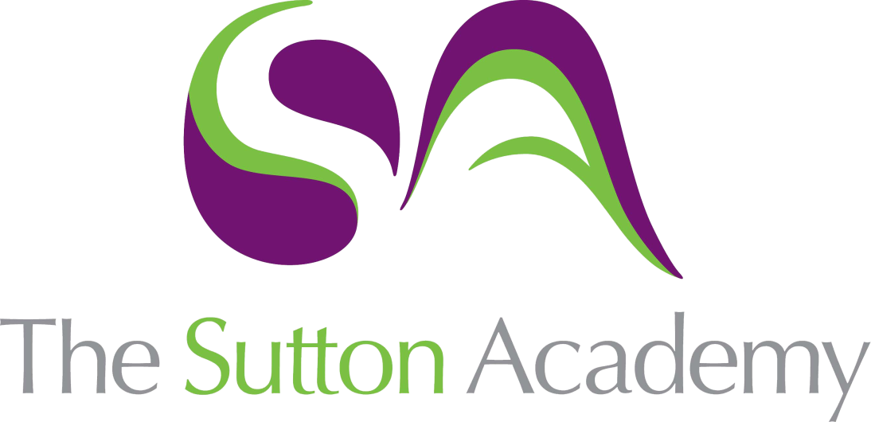

Knowledge Rich Curriculum Plan
Dance – Duo/Trio Performance
Year 10

Dance – Practical  Year 10 | Practical Unit: Duo/Trio Performance
Lesson/Learning Sequence | Intended Knowledge:  Students will know that… | Tiered Vocabulary | Prior Knowledge:  In order to know this students, need to already know that… | Assessment
Lesson 1:  Introduction to the duo/trio and learning the first section | What is the choreographic intent of the duo/trio?  - The intent depends on what the teacher has decided and choreographed. The intent in 2021 (examined 2022) is about two people who have fallen in love with one another.  Why are we learning the duo/trio?  - The duo/trio performance will focus on the student's ability to demonstrate application of: physical skills and attributes safely during performance, technical skills accurately and safely during performance, expressive skills and mental skills and attributes during performance.  - They need to decide on their partner carefully  Students will know how...  - To accurately replicate the dance demonstrating a range of physical, technical, expressive and mental skills. | Tier 3  Physical Skill  Posture – The way the body is held.  Technical Skill  Dynamics – The qualities of movement based upon variations in speed, strength and flow.  Expressive Skill  Musicality - The ability to pick out the unique qualities of the accompaniment and make them evident through performance. | - All students have just learnt and filmed the set phrase where as an individual they have had to demonstrate the physical, technical and expressive skills of the dance.  - To accurately replicate a teacher taught dance.  - What the following Tier 3 words mean from the Year 7, 8, 9 and 10 units of work. | Set phrase final performance in front of a camera in the Arts Theatre.
Lesson 2:  Section 2 and recap of section 1 | - Practicing and refining outside of school is essential to improving their movement memory to ensure accuracy of action, dynamic and spatial content within the context of the duo/trio.  - To accurately replicate section 2 of the dance demonstrating a range of physical, technical, expressive and mental skills. | Tier 3  Physical Skill  Posture – The way the body is held.  Technical Skill  Dynamics – The qualities of movement based upon variations in speed, strength and flow.  Expressive Skill  Musicality - The ability to pick out the unique qualities of the accompaniment and make them evident through performance. | - They need to perform every lesson full out and push themselves physically to gain the most marks as they can in the exam.  - To accurately replicate the first section of the dance demonstrating the physical, technical, expressive and mental skills. | Set phrase final performance in front of a camera in the Arts Theatre.
Lesson 3:  Section 3 and recap of section 2 | - Practicing and refining outside of school is essential to improving their movement memory to ensure accuracy of action, dynamic and spatial content within the context of the duo/trio.  - To accurately replicate section 3 of the dance demonstrating a range of physical, technical, expressive and mental skills. | Tier 3  Physical Skill  Posture – The way the body is held.  Technical Skill  Dynamics – The qualities of movement based upon variations in speed, strength and flow.  Expressive Skill  Musicality - The ability to pick out the unique qualities of the accompaniment and make them evident through performance. | - They need to perform every lesson full out and push themselves physically to gain the most marks as they can in the exam.  - To accurately replicate the first and second section of the dance demonstrating the physical, technical, expressive and mental skills. | Set phrase final performance in front of a camera in the Arts Theatre.
Lesson 4:  Section 4 and recap of section 3 | - Practicing and refining outside of school is essential to improving their movement memory to ensure accuracy of action, dynamic and spatial content within the context of the duo/trio.  - To accurately replicate section 4 of the dance demonstrating a range of physical, technical, expressive and mental skills. | Tier 3  Physical Skill  Posture – The way the body is held.  Technical Skill  Dynamics – The qualities of movement based upon variations in speed, strength and flow.  Expressive Skill  Musicality - The ability to pick out the unique qualities of the accompaniment and make them evident through performance. | - They need to perform every lesson full out and push themselves physically to gain the most marks as they can in the exam.  - To accurately replicate the first, second and third section of the dance demonstrating the physical, technical, expressive and mental skills. | Set phrase final performance in front of a camera in the Arts Theatre.
Lesson 5:  Section 4 and recap of section 3 | - Practicing and refining outside of school is essential to improving their movement memory to ensure accuracy of action, dynamic and spatial content within the context of the duo/trio.  - To accurately replicate section 5 of the dance demonstrating a range of physical, technical, expressive and mental skills. | Tier 3  Physical Skill  Posture – The way the body is held.  Technical Skill  Dynamics – The qualities of movement based upon variations in speed, strength and flow.  Expressive Skill  Musicality - The ability to pick out the unique qualities of the accompaniment and make them evident through performance. | - They need to perform every lesson full out and push themselves physically to gain the most marks as they can in the exam.  - To accurately replicate the first, second, third and fourth section of the dance demonstrating the physical, technical, expressive and mental skills. | Set phrase final performance in front of a camera in the Arts Theatre.
Lesson 6:  Section 6 and recap of section 5 | - Practicing and refining outside of school is essential to improving their movement memory to ensure accuracy of action, dynamic and spatial content within the context of the duo/trio.  - To accurately replicate section 6 of the dance demonstrating a range of physical, technical, expressive and mental skills. | Tier 3  Physical Skill  Posture – The way the body is held.  Technical Skill  Dynamics – The qualities of movement based upon variations in speed, strength and flow.  Expressive Skill  Musicality - The ability to pick out the unique qualities of the accompaniment and make them evident through performance. | - They need to perform every lesson full out and push themselves physically to gain the most marks as they can in the exam.  - To accurately replicate the first, second, third fourth and fifth section of the dance demonstrating the physical, technical, expressive and mental skills. | Set phrase final performance in front of a camera in the Arts Theatre.
Lesson 7:  Self Assessment | - What makes a good performance?  - How they are/aren’t demonstrating the examination criteria of the duo/trio performance?  - Students will know how... To use the examination criteria effectively when analysing their performance.  - To identify areas of strength and areas of development in their own and others’ dance performances.  - How to improve their areas of development through rehearsal discipline.  - When analysing their own performance, they need to focus on the key vocabulary of the unit; posture, dynamics and projection. | Tier 3  Physical Skill  Posture – The way the body is held.  Technical Skill  Dynamics – The qualities of movement based upon variations in speed, strength and flow.  Expressive Skill  Musicality - The ability to pick out the unique qualities of the accompaniment and make them evident through performance. | - A selection of technical, physical and expressive skills particularly focusing on stamina, dynamics and musicality.  - To accurately replicate the whole of the dance demonstrating the physical, technical, expressive and mental skills. | Set phrase final performance in front of a camera in the Arts Theatre.
Lesson 8:  Teacher Assessment and Feedback | - What makes a good performance?  - What their strengths and areas for development are from teacher feedback straight after the performance  - To perform under pressure in preparation for filming the duo/trio  - How to improve their performance from the previous self-assessment lesson.  . | Tier 3  Physical Skill  Posture – The way the body is held.  Technical Skill  Dynamics – The qualities of movement based upon variations in speed, strength and flow.  Expressive Skill  Musicality - The ability to pick out the unique qualities of the accompaniment and make them evident through performance. | - A selection of technical, physical and expressive skills particularly focusing on stamina, dynamics and musicality.  - To accurately replicate the whole of the dance demonstrating the physical, technical, expressive and mental skills. | Set phrase final performance in front of a camera in the Arts Theatre.
Lesson 9:  Filming | - Students will be filmed for assessment purposes |  |  | Set phrase final performance in front of a camera in the Arts Theatre.

