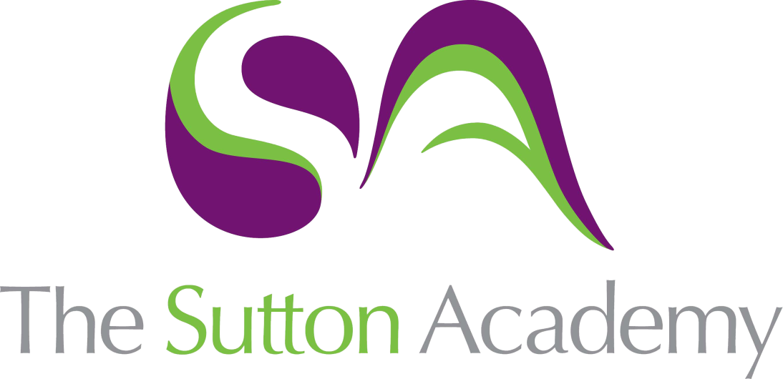

Knowledge Rich Curriculum Plan
SCIENCE- Light & How We See

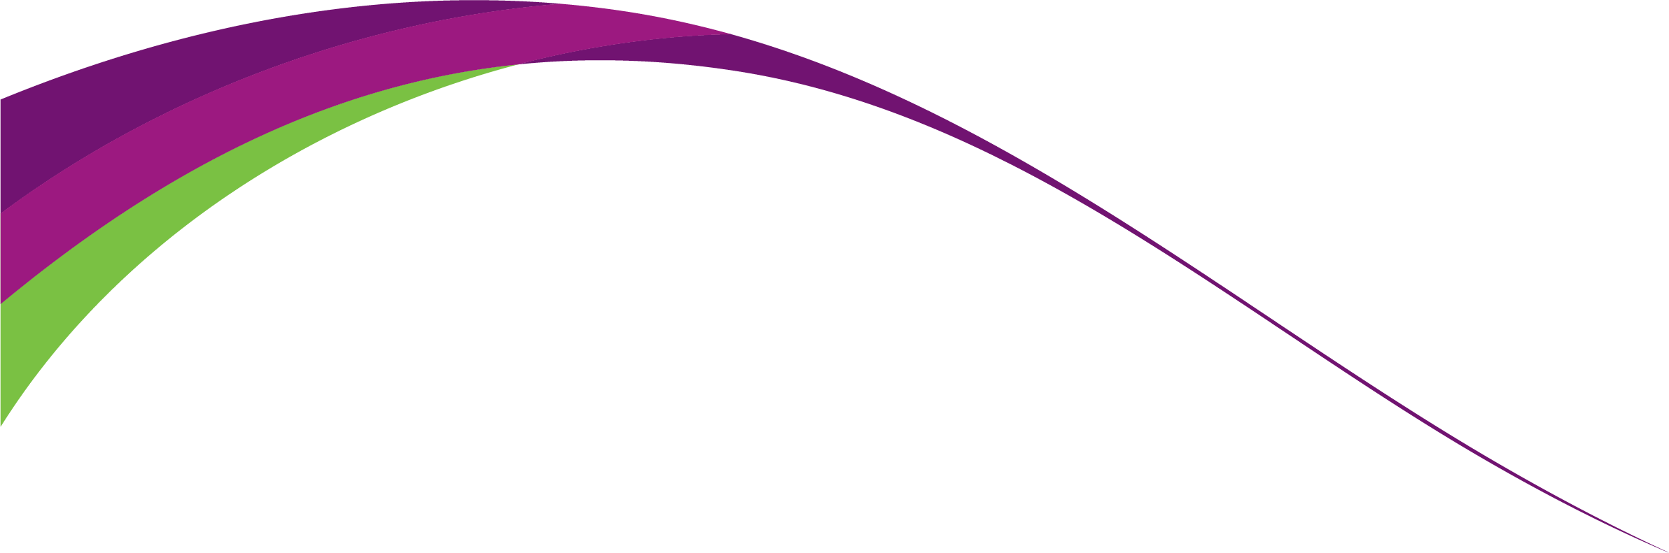

Lesson/Learning Sequence | Intended Knowledge:  Students will know that… | Prior Knowledge:  In order to know this, students need to already know that… | Working Scientifically | Tiered Vocabulary and Reading Activity | Assessment | Support
01  Light | Students will learn that light is emitted by luminous objects. They will learn that light travels in straight lines at the speed of light. Students will learn that light can pass through transparent materials. Students will learn that light cannot pass through opaque materials and can form shadows. Students will know that light can reflect off some materials (i.e. mirrors). | Students need to know already that light illuminates’ objects and that light can be reflected off materials. | Enquire: students will collect data. | Luminous- an object able to provide your own light  Non-luminous- an object not able to provide your own light  Transparent- able to see through  Opaque- not able to see through  Reflection- the throwing back by a body or surface of light | Retrieval questions  Simple exam questions  Homework Quiz  End of topic test  Summative assessment 2 | Knowledge organiser (provided on Teams and in class)  https://www.bbc.co.uk/bitesize/guides/zq7thyc/revision/1  https://www.bbc.co.uk/bitesize/guides/zq7thyc/revision/1  https://www.kayscience.com/d/transverse-longitudinal-waves
05 The eye and vision | Students will be able to label the parts of the eye; iris, lens, pupil, cornea, ciliary muscles, sclera, retina, optic nerve and suspensory ligaments. Students will be able to describe the function of some parts of the eye. The cornea retracts light, the iris controls how much light enters the pupil, the lens focuses light into the retina, the retina contains light receptors and the optic nerve carries impulses to the brain. | Students will know that light travels in straight lines. Students know that people have different eyes colours. Students will know some people need glass to improve their vision. |  | Binocular: adapted for or using both eyes  Iris- the ring-shaped membrane behind the cornea  Retina- the layer at the back of the eyeball that contains cells sensitive to light  Optic nerve- sends messages from the eye to the brain | Retrieval questions  Simple exam questions  Homework quiz 2  End of topic test  Summative assessment 3 | Knowledge organiser (provided on Teams and in class)  https://www.bbc.co.uk/bitesize/topics/zgdmsbk/articles/z7by92p
06 Colour | Students will know that white light is a mixture of all colours in the visible light spectrum. White light is separated by a process called dispersion because of different wavelengths. The colours that can be seen are red, orange, yellow, green, blue, indigo and violet. Students will know that objects look coloured because they reflect certain colours of light and absorb others. For example, grass looks green because it reflects green light and absorbs the other colours of the spectrum | Students will know the colours of the rainbow. | Communicate: Student s will be able to construct and explanation as to why objects appear a specific colour. | Dispersion- the separation of light  Wavelength- the distance between the same point on two successive waves  Refracted- the bending of light which occurs in different object densities  Absorbed- energy taken in  Reflected- the change in a direction of a wave | Retrieval questions  Simple exam questions  Homework quiz 2  End of topic test  Summative assessment 3 | Knowledge organiser (provided on Teams and in class)  https://www.bbc.co.uk/bitesize/guides/zq7thyc/revision/6#:~:text=Light%20is%20refracted%20when%20it,colours%2C%20a%20process%20called%20dispersion%20.
07 Reflection | Students will know that the angle of incident is the measurement from the incident ray and the 'normal' line. Students will know that the angle of reflection is the measurement from the reflected ray and the 'normal' line. Students will know that the 'normal' line is perpendicular to the reflective medium. Students will know that the angle of incident is equal to the angle of reflection. | Students need to already know that light can be reflected. Students need to already know that a right angle is 90 degrees. Students need to already know how to use a protractor. | Enquire: Students will be able to collect data about the change in angle of incidence when the angle of reflection has changed  Analyse: Students will be able to draw conclusions based on their data. | Incident ray- the ray of light that falls on any surface  Reflective ray- the ray of light that is reflected off an object  Normal- A line drawn at 90 degrees to the reflective surface  Medium- A matter/materials | Retrieval questions  Simple exam questions  Homework quiz  https://www.satchelone.com/quizzes/67357236-assessment---reflection-and-refraction-quiz  End of topic test  Summative assessment 3 | Knowledge organiser (provided on Teams and in class)  https://www.bbc.co.uk/bitesize/guides/zq7thyc/revision/2
08. Refraction | Students will need to know that light moves in straight lines away from a source. Students will need to know that light moves through translucent materials. Students will need to know that light waves change speed when moving between objects with different densities. Students will need to know that the angle a ray of light approaches a translucent material is known as the angle of incidence (i). Students will need to know that the angle a ray of light that enters a translucent material is known as the angle of refraction (r). Students will need to know how to draw ray diagrams to show angles of incidence and refraction | Students need to already know that light travels in straight lines. Students need to already know that light passes through translucent materials. Students will need to already know how to use a protractor. | Enquire: Students will be able to devise questions regarding the change in the speed of light through different objects.  Communicate: Students will be able to construct an explanation of why refraction happens. | Translucent- allows light to pass through it  Refraction- the change in the speed of light due to the density of a medium | Retrieval questions  Simple exam questions  Homework quiz  https://www.satchelone.com/quizzes/67357236-assessment---reflection-and-refraction-quiz  Summative assessment 3  End of topic test | Knowledge organiser (provided on Teams and in class)  https://www.bbc.co.uk/bitesize/guides/zq7thyc/revision/4

